Can makerspaces merge traditional and innovative skills in crafts to design sustainable intergenerational spaces, benefiting well-being through making?

BY: ZAHIRA KHATUN
STUDENT ID: 21413773
DATE: 24/04/2024
MODULE: 3DD4006-STD

University Of Northampton
BA Interior Architecture & Spatial Design
2023/2024
CONTENTS:

INTRODUCTION……………………………………………………………….…………….....……3

CHAPTER 1:
1.0: Merging traditional and Innovative skills across generation……...…….…………..….5
1.1: The effect of making to human well-being………………..…..…....………...………6
1.2: Designing a sustainable intergenerational makerspace……………………………………7

CHAPTER 2:
2.0: CASE STUDY 1: The Blackhorse Workshop…………………………………………….9
I: Merging traditional and innovative skills across generations……………….…….10
ii: The effect of making to human well-being………………………….….….……...11
iii: Designing a sustainable intergenerational makerspace………….…………….…11

CHAPTER 3:
3.0: CASE STUDY 2: PRIMARY: The Northampton Community Sheds…………….……..13
i: Merging traditional and Innovative skills across generations…………………..…14
ii: The effect of making to human well-being…………………………………….…14
iii: Designing a sustainable intergenerational makerspace………………….…….…15
3.1: Primary Research Findings……………………………………………..………….16

CONCLUSION……………………………………………………………………………..………..17
LIMITATIONS………………………………………………………………………………………18
REFERENCES………………………………………………….…….….……..……..……….……19
IMAGE REFERENCES………………………………………………………………….…….……24
APPENDIX……………………………………………………………………………….…….…….25

INTRODUCTION:

An open dataset of UK makerspaces by Nesta (2015) shows a significant growth in number of makerspaces over the last decade, with now ninety-seven makerspaces across the country. These engaging environments are well connected with the community and with other makerspace communities. Makerspaces are creative spaces where people of all ages can explore, learn new skills, and create products and models within a community where individuals can receive help from one another (Sheridan, et al. 2014). Makerspaces are becoming a more accessible facility open to all people to use, although it is predominantly accessed by affluent males and younger individuals with a technical or creative background (Taylor et al. 2016).
As opportunities for social interaction declines across generations, ways to rebuild such interactions are being sought for (O’Connor, Alfrey, Hall and Burke, 2019). The Maker Movement was stemmed from the satisfaction that is found in creating things (Dougherty, 2012). It provides individuals with an informal space to express themselves creatively, encouraging them to develop their technical and people skills simultaneously (Hira et al. 2014). A community like makerspaces are a helpful way to promote health and well-being (Vaandrager and Kennedy, 2017). Some argue that working on the connectedness between individuals of all ages in productive daily activities can help encourage a strengthened community and personal health and wellness (O’Connor, Alfrey, Hall and Burke, 2019). Much of the research on intergenerational bonding highlights positive implications for health and well-being (Glass, et al. 2004).
Traditional skills are passed from generations to generations keeping the skills preserved to continue the legacy. On the other hand, innovative skills require proposing new ideas while using a range of digital resources (Zenta and Akhatov, 2017). By merging traditional and innovational together can benefit makers to learn in a world that is constantly changing (Zenta and Akhatov, 2017). Therefore, this idea of merging skills to bring a community of young and old people together in a makerspace can have positive effects on the well-being of the community.
This investigation will explore how successful makerspaces are at creating intergenerational spaces, the challenges it may face and how they resolved them, to understand how these environments impact well-being. The analysis will assess how the design of these makerspaces is used and its impact of user-centred designs on creating a suitable working environment. This paper aims to study the potential of merging traditional and innovational skills in creating intergenerational spaces, which helps the well-being of the youth and older adults. Both primary and secondary research will be used through case studies on The Blackhorse Workshop and The Northampton Community Sheds.
The Blackhorse Workshop and the Northampton Community Sheds both exemplify the potential of makerspaces embracing intergenerational collectiveness whilst promoting well-being. Situated in London, The Blackhorse Workshop is an income run, well-established makerspace that is uniquely designed to cater the needs of a community of designers and freelancers (Lam, et al. 2021). Inspired by the local heritage of industrial crafts, the makerspace embodies inclusivity, welcoming designers of all ages to use (Blackhorse Workshop, 2023). Whereas the community-based, Northampton Community Sheds is a not-for-profit organisation that was created to reduce loneliness and isolation in older adults where they can share skills whilst reestablishing a social network (Northampton Community Sheds, 2016). With the makerspace facing various challenges with its current space, they wish to design a purpose-built makerspace. This initiative looks to improve its accessibility whilst reaching out to wider communities, emphasising on engaging with the youth. By comparing both case studies, we look to understand the effectiveness of intergenerational makerspaces, particularly looking at the spatial designs and effects on well-being.

CHAPTER 1:

1.0: Merging Traditional and Innovative Skills Across Generations

In today’s industry of crafts, there is a divide between skills of the younger generations and traditional skills of the older generations. Young makers of crafts often gravitate towards innovation. This involves objects to be created through machines removing handmade crafts, which was once needed to survive (Johnson, 2002). In the present economy, innovative skills are increasingly necessary to be learnt such as 3D printing. However, Carpenter (2023) states that the traditional skills which are passed through generations, are declining because of the current effects of COVID-19 and inflation. Moreover, where innovation is regarded as an essential factor, the decline of traditional crafts shows the concerns for its uniqueness. This shows the importance in keeping these old skills alive whilst using innovative technology (Shafi, et al. 2022).
The contrast of traditional and innovational crafts brings out the importance in bringing them together through a unique design of intergenerational learning in a well-designed makerspace. However, Skyes (2018) addresses that intergenerational interactions are declining. Therefore, to regain the loss of traditional skills and crafts, ‘cultural citizenship’ should be a method used to pass on to the younger generations (Boyd, 2020). On the other hand, the transfers of skills are not only from old to young, but also the other way around (Coll, 2022). According to Tedde (2023), preserving traditional craft skills and merging with innovational crafts gives artisans and aspiring artisans the foundations to future innovations whilst safeguarding the valuable skills of the past.
Bringing tradition and innovation together gives a true value to intergenerational knowledge exchange by coming together as co-designers and co-learners. The young generation have fresh perspectives in crafts, with skilled knowledge of digital and innovative technologies than the older artisans, despite having invaluable experience and techniques in crafts. Encouraging an environment where the two merge creates numerous opportunities in the growth of future generations and older artisans by achieving the goal of inclusive design (Romero, 2017).
The act of learning and showing these traditional and innovative craft skills have significant effects to both generations. For the younger aspiring artisans, engaging in these crafts gives them a sense of connection with history, a break from a digital life and a chance to experience firsthand activities. On the other hand, the older and retired artisans will feel included giving them a purpose of satisfaction in carrying on traditions and invaluable knowledge to the next generation. As a result, this highlights the mutual benefits of the youth getting a transfer of lifetime skills whilst the old getting a transfer of new insights, giving this concept a sense of continuing a legacy in craft (Sykes, 2018).
Merging traditional and innovative skills with the distinct generations is not only about the preservation of the heritage skills or creating a future but it is also about the connections it creates. It would build an inclusive and creative community that creates meaningful connections as Sykes, (2018) suggests that to restore a community, the past and future, we need to join old and young people together. This also leads to new relationships between the young and old. Consequently, breaking down communication barriers and stereotypes between the generations (Coll, 2022).

1.2: The Effect of Making to Human Well-being

According to Age UK (2018) recent studies show isolation and loneliness are prevalent issues affecting all ages. Well-being has fluctuated qualities where it manifests through subjective experiences (Bowling, 2011). It is therefore vital to look at ways in which this issue can be tackled within communities in a diverse way to help a diverse group of people. Atkinson, et al. (2020) suggests that focusing on collectiveness and social interactions would be a more productive way to address well-being in a community.
The COVID-19 pandemic is an example of how social isolation and social exclusion took places for all ages. Much of the research and empirical findings has been conducted on the topic of well-being in youth, particularly following the COVID-19 pandemic. It is clearly underlined that the impact has caused disruption to their physical activities and educational progress leading to prevalent issues of post-traumatic stress disorder and social isolation (Zolopa, et al. 2022).
Age UK (2023) reports that, 1.4 million older people in the UK are often lonely. One of the main factors of this in the COVID-19 pandemic, was the reliance on digital skills, posing a challenge for older people who may not be as familiar with technology, limiting their access to knowledge (Coll, 2022). As a result, technology became fundamental to promote social inclusion for the older adults during and after the pandemic (Zapletal, et al. 2023). Moreover, the act of loneliness can be found within older generations due to their retirement or significant experiences in life (Valtorta & Hanratty, 2012). Therefore, considering the challenges faced by older adults, makerspaces can play a vital role in enhancing well-being, mitigating the negative impacts of social isolation and loneliness.
The performance of making, exchanging skills and knowledge can create positive impacts to the community of both generations by opening pathways to well-being. This embraces social inclusion and reduces feelings of isolation, anxiety, and insignificance, replacing it with a feeling of being valued and included (Sykes, 2018). Taylor, Hurley, and Connolly (2016) found in their study how the aspect of well-being became a significant factor in makerspaces used by a participant group of one disabled arts organisation. It was the simple act of making that was commonly expressed to be the main benefit to their well-being rather than what was being made (Taylor, Hurley, and Connolly, 2016). This shows the critical need for promoting makerspaces as an example of a community environment that embraces creativity and, therefore, can be looked at as a way of addressing well-being. In this collection of studies, there is a common theme where engaging in creative activities can play a positive role in promoting well-being in individuals.

1.3: Designing a Sustainable Intergenerational Makerspace

When designing a sustainable intergenerational makerspace that merges traditional and innovational crafts, there are many factors that need to be considered to accentuate creativity, a sense of community and collaboration. To do this, we must consider the principles of user-centred design. It is a way of inquiring into potential user perspectives to help consider the needs of the space (McGrath, 2016). Perez, et al. (2020) carried a research study to find out interactions between the ages in an intergenerational making space. They found that the design of the space needs to consider accessible tools to all, a user-centred space that allows people to freely switch between different tasks (Perez, et al. 2020). Therefore, the space design needs to signify inclusivity and accessibility. The importance of each factor will be examined to see how designing a successful makerspace can be achieved.
In the past, makerspaces have shown evidence in not being inclusive on gender due to it being dominated by males (Hynes and Hynes, 2018). Therefore, it is crucial to consider the design to be inclusive, attracting all groups and abilities. Richard and Giri, (2017) suggest inclusivity though collaborating. By providing diverse activities in makerspaces will help encourage people to work together, share skills and knowledge whilst promoting a safe environment (Richard and Giri, 2017). Furthermore, the significance of inclusivity in makerspace design not only emphasises collaboration and skills sharing, but also ensures the importance of equity in fostering a makerspace where makers can thrive.
Accessibility is significant in makerspace design since they can be affected in loss if it is not accessible to everyone (Moorefield-Lang and Dubnjakovic, 2020). Accessibility includes both the accessibility of equipment and the inclusion of disabilities. Steele, et al. (2018) conducted a study using people of abilities in a makerspace. The results suggest that the space needs to be flexible with wide walkways and diversity in equipment. Ultimately, the space should be organised with clear safety procedures (Steele, et al. 2018). Therefore, accessibility is another significant factor when considering the design of an intergenerational makerspace.
Another important aspect of designing a makerspace is fostering a sense of community (Moorefield-Lang and Dubnjakovic, 2020). A way to achieve this can be through designing designated communal spaces where makers can gather, interact, and learn. This results in an inclusive environment creating support and value amongst everyone. Taylor, Hurley, and Connolly (2016) observed two makerspaces with and without communal facilities. They found that having communal facilities, makers would socialise, play games, and share knowledge. In contrast, makerspaces without these facilities, observed that makers will come and go for their projects without socialising. This highlights the importance of having communal spaces in makerspaces (Taylor, Hurley, and Connolly, 2016).
In addition to these considerations, the sustainability of an intergenerational makerspace should be highlighted. In makerspaces, a lot of waste is produced. This is the best opportunity to provide environmentally friendly materials whilst raising awareness about reuse and recycling throughout the makerspace (Unegg, et al. 2023).
Furthermore, designing a sustainable intergenerational makerspace, requires factors such as inclusivity, accessibility, a sense of community and sustainability. Hence, makerspaces can become inspiring environments for all ages that want to create, craft, learn or share skills, creating a meaningful community in a focused intergenerational makerspace.

CHAPTER 2:

2.0 Case Study 1: The Blackhorse Workshop, London

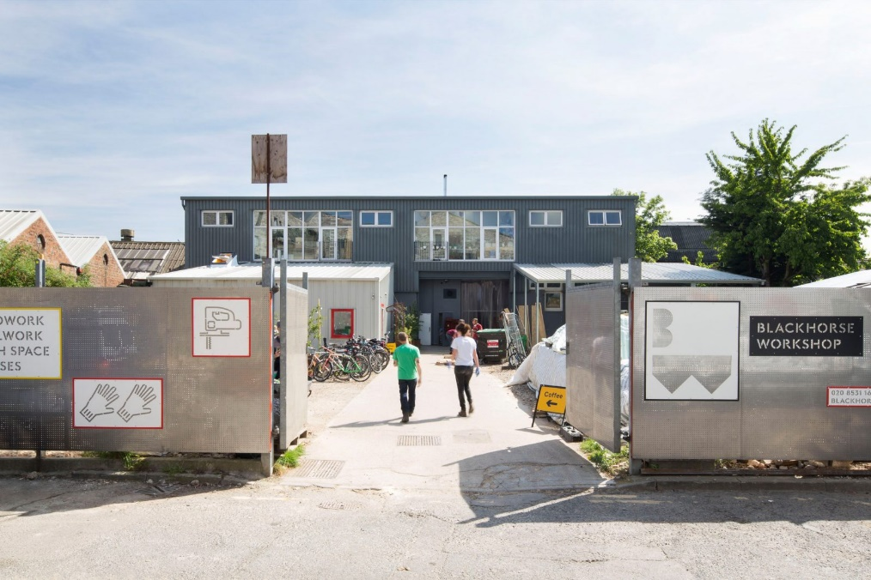

Courtyard and entrance Figure [1]

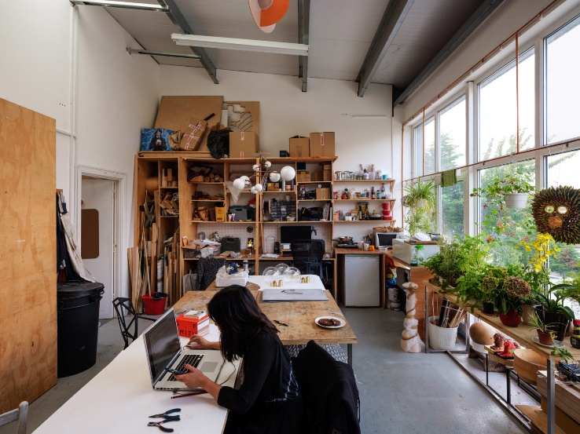
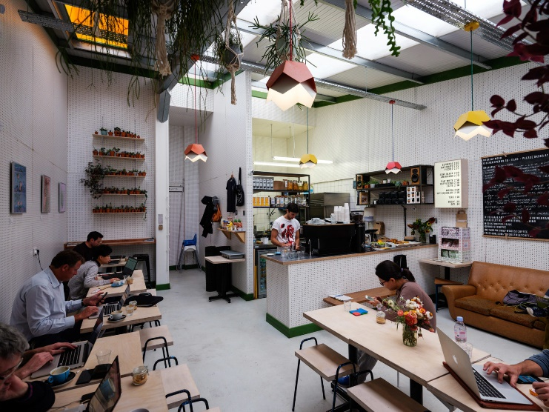
Café Figure [2]
Studio space Figure [3]

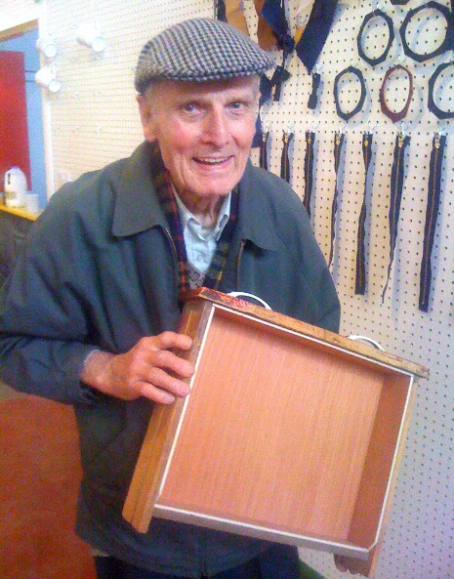
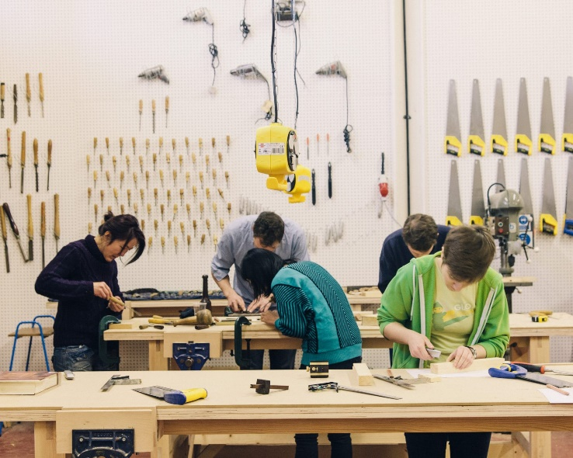
Workshop Figure [5]
Maker Figure [4]

- Merging Traditional and Innovative Skills Across Generations

Initially, being a temporary community, The Blackhorse Workshop became a successful and well-established social enterprise that offers workspace, classes and firsthand making experiences (The Blackhorse Workshop, 2022). Housed within an industrial warehouse, it is equipped for woodworking and metalworking amongst other creative industries (Hitchcock, 2024). Taking on approaches to traditional and innovative methodologies, the workshop offers a diverse mix of equipment, ranging from traditional hand tools to modern machinery (Hitchcock, 2024). This workshop creates an environment for all ages to explore the creativity of making. Makers can move between the past and present by combining traditional techniques and contemporary skills throughout the space.
Hitchcock (2024) comments that the makerspace has an ‘everyone is welcome’ approach. This displays the inclusivity and diversity throughout the workshop, welcoming both amateurs and professionals with no boundaries of age. This is also shown in figure [4] and [5]. According to the 2020-2021 annual report of Blackhorse Workshop, themes of collaboration, sharing skills, and knowledge acquisition have been mentioned as a benefit of having a shared space (The Blackhorse Workshop, 2022). This approach to craftmanship preserves heritage skills whilst exploring innovative skills in a workshop that embodies the courage of intergenerational learning.
Chanelle Brown, a young craftsperson that is a member of The Blackhorse workshop, illustrates the merging of traditional and innovational skills and evidence of the diverse age range. Brown used her grandmother’s heritage in washing and mending textiles to craft a wooden frame loom for weaving threads during her contracted residency with Blackhorse Workshop (The Blackhorse Workshop, 2022). This shows innovative potential that can strengthen from merging traditional skills with innovation. Using ultramodern machinery to design a traditional loom, Brown shows the blending of craft skills in a contemporary way. Brown tells us her aspirations to develop a learning exchange space like The Blackhorse Workshop that emphasises cultural legacy and the promotion of well-being.

- The Effect of Making to Human Well-being

The Blackhorse Workshop (2022) mentions in its annual report of 2020-2021, that even with the challenges of COVID-19, there were still members encouraged to return to the workshop to be amongst other makers, with 64% of members collaborating with other members. Therefore, this shows the motivation to reconnect, with the workshop supporting this social interaction that contributes to improving well-being. The Blackhorse workshop (2022) states the method they follow of improving well-being is by the act of making in a creative environment. This method is followed by Maartje Schalkx who in 2019 took on a woodcarving course at the workshop to improve her well-being. Schalkx reviewed it to be a ‘sociable learning experience’ (Making for Well-being, 2019). This underlines the positive effects of well-being when being involved in crafting activities.
The director of The Blackhorse Workshop highlights the ability and importance of makers connecting with others to share skills and learning new techniques (Hitchcock, 2024). An example of this was the ‘Maker Mornings’ in 2022. The Blackhorse Workshop worked with Age UK to combat loneliness and isolation by bringing people together post pandemic (The Blackhorse Workshop, 2022). These interactions encourage a strong community where feelings of satisfaction and accomplishment are clear. Overall, The Blackhorse Workshop stands as a foundation of well-being by providing a supportive environment broadening makers to explore creativity and engage in crafts with others in a social hub workshop.

- Designing a Sustainable Intergenerational Makerspace

The Blackhorse Workshop has an approach to community engagement through inclusivity and intergenerational collaboration. One of the ways this is done, is through the spatial design of the workshop. Figure [1] shows the entrance to the workshop with two new construction buildings on either side, one accommodating the café, reception and office spaces while the other provides as an outdoor workshop space (Blackhorse yard, 2017). The ground floor of the workshop features an open-plan layout allowing easy movement between the rooms. It is divided by walls to separate the different areas of craft industries and studio spaces. This allows freedom of socialising and sharing ideas (Lam, et al. 2021). The first floor finds the self-contained studio spaces shown in figure [3] offering plenty of space and light (Blackhorse yard, 2017).
Figure [2] shows the café space with natural sky lighting, thoughtfully arranged with seatings ranging from sofas to benches, creating a warm invitation for people to come into. We can see the effects of the spatial design through the comfortable setting where people of all ages can get on with their work and socialise.
Furthermore, the amount of lighting that flows throughout the whole makerspace enhances well-being and motivation in a positive and creative environment. There is sufficient walking space and room for disability access that further shows inclusivity. Throughout the makerspace, there are visible number of sustainable materials integrated in the spatial design such as plywood.
Overall, through the space and the community of the makers, the Blackhorse Workshop shows occurring themes of sustainability, accessibility, community engagement and well-being throughout the makerspace.

CHAPTER 3:

3.0 Case Study: The Northampton Community Sheds, Northampton
Workshop Figure [6]

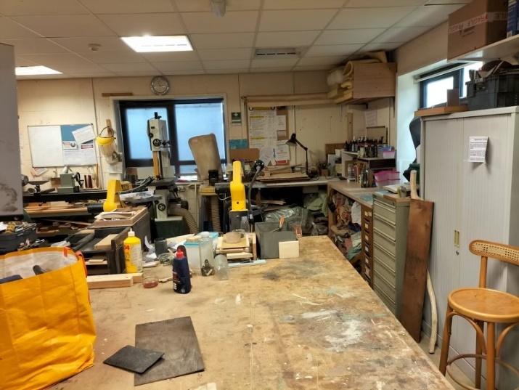
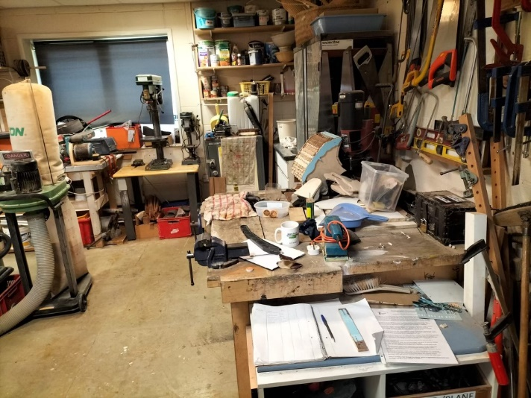
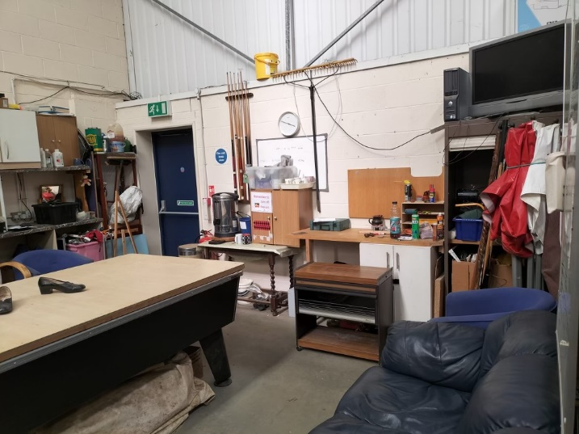
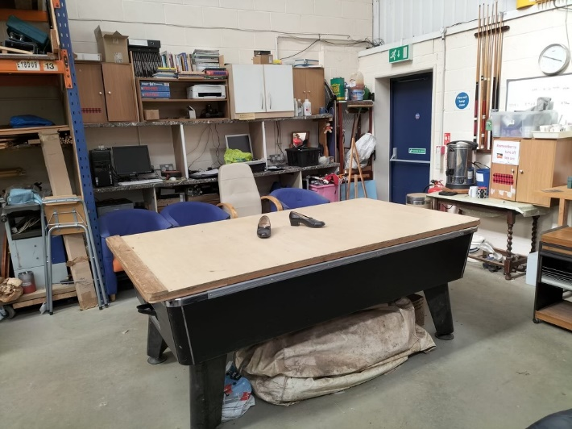
Compared to the well-established Blackhorse Workshop, this not-for-profit organisation is a community and meeting place where men and women work together on projects for the community (Northampton Community Sheds, n.d). Ward, (2023) states how the idea started off as a Men’s shed in Australia before coming to the UK that later opened to women. This corresponds to an article by Taylor, Hurley, and Connolly, (2016) where it mentions the idea was to respond to mental health issues amongst men. Westhead, (2024) a chairman of the Northampton Community Sheds adds that it was to combat isolation, promote community engagement and skills sharing. Therefore, this suggests how the sheds fight social challenges and skills sharing encouraging well-being across the members and the wider community. Combining primary research and existing articles, this chapter will compare the Blackhorse Workshop and the Shed to help redesign the Northampton Community Sheds while focusing on the community’s needs.
Communal area Figure [9]
Communal area Figure [8]
Workshop Figure [7]

- Merging Traditional and Innovative Skills Across Generations

The current situation of the Northampton Community Sheds has no facility of merging traditional and innovative skills because of the lack of space and funding. Therefore, the plans for an additional space will help redesign the Community Shed to allow a range of facilities to be put in place. Compared to the Blackhorse Workshop, the Community Shed has the same ambitions however they are yet to be achieved. Westhead, (2024) mentions the possibilities of young people bringing new perspectives to the space leading to intergenerational learning, aligning with the goals of the community. Therefore, designing a new space for this Community Shed can allow many benefits for intergenerational learning whilst benefitting the community’s well-being.
As the Northampton Community Sheds dreams of expanding aspire to become a skills hub, the plans of traditional and innovative skills will combine through the making and exchanging skills between the young and old (Ward, 2024). This suggests the openness of adapting to innovation while preserving the heritage, ensuring the inclusivity of the community. As Westhead, (2024) discusses community development, it is mentioned that the Shed encourages the young people at schools through a range of activities showing the keen interest of expanding the community.

- The Effect of Making to Human Well-being

Like other communities, the Northampton Community Sheds faced difficult challenges during COVID-19. However, the in-person activities being on pause meant it had to close, effecting the community’s well-being (Westhead, 2024). This highlighted the importance of social connections and mental health support, as members could not meet (Westhead, 2024).
Northampton Community Sheds, (n.d) states the objectives of the Community Sheds is to reduce loneliness and social exclusion. Like the Blackhorse Workshop, this benefit of the Community Sheds is seen in the post COVID-19 outcomes where it is said that members being able to reconnect has led to positive impacts. The Community Sheds created a supportive environment for sharing skills that helped members come out of the pandemic improving their mental and physical health through these events. When conducting the questionnaire, members expressed they had positive outcomes of well-being since the pandemic from going back to the activities held by the Community Sheds.
Since the resurgence of memberships post pandemic, the community has expanded (Westhead, 2024). Underlining the positive impacts of making to the well-being of members of the Northampton Community Sheds. This has also benefited the Community Sheds through diversifying their activities and growing out to a wider community resulting in partnerships with local communities, councils and schools to offer a range of workshops (Westhead, 2024). The benefit of making proves itself through the development of the shed.

- Designing a Sustainable Intergenerational Makerspace

Westhead, (2024) mentions the problems that come with the development of the Community Sheds. Unlike the Blackhorse Workshop, the not-for-profit community faces extreme challenges of space for this expanding community. Funding, limited space, outdated equipment and accessibility issues are just a few of them. “Our biggest issue right now is space.” (Ward, 2024). As health and safety needs to be considered, it is unsafe to allow more members from the current 50 members. The figure of members has been the same since October 2023 because of the limited space. However, Ward, (2024) states there can easily be hundreds of members if this was not a problem. These challenges show the needs of a new and developed space to keep the positivity of community well-being.
The existing space of the Northampton Community Sheds is welcoming and inclusive with a workshop and a communal area for members to sit and socialise. The communal space proves to be quite popular with members who cannot stand for long periods of time (Westhead, 2024). These spaces encourage a sense of belonging and gives purpose to all the members. Figure [6] and figure [7] shows the current workshop space of the Community Shed. This shows how compact and disorganised the space is because of the limited space. Figure [7] asserts the tools that are not safely stored; therefore, this shows the lack of space for storage and organisation. The communal area shown in figure [8] and [9] is a space in the same room as the workshop. As Brebner, (2024) states, the second-hand sofa is where everyone likes to sit and have a chat. We can also see the snooker table that is being reused with a slab of plywood on top to create a table for people to sit around. We can also see the refreshment station and the corner tv in figure [8]. These figures showing the current state of the Northampton Community Sheds has been able to prove the struggles they are facing, concluding to the desperation of a new and redesigned makerspace.
To expand the community, the Northampton Community Sheds desire for a new makerspace that is modern and versatile with larger workspaces, storage areas, improved accessibility and communal areas (Westhead, 2024). The makerspace goals are to offer a wide range of activities to the growing community targeting different age groups. The chair of trustees, Phil Osborne mentions the possibilities of older people transferring their skills to the younger generation (Ward, 2024). This shows the positive intentions of the Community Sheds with a new space. A new focus on sustainability throughout the desired makerspace include resources such as solar panels and rainwater harvesting systems. The objectives of the Community Sheds incorporate the commitment to benefit the well-being of the local community and the well-being of the environment showing the approach to encouraging health and sustainability.

3.1: Primary Research Findings

To conduct a valid and informed conclusion, mixed methods of research of quantitative and qualitative data has been collected through a questionnaire filled by a few members of the Northampton Community Sheds. Quantitative data generates analytics that results to statistical analysis whereas qualitative data produces descriptive feedback based on the participant (Kelley-Quon, 2018). Therefore, the research collected gives a deeper understanding of the necessity of having a sustainable intergenerational makerspace which benefits human well-being.
The primary research completed by ages 55+ which of whom 75% were female, said that they have worked with other members of the shed. This proves the Community Shed succeeds in helping members socialise in a method to relieve isolation and loneliness. Members have mentioned this has greatly benefitted them by being part of an inclusive community. The current space of the Community Shed limits the space of intergenerational learning. However, redesigning a new space, members have expressed positive feedback to working with young people within the space.
All members have shared their views of having experience with traditional skills however only 50% say they have experience with innovative skills. Majority of them see the benefits of combining both set of skills together in a makerspace can have positive benefits such as learning new skills. This suggests the openness that the members of the Community Shed have, to trying out new ideas which can spread goodness through the community for everyone to be a part of.
When asking members what the challenges of merging traditional and innovative skills are to create an intergenerational makerspace community, 75% have mentioned the struggle of funding. The not-for-profit Community Shed gathers money from projects they complete for the community, making it challenging to convey their vision to life. Furthermore, the vision shared by the community helps to bring it to reality.
Lastly, members of the Community Shed mentioned ways to create intergenerational learning. They have expressed holding a diverse range of events, community skills sharing activities with facilities that are accessible and inclusive. This would encourage the makers to socialise and come out of their comfort zone.
Concluding the primary research findings, it has been found that creating a strong and inclusive community is crucial to achieve an intergenerational makerspace that improves the well-being of both humans and the environment.

CONCLUSION

With the development of society and the unprecedented COVID-19, there has been a noticeable reduction in social interaction, inspiring the need to reduce social isolation and loneliness. This research was conducted to analyse ways that makerspaces can use traditional and innovational skills to create an intergenerational space where well-being can be improved.
By analysing the case studies of a well-established Blackhorse Workshop, and a not-for-profit Northampton Community Shed, it helps underline the importance of community interaction that promotes inclusivity and well-being. The research showed that the makerspaces have been a powerful way to incorporate social interactions in a creative way, making it an engaging source of social interactions.
The Blackhorse Workshop proves the success in merging traditional and innovative skills together to create community interactions, which benefits the well-being of humans and the environment throughout the workshop. On the other hand, the charitable Community Shed shows a strong commitment to well-being by finding ways to expand the community through inclusivity and sustainability.
Using mixed research for both primary and secondary case studies, the findings have underscored the significance of creating a strong community to succeed in designing a sustainable intergenerational makerspace. Furthermore, the art of skills sharing helps to consolidate bonds between people of all ages, therefore, reducing isolation and strengthening individuals knowledge and skills. Through the investigation of two distinct case studies, makerspaces can use both traditional and innovative skills to design a sustainable intergenerational space that benefits the well-being of young and old people through the form of making.
This study has shown ways of designing a sustainable intergenerational makerspace through user-centred design, focusing on the needs of accessibility and inclusivity for the making community. This has been done by comparing the case studies to discover the differences of a successful makerspace and a developing makerspace. There are significant benefits of creating spaces between generations on individuals’ well-being and skill development highlighting a need for sustainable intergenerational makerspaces to be designed and sustained.

LIMITATIONS

The limit of this study consists of restricted access to the Northampton Community Sheds as they are only open twice a week for half a day. As a result, it was difficult and challenging to make time to visit the site.
Additionally, the questionnaires were only filled by 4 members of the shed. In the time frame for this completion, this survey has been limited to a small number of participants. However, given more time, there would have been more participants. It is important to survey a large number of people to ensure reliability and validity of all the data collected.
Lastly, when interviewing Ann Brebner (managing member of the sheds), she mentioned she has been a part of the group for only a couple of years which may have affected the depth of her responses during the interview. However, Keith Westhead (the chairman of the shed) was available for an interview and answered the same questions which partially mitigates this limitation, providing somewhat reliable data.

REFERENCES:

A
- Andersen, R.S., Hoybye, M.T. and Risør, M.B. (2024) Expanding Medical Semiotics. Medical Anthropology, pp.1-11.
- All the lonely people: Loneliness in later life (2018) Age UK [online]. Available from: https://www.ageuk.org.uk/latest-press/articles/2018/october/all-the-lonely-people-report/ (Accessed: 09 March 2024).
- Atkinson, S., Bagnall, A.M., Corcoran, R., South, J. and Curtis, S. (2020) Being well together: Individual subjective and community wellbeing. Journal of Happiness Studies, 21 (5), pp.1903-1921.
B
- Blackhorse Yard (2017) Assemble [online]. Available from: https://assemblestudio.co.uk/projects/blackhorse-yard (Accessed: 26 March 2024).
- Blackhorse Workshop: Making for wellbeing (2019) Blackhorse Workshop [online]. Available from: https://www.blackhorseworkshop.co.uk/making-for-wellbeing/ (Accessed: 21 March 2024). (New website under construction)
- Blackhorse Workshop: Maker mornings: bringing people together (2022) Blackhorse Workshop [online]. Available from: https://www.blackhorseworkshop.co.uk/maker-mornings-bringing-people-together/ (Accessed: 26 March 2024). (New website under construction)
- Blackhorse Workshop: The Blackhorse Workshop (2022) Background [online]. Available from: https://www.blackhorseworkshop.co.uk/about/ (Accessed: 21 March 2024). (New website under construction)
- Bowling, A. (2011) Do older and younger people differ in their reported well-being? A national survey of adults in Britain. Family practice. [Online] 28 (2), 145–155.
- Boyd, D. (2020) The legacy cafe-the holistic benefit of reviving lost arts, crafts and traditional skills through an early childhood intergenerational sustainable skills project. Education 3-13, 48 (2), pp.204-216.
- Brebner, A. (2024) Northampton Community Sheds. Interviewed by: Khatun, Z. [phone call] 1 March.

C
- Carpenter, D. (2023) Craft skills under threat with 17 additions to the Red List of Endangered Crafts, Heritage Crafts [online]. Available from: https://heritagecrafts.org.uk/redlist2023/ (Accessed: 29 February 2024).
- Coll, A.S. (2022) Digital Partners: Benefits of Intergenerational Learning: Barcelona Metropolis: Barcelona City Council, Barcelona Metropolis [online]. Available from: https://www.barcelona.cat/metropolis/en/contents/digital-partners-benefits-intergenerational-learning (Accessed: 29 February 2024).
D
- Dougherty, D. (2012) ‘The Maker Movement’, Innovations: Technology, Governance, Globalization, 7 (3), pp. 11–14. doi:10.1162/inov_a_00135.
H
- Hira, A., Joslyn, C.H. and Hynes, M.M., 2014, October. Classroom makerspaces: Identifying the opportunities and challenges. In 2014 IEEE Frontiers in Education Conference (FIE) Proceedings (pp. 1-5). IEEE.
- Hitchcock, N. (2024) Blackhorse Workshop on the art of a good creative space, Hole & Corner [online]. Available from: https://www.holeandcorner.com/interviews/making-space-blackhorse-workshop (Accessed: 23 March 2024).
- Hynes, M.M. and Hynes, W.J. (2018) If you build it, will they come? Student preferences for Makerspace environments in higher education. International Journal of Technology and Design Education, 28, pp.867-883.
J
- Johnson, J. (2002) Contemporary Craft, jeweller [online]. Available from: https://www.brucemetcalf.com/contemporary-craft#:~:text=The%20subject%20here%20is%20contemporary,a%20collective%20response%20to%20industrialization. (Accessed: 15 April 2024).
K
- Kelley-Quon, L.I. (2018) December. Surveys: Merging qualitative and quantitative research methods. In Seminars in paediatric surgery 27 (6), pp. 361-366. WB Saunders.

L
- Lam, B., Choi, Y., Chen, X., Ni, M. and Sousa, S.D. (2021) Fostering creativity through co-design and making: case studies of makerspaces in the UK. Journal of Design Research, 19 (1-3), pp.133-154.
- Loneliness Research and Resources (2023) Age UK [online]. Available from: https://www.ageuk.org.uk/our-impact/policy-research/loneliness-research-and-resources/#:~:text=1.4%20million%20older%20people%20in,influencing%2C%20campaigning%20and%20service%20provision. (Accessed: 01 March 2024).
M
- McGrath, O.G. (2016) November. Making a makerspace: Designing user services to serve designing users. In Proceedings of the 2016 ACM SIGUCCS Annual Conference (pp. 95-98).
- Moorefield-Lang, H. and Dubnjakovic, A. (2020) Factors influencing intention to introduce accessibility in makerspace planning and implementation. School Libraries Worldwide, 26 (2), p.14.
N
- Northampton Community Sheds (n.d). Northampton Community Sheds [online]. Available at: https://www.northamptoncommunitysheds.org/ [Accessed 12/04/2024].
O
- O’Connor, J.P., Alfrey, L., Hall, C. and Burke, G. (2019) Intergenerational understandings of personal, social and community assets for health. Health & place, 57, pp.218-227.
- Our impact (2022) Blackhorse Workshop [online]. Available from: https://www.blackhorseworkshop.co.uk/about/our-impact/ (Accessed: 23 March 2024).
P
- Perez, M.A. et al. (2020) Intergenerational making with young children: Proceedings of the fablearn [online]. Available from: https://dl.acm.org/doi/pdf/10.1145/3386201.3386225 (Accessed: 06 March 2024).
R
- Romero, M. and Lille, B. (2017) Intergenerational techno-creative activities in a library fablab. In Human Aspects of IT for the Aged Population. Applications, Services and Contexts: Third International Conference, ITAP 2017, Held as Part of HCI International 2017, Vancouver, BC, Canada, July 9-14, 2017, Proceedings, Part II 3 (pp. 526-536). Springer International Publishing.
- Richard, G. and Giri, S. (2017) Inclusive collaborative learning with multi-interface design: Implications for diverse and equitable makerspace education. Philadelphia, PA: International Society of the Learning Sciences.
S
- Shafi, M., Szopik-Depczyńska, K., Cheba, K., Ciliberto, C., Depczyński, R. and Ioppolo, G. (2022) Innovation in traditional handicraft companies towards sustainable development. A systematic literature review. Technological and Economic Development of Economy, 28 (6), pp.1589-1621.
- Sheridan, K. et al. (2014) ‘Learning in the making: A comparative case study of three makerspaces’, Harvard Educational Review, 84 (4), pp. 505–531.
- Sleigh, A., Stokes, K. and Stewart, H. (2015) Open dataset of UK Makerspaces: A user’s guide, Nesta. Available at: https://www.nesta.org.uk/report/open-dataset-of-uk-makerspaces-a-users-guide/ (Accessed: 22 April 2024).
- Steele, K., Blaser, B. and Cakmak, M. (2018) Accessible making: Designing makerspaces for accessibility. International Journal of Designs for Learning, 9 (1), pp.114-121.
- Sykes, G. (2018) “Intergenerational communities: The young and the old together,” in Young Children and Their Communities. 1st edition [Online]. United Kingdom: Routledge. pp. 70–84.
T
- Taylor, N., Hurley, U. and Connolly, P., 2016, May. Making community: the wider role of makerspaces in public life. In Proceedings of the 2016 CHI Conference on human factors in Computing systems (pp. 1415-1425).
- Tedde, A. (2023) Preserving the past, reviving ancient craft skills for the future., ANTONELLO TEDDE [online]. Available from: https://www.antonellotedde.com/blogs/news/preserving-the-past-crafting-the-future#:~:text=Ancient%20craft%20skills%20embody%20the,for%20future%20innovation%20and%20creativity. (Accessed: 28 February 2024).
- Top findings from the open dataset of UK Makerspaces (2015) nesta [online]. Available from: https://www.nesta.org.uk/blog/top-findings-from-the-open-dataset-of-uk-makerspaces/ (Accessed: 09 March 2024).

U
- Unegg, M.C., Bujan, Z., Schnoell, H.P., Herstaetter, P., Kohlweiss, A.F. and Ramsauer, C. (2023) The choice of materials in makerspaces-demonstrating its impact on sustainability 7th International Symposium on Academic makerspaces.
V
- Valtorta, N. and Hanratty, B. (2012) Loneliness, isolation and the health of older adults: do we need a new research agenda? Journal of the Royal Society of Medicine, 105 (12), pp.518-522.
W
- Ward, S. (2023) ‘we have far more ideas than space’, ‘We have far more ideas than space’ [online]. Available from: https://www.nnjournal.co.uk/p/we-have-far-more-ideas-than-space (Accessed: 12 April 2024).
- Westhead, K. (2024) Northampton Community Sheds. Interviewed by: Khatun, Z. [email] 21 March.
Z
- Zapletal, A. et al. (2023) On the triple exclusion of older adults during COVID-19: Technology, digital literacy and social isolation. Social sciences & humanities open. [Online] 8 (1), 100511–100511.
- Zenta, A. and Akhatov, D.S. (2017) The traditional and innovative in the 21st century school. Казанский вестник молодых учёных, 1 (3 (3)), pp.10-16.
- Zolopa, C., Burack, J.A., O’Connor, R.M., Corran, C., Lai, J., Bomfim, E., DeGrace, S., Dumont, J., Larney, S. and Wendt, D.C. (2022) Changes in youth mental health, psychological wellbeing, and substance use during the COVID-19 pandemic: a rapid review. Adolescent Research Review, 7 (2), pp.161-177.

IMAGE REFERENCES:

Figure 1: Blackhorse Yard (2017) Assemble [online]. Available from: https://assemblestudio.co.uk/projects/blackhorse-yard (Accessed: 26 March 2024).
Figure 2: Blackhorse Yard (2017) Assemble [online]. Available from: https://assemblestudio.co.uk/projects/blackhorse-yard (Accessed: 26 March 2024).
Figure 3: Blackhorse Yard (2017) Assemble [online]. Available from: https://assemblestudio.co.uk/projects/blackhorse-yard (Accessed: 26 March 2024).
Figure 4: Blackhorse Workshop (2014) Assemble [online]. Available from: https://assemblestudio.co.uk/projects/blackhorse-workshop (Accessed: 27 March 2024).
Figure 5: Blackhorse Workshop (2014) Assemble [online]. Available from: https://assemblestudio.co.uk/projects/blackhorse-workshop (Accessed: 27 March 2024).
Figure 6: Brebner, A. 2024. Northampton Community Sheds. Messages with: Khatun, Z. [text]. 27 March. 16:32.
Figure 7: Brebner, A. 2024. Northampton Community Sheds. Messages with: Khatun, Z. [text]. 27 March. 16:32.
Figure 8: Brebner, A. 2024. Northampton Community Sheds. Messages with: Khatun, Z. [text]. 27 March. 16:32.
Figure 9: Brebner, A. 2024. Northampton Community Sheds. Messages with: Khatun, Z. [text]. 27 March. 16:32.

APPENDIX:

Conversation through Messenger with Ann (managing member of Northampton Community Sheds) 19/02/2024 - 27/03/2024.
Hi Zahira,
Thank you for contacting us, it is great to hear from you.
Your topic seems interesting, and I hope I can get you the help you need. Please feel free to call me on my number to further discuss this.
In the meantime, can you please send me the questionnaire so I can check them before passing these over to the other members to answer.
I will send over any questions to Keith as he is the chairman, and I can answer any questions in our phone call!

Regards,
Ann
Hello,
My name is Zahira Khatun, and I am currently undertaking research for my dissertation at the University of Northampton. I am reaching out to you as I am interested in conducting a case study on the Northampton Community Sheds, focusing on makerspaces and intergenerational exchange of skills.
I would greatly appreciate the opportunity to ask questions about the Northampton Sheds, its activities, history, and future goals and share out questionnaires amongst the members. This would help me greatly in my research findings.
Thank you for considering my request and I look forward to hearing from you soon.
Regards,
Zahira
Questions asked to Ann Brebner (phone call: 01/03/24) and Keith Westhead (email: 27/03/24):

What was the reason for creating a community like this?
How was the community developed?
What were the effects of this during COVID-19 and how it is post COVID-19?
Are the effects positive or negative towards the community?
How is the space like? What problems are there and what is good about the space?
Are there any plans to move to an improved space?
If you had an extra space designed, would you be open to making it open for young people too?
What would you say is missing that you would like in an extra space? And what would you want to add to make it better for other members?
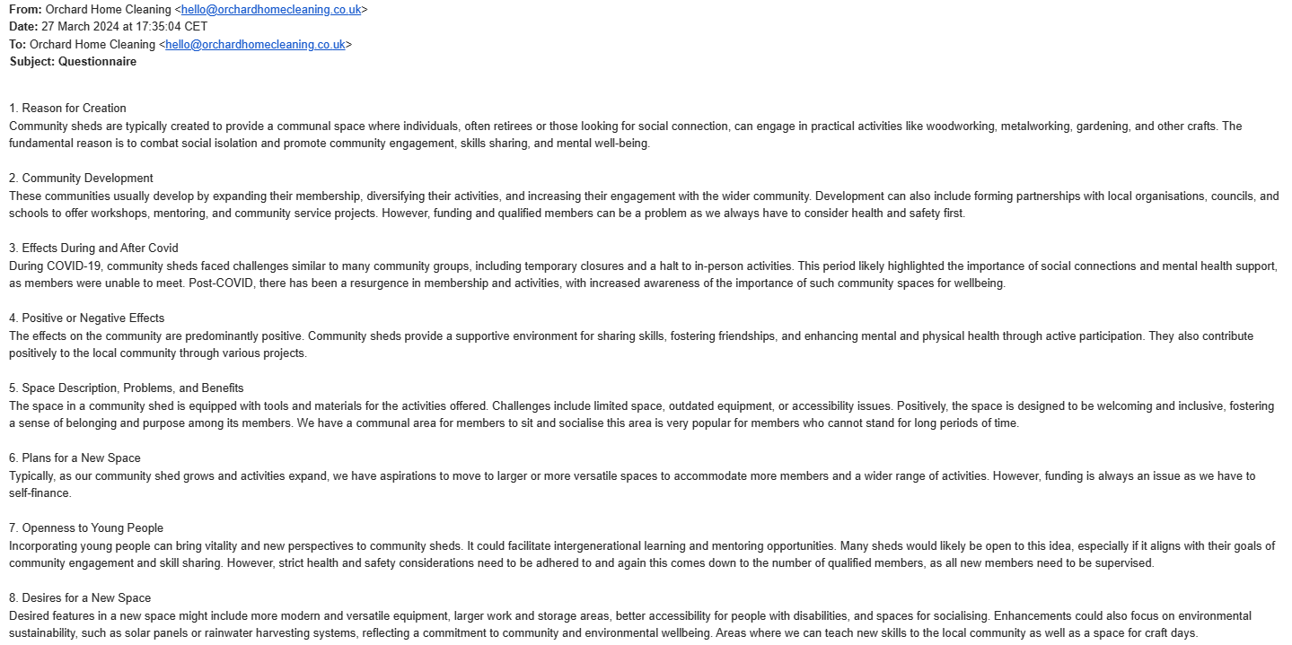
Answers from Keith (chairman):

Questionnaires for members:
- What age group do you belong to?
Under 45
45-54
55-64
65 or older
- Gender:
Male
Female
Other
- Employment status:
Self-employed
Employed
Student
Retired
- How often do you visit the shed?
Daily
Weekly
Monthly
Rarely
- Do you have experience with traditional skills (e.g., woodworking, textiles, etc.)?
Yes
No
- Do you have experience with innovative skills (e.g., laser cutting, 3D printing, etc.)?
Yes
No
- Have you ever participated with working with others in the shed?
Yes
No
- How has the effects of COVID-19 affected you as a member?
- How do you feel about collaborating with individuals in the shed?
Very positive
Positive
Neutral
Negative
Very negative
- What are the benefits of combining traditional and innovative [digital] skills in maker spaces?
- Have you experienced any benefits in terms of social connection or community building while working with different age groups in maker spaces?
Yes
No
- How do you think working together in an intergenerational space [people from different age groups] in maker spaces helps reduce feelings of isolation and loneliness?
- Have you experienced a reduction in feelings of isolation or loneliness because of collaborating with people of different ages in maker spaces?
Yes
No
- What barriers or challenges do you perceive in bringing together traditional and innovative skills in maker spaces to create intergenerational communities?
- How do you think makerspaces can make it easier for people of all ages to work together?

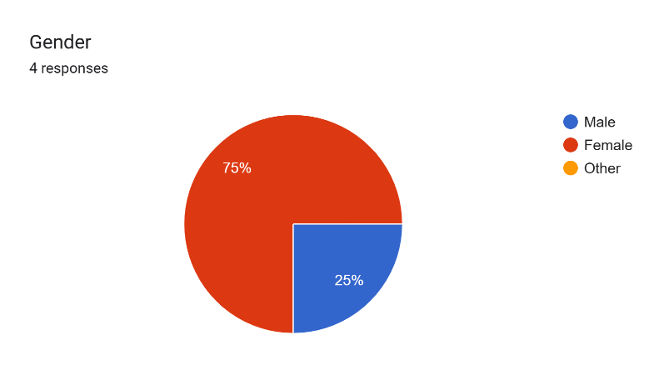
Questionnaire results

