Abandoned history

Rabij, Wiktoria (18681340)

Submitted in fulfilment of part of the requirements for the degree Bachelor of Arts in Interior Architecture and Design.

Supervisor: Dr. Begum Ulusoy
Module: Research Process 3 -Design Exegesis
INT3179M-1920
March 2021

I declare that this report is my own work and has not previously been submitted for assessment.

Wiktoria Rabij
30 March 2021

acknowledgemets

I would like to express my appreciations towards people who have been supporting and encouraging me throughout my years studying at university.
No doubt, it has been challenging and emotional journey, however it was a great experience which allowed me to grow as a person.
Firstly, I would like to thank all the academic tutors who have been guiding me throughout the studies at University of Lincoln. Each of you have brought something different to my studies and helped me to become better and better as a designer. A huge thank you to Tom Marshall and Rosie Elvin who have pushed me to get out of my comfort zone and think more outside of the box which extremally helped me in becoming more creative within my designs.
I would also like to thank the class of 2021, especially my course friends for making these past three years a special experience. As a class we have been exposed to an unexpected situation which has affected our studies, however we all worked hard and didn’t let the pandemic take over. I wish you all the best and loads of success in the future.
Last but not least, I would love to offer a special thank you to my family and my partner for their support throughout the toughest times during the studies. Thank you for cheering me up, listening, believing in me, keeping me motivated and of course putting up with my stress.

Abstract

The problem of derelict buildings arises within the time. It is sad to see these beautiful, full of history structures slowly disappear. Once it’s gone, it cannot be brought back to life, therefore something needs to be done about them (Dell’Ovo et al., 2020, 107 -108).

But what is actually their fate?
Are they meant to still exist?
How can they be approached?

The problem of derelict buildings will be addressed within this text. Covering both the social and community issues regarding to the abandoned structures.
The document will aim to find some answers throughout deep analysis of variety of sources within the next chapters. The finding will then be used to form an individual opinion and solution to the matter. Hydraulic Tower and Pumphouse will be used to demonstrate the potential of existing fabric and how it can be used. Also, the significance of the built heritage will be highlighted.

ADAPTIVE REUSE –
The process of using the existing again while giving it a new purpose (Department of Environment and Heritage, 2004,3).

BUILDING RESTORATION –
A process of recalling the original condition of a building (Designblends, 2020).

DESTIJIL –
Art movement based on abstract combinations made primary colours and geometric shapes (Rietvield Schroderhuis)

INSERTION –
New and old are completely independent. New can be easily fitted in and removed without affecting the existing structure (Booker, 2004).

INSTALLATION –
A new element which is built to fit, seems like it’s separate. (Brooker, 2004).

INTERVENTION –
Existing and new intertwine with each other (Brooker, 2004).

URBAN REGENERATION –
A process of reversing the economics and physical decay structure of a place (Weaver, 2001).

glossary

Table of contents:

List of figures

Introduction

literature review
  - INTRODUCTION
  - ON ALTERING ARCHITECTURE
  - CURATED DECAY
  - BUILDING REUSE
  - RESCUE & REUSE
  - CONCLUSION

design problem
  - ABANDONED INDUSTRIAL BUILDINGS
  - REASONS OF ABANDONEMENT
  - THE PROBLEM OF DERELICT BUILDINGS

the unused st andrews dock in hull
  - SITE LOCATION & SURROUNDINGS
  - HISTORICAL VALUE
  - HYDRAULIC TOWER AND PUMPHOUSE
  - CURRENT USE & FURTHER PLANS
  - STRUCTURAL ANALYSIS
  - SUN PATH
  - WIND LOADING

DESIGN proposal
  - ADAPTIVE REUSE
  - BRIEF INTRODUCTION TO DESIGN STRATEGY
  - DESIGN MOTIVATION
  - USER &CLIENT
  - FISHERWOMEN

Percedents studies
  - INTRODUCTION
  - THE OLD PUMP HOUSE, NOTTINGHAM
  - GEORGIAN PUMPHOUSES, MISTERTON
  - PRATT INSTITUTE, NEW YORK
  - VILLA SAVOYE, POISSY

vii

1

2
2 3 5 6 7 8

9
9 10 11 13

13
13 15 16
17 19 20 21

22
22 23
25 26 27

29
29 31
36
40 44
  - DOVECOTE STUDIO, SNAPE
  - SCHRODER HOUSE, UTRECHT
  - PUMPHOUSE, BOCHUM
  - CONCLUSION

DESIGN STRATEGY AND APPLICATION
7.1 INTRODUCTION 7.2 WORKING WITH THE EXISTING 7.3 FORMING A CONCEPTUAL LANGUAGE 7.4 CONCEPT IMPLEMENTATION 7.4.1 MIXING OLD WITH NEW 7.4.2 CONNECTING PAST WITH PRESENCE 7.4.3 CREATING A NARRATIVE WITHIN THE SPACE 7.5 FRED SCOTT’S ALTERATION STRATEGY 7.6 CIRCULATION AND SPATIAL PLANNING 8.9 CONCLUSION

reflective practice
8.1 INTRODUCTION 8.2 FORMING A RESEARCH PROBLEM 8.3 FORMING A RESEARCH QUESTION 8.4 THE INFLUENCE OF LITERATURE REVIEW 8.5 FINDING SITE AND A BUILDING 8.5.1 ST ANDREWS DOCK 8.5.2 HYDRAULIC TOWER AND PUMPHOUSE 8.6 THE DEVELOPMENT OF INITIAL IDEA 8.7 INFLUENCE OF PERCEDENTS STUDIES 8.8 CONCLUSION

CONCLUSION

Reference list

Bibliography

Addendum
12.1 SUPPORTING FORMS 12.2 EXISTING CAD DRAWINGS 12.3 PROPOSED CAD DRAWINGS
47 50 53 56

57
57 58 59
60 61 63
65
66
69
71

72 72 74 75 76
78 79 82
84 87 89

91

93

99

106
106 111 115

list of figures

Figure 1: photo of Moseley road baths

Figure 2: book cover of building reuse

Figure 3: photo of st andrews dock area

figure 4: consequences of abandoning repair work diagram

figure 5: site location plan

figure 6: location plan

figure 7: collage of Routes and usage

figure 8: timeline collage of St andrews dock

figure 9: hydraulic tower and pump house diagram

figure 10: DETAILED MODEL OF THE BUILDING

figure 11: STRUCTURAL ANALYSE OF THE BUILDING

figure 12: Sun path diagrams

figure 13: sun path

figure 14: wind zones diagram

figure 15: a conceptual collage of the design idea

figure 16: A conceptual collage of the proposed usage

figure 17: ECMT LOGO

figure 18: number of fishermen in the uk chart

figure 19: The percent of women employed in the fishing industry in the uk CHART

FIGURE 20: PUMPHOUSE FEATURES DIAGRAM FIGURE 21: PUMPHOUSE IN NOTTHIGHAM FIGURE 22: THE PERSPECTIVE VIEWS ON RESTORED PUMPHOUSE
FIGURE 23: THE PROCESS OF ALTERING THE PUMPHOUSE IN NOTTINGHAM

1
6
9
12

13
14
14
15
16

17
18
20
20
21
23

25

26
27
27

30
31
32

33

FIGURE 24: ORIGINAL STRUCTURE AND INTERVENTION DIAGRAM
FIGURE 25: THE PUMPHOUSE, MISTERTON, NOTTINGHAMSHIRE
FIGURE 26: INSERTION DIAGRAM
FIGURE 27: SPATIAL ARRANGEMENT AND MATERIALS
FIGURE 28: HIGGINS HALL, BEFORE AND AFTER ALTERATION
FIGURE 29: BEAM STRUCTURE
FIGURE 30: THE ASYMMETRY BETWEEN FLOOR LEVELS
FIGURE 31: THE RAMP SPACING DIAGRAM
FIGURE 32: GRID STRUCTURE
FIGURE 33: COLUMN RELATIONSHIP TOWARDS DESIGN DIAGRAM
FIGURE 34: VILLA DE SAVOYE, 1930
FIGURE 35: 5 POINTS OF NEW ARCHITECTURE
FIGURE 36: STRUCTURAL GRID OF VILLA SAVOYE
FIGURE 37: DOVECOTE INSERTION DIAGRAM
FIGURE 38: DOVECOTE STUDIO RENOVATION PROCESS DIAGRAM
FIGURE 39: CLOSE UP VIEW ON NEW BRICK WORK
FIGURE 40: THE EXTERIOR OF SCHRODER HOUSE
FIGURE 41: DE STIJL- COMBINATION A
FIGURE 42: THE INSIDE OF SCHRODER HOUSE

34

36

37
38

40

41
41
41
43
43

44
45
46
47
48

49

50

51
52

FIGURE 43: RECREATION OF THE FLOOR DIVISION ACHIEVED THROUGH COLOUR
FIGURE 44: PUMPHOUSE AT THE JAHRHUNDERTHALLE
FIGURE 45: THE APPLICATION OF NEW WORK DIAGRAM
FIGURE 46: THE INSIDE OF BOCHUM PUMPHOUSE
FIGURE 47: CONCEPTUAL STRATEGY AND APPLICATION DIAGRAM
FIGURE 48: OLD + NEW COMBINATIONS
FIGURE 49: COMBINING OLD WITH NEW DIAGRAM
FIGURE 50: SURROUNDING AREAS TO ST ANDREWS DOCK
FIGURE 51: A 3D VIEW OF THE NEW USE
FIGURE 52: PROPOSED USE SHOWN ON LONG SECTION
FIGURE 53: AXONOMETRIC DIAGRAM SHOWING PROPOSED PROCESS OF INTERVENTION
FIGURE 54: STAGES OF ALTERATION DIAGRAM
FIGURE 55: SPATIAL PLANNING AND CIRCULATION DIAGRAMS
FIGURE 56: INTERIOR VISUAL OF FINAL DESIGN
FIGURE 57: LEARNER INVENTORY
FIGURE 58: ST ANDREWS DOCK
FIGURE 59: COLLECTION OF PHOTOS FROM ST ANDREWS DOCK
FIGURE 60: ACCESS TO DISUSED ST ANDREWS DOCK

52

53

54

55

60

61
62

63

64
65
66

67
70
71
72
78
79
80

FIGURE 61: BOAT ACCESS FROM HULL WATERSIDE TO ST ANDREWS DOCK
FIGURE 62: TIMELINE COLLAGE OF HYDRAULIC TOWER AND PUMPHOUSE
FIGURE 63: CONCEPTUAL COLLAGE OF THE INITIAL IDEA
FIGURE 64: A RENDER OF SHORT SECTION DEPICTING THE NEW IDEA
FIGURE 65: ACTION PLAN

81

83

85

86

90

01. introduction

WHAT MIGHT BE THE FUTURE OF ABANDONED INDUSTRIAL BUILDINGS?

There are many beautiful industrial historic buildings all around the UK which have been abandoned and neglected. Once full of life and purpose buildings remain unused for many years. With the time passing by, the neglected buildings are being forgotten. This creates a problem as when the building is slowly decaying, its history slowly dies together with it (Dell’Ovo et al., 2020, 107 -108).
This document addresses the issue of historical abandoned buildings, covering both cultural and community problems related to it. The text also aims to find a future for these buildings, exploring the possibilities and limits. Search for some sort of a solution which might completely change the fate of these vulnerable buildings. Trying to discover whether the building should be altered, preserved, demolished, or simply left to decay.
As there are different opinions on what should be done with a building of historical interest, the aim is to explore them and study their potential. This will be done by investigating variety of literature and sources related to the topic.
For the project and as a case study, an old, derelict Hydraulic Tower and Pumphouse located in Hull will be used. The future of the building is now unknown; therefore, it will be based on the findings from the next chapters and their careful analyse.

Figure 1: Moseley Road Baths (Pendleton, 2019)

02.LITERATURE REVIEW

2.1 INTRODUCTION
This chapter will examine different texts in order to introduce different views on the future of existing architecture pieces. There are different opinions regarding to historical buildings and their future. Whether we shall just let them decay as their function has been fulfilled or keep them. If we decide to keep them, how will their future look like? Different buildings have different heritage meanings and significance to others. How we are going to handle them is a very important and sensitive matter.

2.2 ON ALTERING ARCHITECTURE

In this book Scott (Visiting Professor of Interior Architecture), examines the substitution for demolition of a building. Focusing more on altering the existing buildings and rethinking their design. Scott analyses different arguments regarding to the theory of unaltered architecture as well as the ideology of alteration, conservation, preservation, and restoration. Including the political and social views that may be involved (Scott, 2008, 2). He states that alteration in a process of intervention which may help to keep the existing architecture in use and still be momentous (Scott, 2008, 24). The concept of alteration may be considered as a strategy to substitute preservation or demolition in order to extend building’s life (Scott, 2008, 38).
The destiny of a building varies on three options:
TO REMAIN UNTOUCHED TO BE ALTERED TO BE KNOCK DOWN
There are advantages and disadvantages to each of them. The untouched building may simply result in self-destruction with the time passing by. The fear of alteration is the entropic skid. The outcome of demolition may be a new building, which would bring financial profit (Scott, 2008, 26).
Cedric Price an English Architect was one of the people who wanted old buildings to be demolished as their functionality has come to end. He was so against of saving obsolete buildings that until his death, he was trying to avoid Local Council from listing his own buildings. Some individual with a similar state of mind has said that a particular building was a ‘waste of space’ and was only getting in way of his proposal (Scott, 2008, 30). Soon or later, architecture will be considered as a waste of space by someone (Scott, 2008, 31).
Scott states that restoration is also a form of alteration. Maybe the act of restoration and conservation could form a base to alteration of a building (Scott, 2008, 85). Scott has shared Ruskin’s opinion on restoration from his book called “The Seven Lamps of Architecture”. He has very clear and loud opinion on restoration if it should not be taken into consideration at all. Ruskin thinks that people misunderstand the true meaning of restoration. For him restoration means destruction and deceiving ourselves. He states that it is absurd to think that we can restore something that used to be great in architecture and bring it back to life. The deception is bigger when the restoration is closer to the original building. The energy which has been given by the craftsman will never be the same, only new spirit can be added. There is no point in restoring a part of an architecture which has been run-down, because all the meaning was in that particular part. The run- down part was giving us some sort of suggestions, it could have been interpreted in different ways, depending on what has happened and how it looked before. For Ruskin the whole restoration was a lie. He didn’t only dislike the idea of restoration, but he truly hated it (Ruskin, 2001, 252 - 253).

“I must not leave the truth unstated, that it is again no question of expediency or feeling whether we shall preserve the buildings of past times or not. We have no right whatever to touch them. They are not ours. They belong partly to those who built them, and partly to all the generations of mankind who are to follow us. “(Ruskin, 2001, 255)

This is a citation from ‘The Seven Books of Architecture’ by John Ruskin. The quote highlights Ruskin’s opinion on making changes to the old buildings. Explaining that these buildings don’t belong to us and for that reason we shouldn’t touch them. The feelings and intentions of the person who raised the building, should remain within the building, and should not be removed (Ruskin, 2001, 255). Ruskin was very protective of the old buildings and for him the perfect and the only option seemed to be the pause of using the building in order to preserve it (Scott, 2008, 97).
Scott refers to ‘Scrape and Antiscrape’ essay by Pevsner, talking about Pevsner’s approach to restoration. In his essay he declares that instead of restoring we should protect the buildings. We shall replace Restoration with Protection. Taking a precise care of the existing building regularly will help to prevent a quick decay, meaning that the building will remain in a good condition for longer and no restoration will be then necessary. Both Ruskin and Pevsner are trying to prevent buildings from Restoration and Alteration, as very often the spirit of the building cannot be copied (Scott, 2008, 93- 94).
The author also refers to the manifesto that William Morris has written for the Society for the Protection of Ancient Buildings. The manifesto demonstrates that Morris is not a fan of Restoration as well as Ruskin and Pevsner. Morris thinks that in early ages the restoration was possible and didn’t hurt the building’s history as much. However, he stated that now a day’s people who restore have no model of what restoration is and that the changes are their own impulse. Adding that people who try to restore a building are destroying it firstly and then trying to fill in the void with something they think the dead builder would done to it (Morris, 1877).
In his book Scott doesn’t mention Conservation a lot as in his opinion there is no difference between Conservation and Restoration, as both alterations require restorative works. This matter of fact makes the taboos against improvement and restoring outdated (Scott, 2008, 267- 268).

STAGES OF ALTERATION:
- Stripping back
- Making good
- Enabling works
Stripping back is based on recalling the original state of the building which includes getting rid of the decaying elements such as paint, plaster, or wood. Simply preparing the building by trying to bring back the building to its original state. This stage requires a very good understanding and analysis of the host building and its original condition in order for striping back to be successful. After stripping back, the new work can begin. This includes repairing or replacing the original fabric where necessary. Enabling works is a stage where removal and demolition take place in order to allow new work to be implemented (Scott, 2008, 174). Alteration may come in a form of intervention and supposedly there are two types of alteration: surface and spatial. Surface alteration focus more on the choice of colour and the use of materials. Through the colour and material choice we can express many different things which possibly may allow us to link back to the building’s past. The other type of Alteration is called spatial which targets the use of existing space. This process may include the expansion, division, or combination of the existing spaces. Throughout this stage it is possible to maintain the original arrangement of the spaces within the existing building. The intervention takes a new direction when the special arrangement is being changed. This could possibly be a result of installing a new staircase in a new location which instantly changes the original circulation of the existing space. This kind of special changes and new works may simply ruin the building and the whole process of alteration may become unsuccessful (Scott, 2008, 156).

THE PROCESS OF INTERVENTION:
The book also covers the process of Intervention which is a part of Alteration. The designer’s role in Alteration would be making responsible decisions which could result in a building surviving from the past to the present and last for many years in the future. The intervention should not damage the original building in whatever form but instead emphasise it (Scott,2008,196). Scott compares Intervention to a collage, stating that in both processes elements are cooperating while retaining their own character (Scott, 2008, 214). Intervention must be fair and respect the existing building, otherwise it may just damage it. Recalling the intentions of the builder should be designer’s priority while proposing an intervention (Scott, 2008, 268).

“The enigma of intervention is that one sets out to alter, but at the same time to be the advocate for a building.”

Bringing a building back to life includes the use of new materials and methods throughout the Intervention process. This is when Modernism becomes a component of the Intervention. Meaning that the use of the Modernistic approach can give a building a contemporary twist (Scott, 2008, 275).

2.3 CURATED DECAY
This book has been written by Caitlin DeSilvey the associate professor of cultural geography at the University of Exeter. The text is based on the conservation of the cultural heritage. It covers the issue/s regarding to a typical thinking on the matter of conservation and proposes a solution. DeSilvey discuss the natural process of decaying of the objects and that of which we should not be afraid of. The author is using different case studies of endangered sites to demonstrate that the objects not only create a meaning through conservation but through decay as well (UPress, 2017).
Catlin DeSilvey begins her book by providing its readers with an example of Grade two listed solitary chimney stack located in Cornish village. It has been constructed in the middle of 19th century and has been an adjoined to a masonry building that was used to pump water from mine shafts. The object has been a part of the village heritage for so many years that it became ‘invisible’ to the locals (DeSilvey, 2017, 1). The condition of the chimney is poor, meaning that its significance slowly disintegrates within the time. The object has been listed grade two by English Heritage, however it has a private owner. DeSilvey which has visited the site herself, states that no action has been taken into fixing the apparently significant to heritage object. In her opinion the fate of the chimney will be taken into consideration only when it comes near to the edge of collapse. The opposite fate to conservation is natural decay. As some people may view the chimney as a `memorial` of the past which is at risk and needs to be saved , others may think that its function has finished therefore the object is no longer needed and its decaying still links us to it’s past (DeSilvey, 2017, 2-3).
In her book, DeSilvey discuss how the world that we live in pursues towards saving buildings, objects and sites which are seen as historical memorials that are in the need of preservation. She also states that it has not always been that way. The urge of preserving objects for future generations only started in late 19th century. DeSilvey sets an opposite view by asking a provoking question: “But what happens if we chose not to intervene? “Maria Balshaw (the director of TATE museum) states that it’s time to learn how accept the change and to let some things go. Marc Auge (a French anthropologist), suggest that we need to let go in order to stay in present. Perhaps, conservation is not the only option in order to keep the history of the objects. In this book DeSilvey aims to demonstrate a different perspective to decay and disintegration. In her opinion an object or a building which is left to decay doesn’t necessary mean it’s losing its significance (DeSilvey, 2017, 5). DeSilvey mentions a visit to Grant Kohrs Ranch, where she was meeting a curator. The curator gave her a very interesting opinion on of how people perceive the value of certain objects depending on how these are being approached. using her field collections as an example. If collections were to be thrown in a pile, people could think about them as a garbage. However, if these were to be put separately and displayed on a tray, it would seem more valuable. This is similar to the way we might perceive historical objects. Some people may think that buildings are preserved because these are considered as historically significant, but it may be the opposite. It could be the work of preservation that makes the historical building perceived as significant (DeSilvey, 2017,178). Greg Kennedy (an author of book called ‘An Ontology of Trash’) is his book argues that suspending the care of the old doesn’t mean that we don’t care that the significance will be lost. Instead, allowing nature to take its course may open doors to a more meaningful relationship with the history of an object. Kennedy states that ‘taking care’ can take two different forms. First form could be achieved by physical repair or reconstruction. And the second opposite option which is letting an object keep going without stopping the changing process (Kennedy, 2007, cited in DeSilvey et al., 2017, 180).

2.3 BUILDING REUSE
Building Reuse is a book written by Kathryn Rogers Merlino an Associate Professor of Architecture and an adjunct Associate Professor. Her book is about sustainable design in form of reused existing buildings.
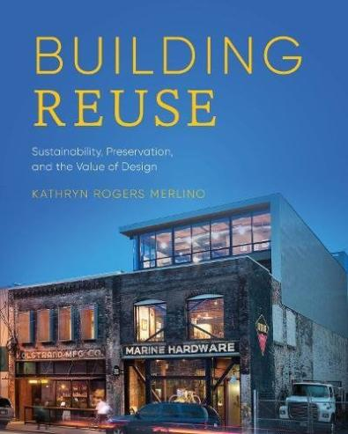
Figure 2: Book Cover - The Kolstrand Building (Merlino, 2018)
Merlino imposes emphasis on the reuse of a building rather than demolition of it. She states that:
“…building demolition should be, not the first option in new development, but a last resort.”
Adding that once the building is gone it won’t come back and nor his history and value. Buildings have been shaping meaning through the time they have existed. We can tell that buildings are a tangible version of history, a physical form of a past (Merlino, 2018, 4). In the book Merlino mentions how many of the old, historic buildings has been demolished in some areas of US in order to build new ones for residential and commercial purposes. Resulting in the loss of narrative in the areas that were created by these significant buildings (Merlino, 2018, 5).

The author not only mentions reuse of building for historical and cultural purposes, but sustainability is taken into consideration as well. Buildings affect climate change in drastically as their construction and operation requires a lot and they are the producers of almost half of all carbon emissions. Especially, the construction of a new building which results in a consumption of loads of energy, electricity, and materials. Demolition also takes part as it creates great amount of waste. Building industry contributes largely to the environmental crisis, however this fact makes it also a solution for the rapidly changing climate change. The way we approach the matter can have a huge impact on our environment and the future. In order to solve a problem, the factors which are causing it needs to me reduced, in this case the construction of new buildings. Although the design industry has come up with the idea of ‘green design’ which uses passive energy systems and more sustainable materials, doesn’t mean that the problem is solved. Indeed, the building may perform well by using less energy and creating less carbon emissions in the future. However, the process of construction, transportation and manufacture contributed largely to the climate change. Merlino states that of course not all of the old buildings will be in a condition to be reused but the approach where we preserve buildings only for the historical significance purposes needs to develop more in the direction of environmental issues (Merlino, 2018, 5-7).
In the book the author discusses what us a successful reuse of an existing building. Each building is different and different factors will affect its new design providing community with different results. However, if we want the design to be fruitful there are a few factors that needs to be plotted into the design. The use of new materials and narrative within the design. Design shouldn’t violate the past but rather emphasise it. And, energy efficient technology should be used (Merlino, 2018, 80).

2.4 RESCUE & REUSE
A book written by Merlin Waterson and edited by Ian Morrison. Waterson has his interest in Architectural Heritage and have been very active with this industry. He is an author of many books related to architecture (Waterson, 2019, ii).
The book is dedicated to the rescue of historic buildings which demonstrated through different case studies how architectural industry has developed in the matter of saving the heritage. The book aims to show that significant to us buildings, buildings which are important to heritage can be kept and reused with the help of experienced in heritage saving sector organisations. The book covers a variety of case studies from small historical local buildings to grand buildings such as churches and castles. Waterson and Morrison have used these case studies to point out how we can successfully protect old, often derelict buildings by reusing them. The revived buildings won’t be less valuable, even opposite they will become a huge part of regenerating some of the areas and communities. On the other hand, the book also covers the issues regarding to the neglection and abandonment of historical buildings and how this matter can affect architectural and communal character (Waterson and Morrison, 2019, v).

2.5 CONCLUSION

The literature review outlines different strategies regarding to the future of derelict historic building. It examines different opinions and views on the matter and proposes different solutions. Some of the books have a common opinion but in some of the books the opinion clashes. The literature review allowed to have a deeper understanding of the historic buildings and their possible future. Having to explore different arguments, helped to create my own opinion and interpretation of the matter which will inform my design and choices that will be made.

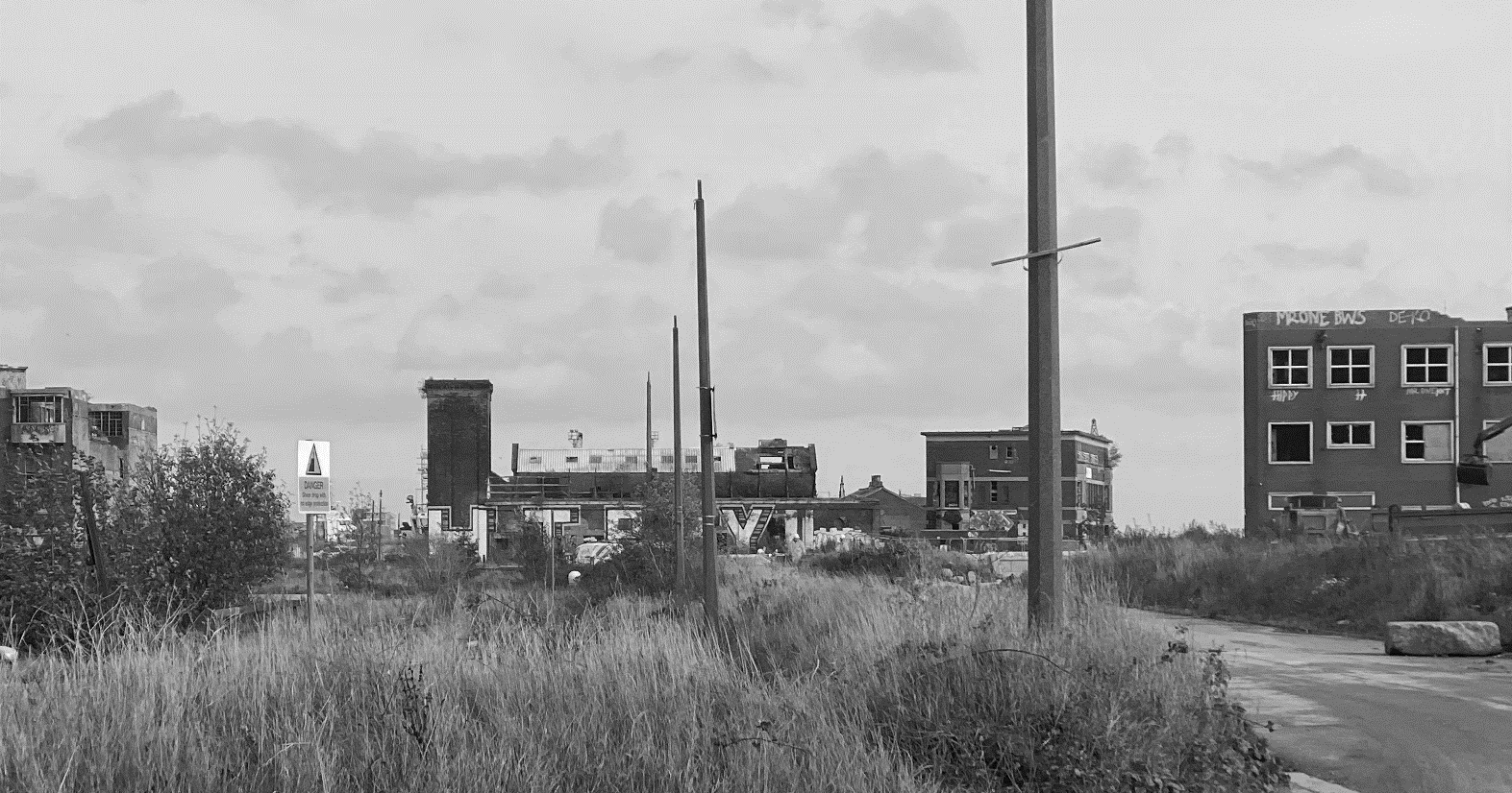
0.3 design problem
Figure 3: A photo of St Andrews dock conservation area (Rabij, 2020)

3.1 ABANDONED INDUSTRIAL BUILDINGS

“The term “abandoned building” connotes an image of a building that is unoccupied and in a state of grave disrepair, perhaps boarded up, strewn with trash, and scrawled with graffiti.” (Shane, 2012)
Many industrial sites are being abandoned for different reasons but mainly because these are seen as problematic to redevelop. New developments are currently the biggest threat to the historic sites as these are being simply replaced by new buildings (Loures, 2008, 687). The number of disintegrating of abandoned historic buildings arises as very often there is no owner, and nobody tries to appeal to take over the building. Another reason could be because of the costs and limited market values of the location which makes it unappealing for the potential investors (Dell’Ovo et al., 2020, 107). There is no formula to tell why the buildings are being abandoned as different factors can affect different buildings (Shane, 2012, 14). Although, the industrial heritage becomes more important with the time passing by, in some of the countries the old industrial buildings and landmarks are considered as obsolete and seen as just a problem by the public (Loures, 2008, 688). There are properties which are significant to the history and are being protected. However, it doesn’t make them be adored and considered as meaningful by everyone. For some these buildings do not fulfil the esthetical, economical, and functional requirements. Very often their value is assessed by their visual appearance rather than historical importance (Loures,2008, 688-699).

3.2 REASONS OF ABANDONMENT
There are different reasons why not only historical, but all buildings are being abandoned. The factors leading to the building being empty for years may vary on the building state, location, community, and other factors. However, economics influences it the most. Determining these factors will help to take appropriate measures and successful decisions regarding to the future of the particular building (Shane, 2012, 14).

The reason why owners are giving up on their properties are caused mainly because of financial factors. Very often owners are not able to pay back money which they have borrowed from lending agencies and this results in foreclosure of the property. In some cases, agencies ask for high interest rates and excessive closure fees, which owners may find challenging to pay off.
On top of that there are increasing property tax rates. As owners have to also pay constantly increasing tax, they find it harder and harder to pay mortgage. Also, when the mortgage becomes more valuable than the property, owners choose to abandon their properties.
Another factor that pins under financial issues is the cost of commercial compliance and remediation. Proper licensing and disposal of hazardous materials may seem too expensive for some owners. That’s why they chose to bury or burn the waste to avoid charges and then leave the building for good (Shane, 2012,15).

These kinds of owner do not live in the property, instead they rent it to others. Many owners are not active in checking and controlling the state of house which they are renting out. This neglection leads to faster deterioration of the building’s condition. The values of the property lower together with its bad condition and inappropriate tenants are moving in due to low rent. The unattended by owner’s property may also lead to crimes committed by its irresponsible tenants which may badly affect property’s condition (Shane, 2012, 16).

Some real estate spectaculars are hunting for more money and that’s why they buy properties and leave them unused. This approach may lead them to tenants which are willing to pay higher rent. They also hope that in the future they may sell the building for a better profit (Shane, 2012, 17).

FINANCIAL ISSUES:

ABSENTEE OWNERS:

MONEY SEEKING:

3.3 THE PROBLEM OF DERELICT BUILDINGS
Although, historic buildings are stood empty, they may be seen as problematic in different ways and this will be examined. Two categories have been made: local community problems and cultural problem. The ‘community problems’ demonstrates the more physical side of harms which abandoned buildings may cause to the local communities and population. The ‘cultural problem’ will examine less intangible impact of derelict buildings against the cultural and historical background. This is the category which the project mainly focuses on.

COMMUNITY PROBLEMS:

▪ FEAR AND CRIME
As some of the crimes take place within the building or its site, locals, especially elderly people are afraid of these buildings and don’t feel comfortable to have them around. It may affect their daily life as they are nervous to come out and do their activities (Shane, 2012,9).

▪ ARSON & ACCIDENTIAL FIRE
Abandoned buildings attract loads of crime such as arson, where people purposely set the building on fire for fun purposes. Of course, the abandoned building like any other may suffer from accidental fire caused by things such as homeless people keeping warm inside (Shane, 2012,10).

▪ BURGLARY & THEFT
Many people trespass the building to steal and then sell what has been found within the building. Stripping it back from its original building fabric and leaving it in a poor condition (Shane, 2012,10).

▪ PUBLIC HEALTH
All the hazardous material and substances which either have been left or brough into the building expose public health to infectious diseases, as insects, rats and other vermin start to appear. Also, left out needles from drug use may be very harmful, especially for children (Shane, 2012,11).

▪ VANDALISM
Vandalism which occurs within the derelict site causes fear of locals. Also, it not only ruins the building but the appearance of nearby communities (Shane, 2012, 11)

Cultural PROBLEM:

▪ The cultural heritage is significance but for some its less important. Certain people are interested in keeping the old traditions and cultural heritage as it is meaningful to them. However, the redevelopment and rapidly increasing urban expansion, often compromises with the destruction of what is already there. It contributes to the disappearance of historic industrial sites, a heritage which is important part of many communities (Loures, 2008, 687). Current approach to the industrial past has changed together with the evolution which has begun the consideration of reuse (Dell’Ovo et al., 2020, 107).
▪ Cultural elements such as buildings and sites remain and serve as the connection to the history which goes through the present time further into the future. Industrial heritage provides us with a character of a place, as they contain information about our origin and the evolution that has happened over the time. Because of these reasons we should try to protect and appreciate the value of our heritage. Rather than letting go of the history and allowing it to be forgotten, we must emphasise it. In order to retain the values, we should maintain what is already there, develop the knowledge of history and clarify the importance of cultural heritage (Loures, 2008, 687-688)

▪ Urbanisation contribute to the loss of the heritage, as historic industrial buildings are being demolished in order to process with a new development which very often is not related to the history at all. This creates a problem as all the industrial buildings are a major part of our heritage which carries loads of history with them. When a building is being demolished the nostalgia, history and significance of the building disappears together with it. We should want to build on the history rather than slowly destroy it, and in that case the abandoned buildings supposed to be considered as an open door and a way to highlight history and creating a new one. This could be achieved by ‘Adaptive Reuse’ (Dell’Ovo et al., 2020, 107 -108).
Figure 4: Recreation of “consequences of abandoning repair work” diagram by Nowogonska, 2020.

Not only demolition contributes to buildings disappearance but ignorance of repair work as well. The diagram below (see Figure 4), shows the consequences of not applying repair work onto the existing structure which is in a need of repair. (Nowogonska, 2020)

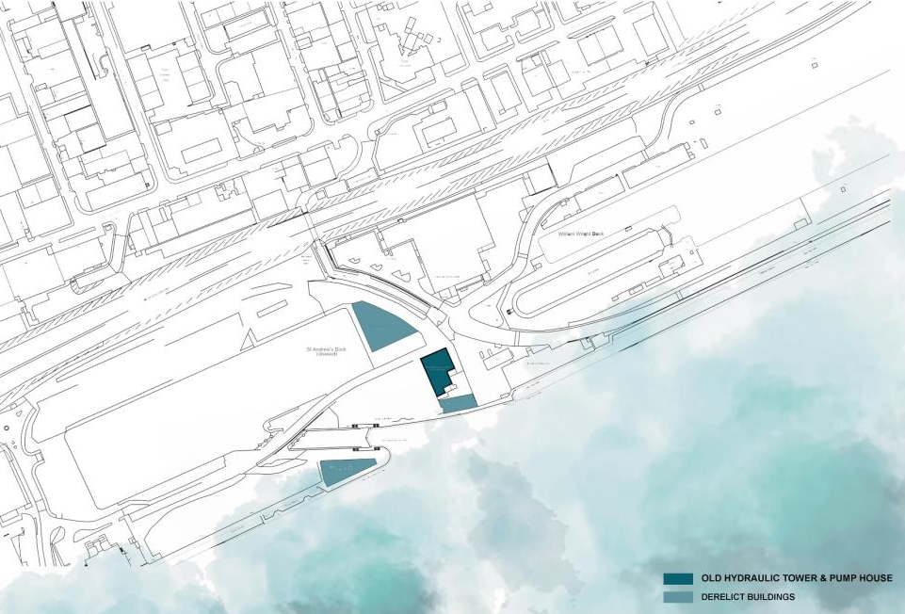
0.4 the unused st andrews dock in hull
Figure 5: Site Location plan (Rabij, 2020)

4.1 SITE LOCATION & SURROUNDINGS

The selected site ‘St Andrews Dock’ is situated in Hull, between the Huber River and main road A63. Once full of life site has been announced as conservational area in 1990. It is full of history related to the massive fish industry back in 1883 (Hullwebs, 2004). The old St Andrews Dock and its remains has been separated with a metal fence from William Wright Dock which is still in use. The site consists of plenty unused land and 4 abandoned buildings and old Hydraulic Tower and Pump House is one of them. Right now, on the site, constructions of flood defences walls are carried out around the Boston Building, except of that no other work is currently being done on the abandoned buildings which are already in a poor state and need repair. Each year lost trawlerman memorial service is held at the dock to remember these who died in Triple Trawler Disaster.

1. The only way to access the site
2. Unused land left after demolition of the Marr Fisheries building
3. A metal fence separating the insurance building from the Hydraulic Tower and Pump House
4. A metal fence separating the old St Andrews Dock from William Wright dock which is still in use
5. Humber River
Figure 7: Routes and usage collage (Rabij, 2020)
Figure 6: Site Plan (Rabij, 2020)

4.2 HISTORICAL VALUE
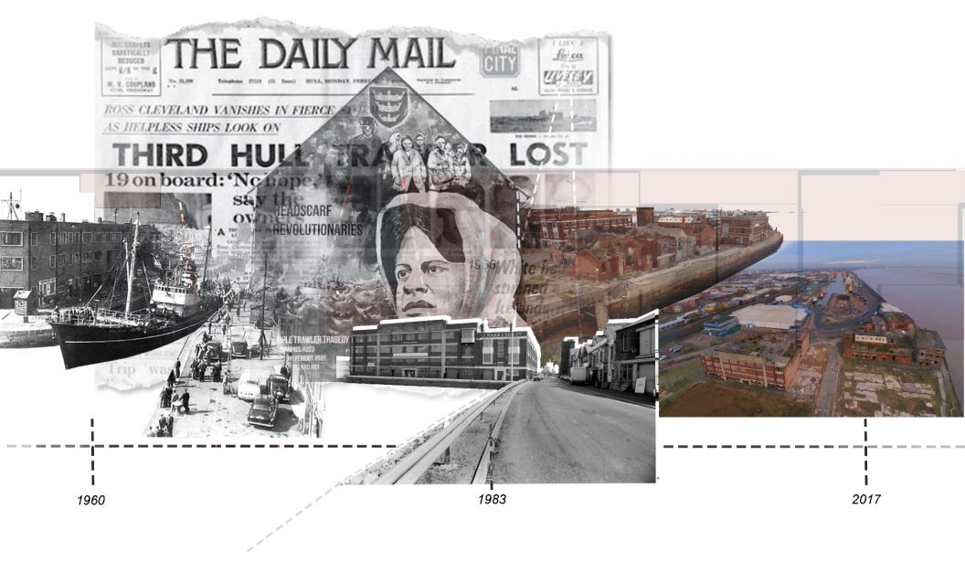
St Andrews dock has opened on the 24th September in 1883, originally designed for coal trade but has quickly became the heart of Hulls fishing industry (Hullwebs, 2004). The name St Andrew was after the patron saint of fisherman. Unfortunately, in 1975, the dock has been closed when the trawlers transferred into the Albert and William Wright Docks which are used until today. St Andrews Dock was always a busy place full of workers and locals. The site consisted of everything needed for the fishing jobs, starting from places were fish nets were mended to boat repair station. There were a few factories around the site. The fish meal factory where fish guts, bones and head were processed and then made into fertiliser for farms or animal and fish feed. Smoke house factories were used to smoke a large amount of fishes. Now there are only a few buildings left which serve as the remains of history associated with St Andrews Dock. (Hull Maritime Museum)
Figure 8: St Andrews dock - Timeline Collage (Rabij, 2020) )
In 1968, Hull city, especially the fishing community went to shock as 57 trawlermen lost their lives. hull’s three trawlers: St Romanus, Kingstone peridot and Ross Cleveland has sunk. Harry Eddom was the only person to survive the disaster. After the tragedy a campaign was launched by Lillian Billoca to improve safety and conditions for trawlermen (Hull Marine Museum).
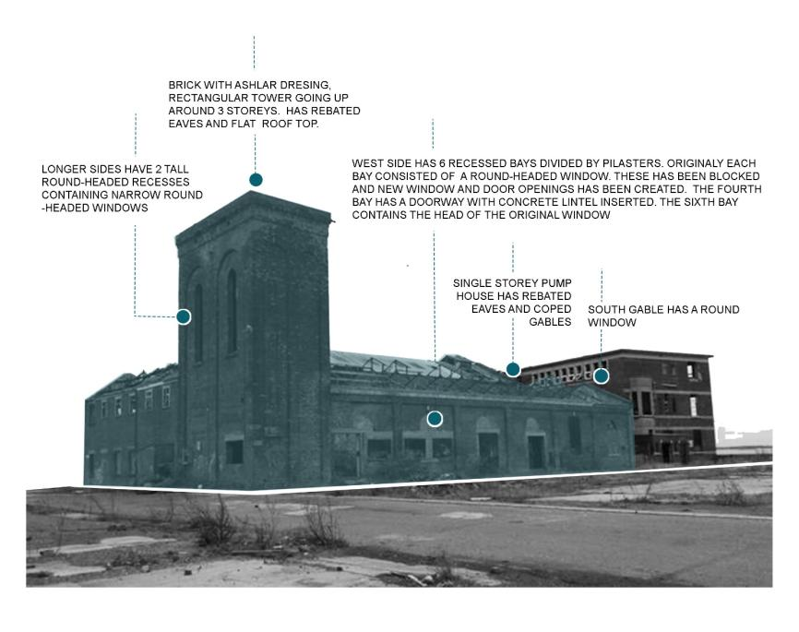
Figure 9: Hydraulic Tower and Pump House diagram (Rabij, 2020)

4.3 THE OLD HYDRAULIC TOWER AND PUMPHOUSE

The Hydraulic Tower and Pump House is one of the derelict buildings situated 50 metres south east of St Andrews Dock area, Clive Sullivan way. The building has been built around 1870 and has been listed as grade two building in 1994, excluding the three adjoining workshops. The pump house has provided hydraulic power to operate the lock gates. the tank which was providing water to the whole dock has been fixed to the rectangular tower (Hull City Council). The building consists of the hydraulic tower and adjoined to it single storey pump house on the South (short) side. There are three workshop buildings that has been later adjoined to the east side of hydraulic tower and pump house. Most of the roof structure has been destroyed by fire and removed. The building needs repair in some of the areas as they are unsafe (ELG, 2017).

4.4 STRUCTURAL ANALYSIS

The building has suffered a lot of damage since it’s abandonment (ELG, 2017). A visit to the site has helped not only to understand the area better but the building itself as well. The following diagrams on the next page have been created based on the findings from a visit to the site (see Figure 11) and the structural inspection report from MJM Consulting Engineers Limited, 2015, found on the Hull’s planning portal. These show the structural analyse which demonstrates the current condition the building is in.
The 2-storey building on the north has a remaining roof which has been burnt in the past. Missing windows , broken doors, and remains of previous floor inside. The two single-storey workshops on the east side, have also got missing windows and doors. However, the inside is very unsafe as there are remains of the first floor and hanging broken elements of it. Both of the roofs are in poor condition and may need replacement or removal. Looking front on the original pumphouse and tower we can see that there is rooftop missing but the metal truss still remains in a stable condition. However, not as good to carry a heavy work as it has been weakened with the time due to weather conditions. Overall, the whole building needs repair and restoration in some places and a deep cleaning as there is loads of debris inside each of the buildings. To briefly conclude, the grade 2 listed Hydraulic Tower and Pumphouse is in a good condition which does not require loads of repair work (MJM Consulting Engineers Limited, 2015). The two-storey building on the north is also in a good condition, however the remains of the previous floor and damaged roof remains needs to be removed. The adjoining workshops are in the worse state consisting of major unsafe elements and damaged brick work on the south side.

Figure 10: detailed model of the building (Rabij, 2020)

Based on the findings a detailed model depicting the current condition of the building have been made.
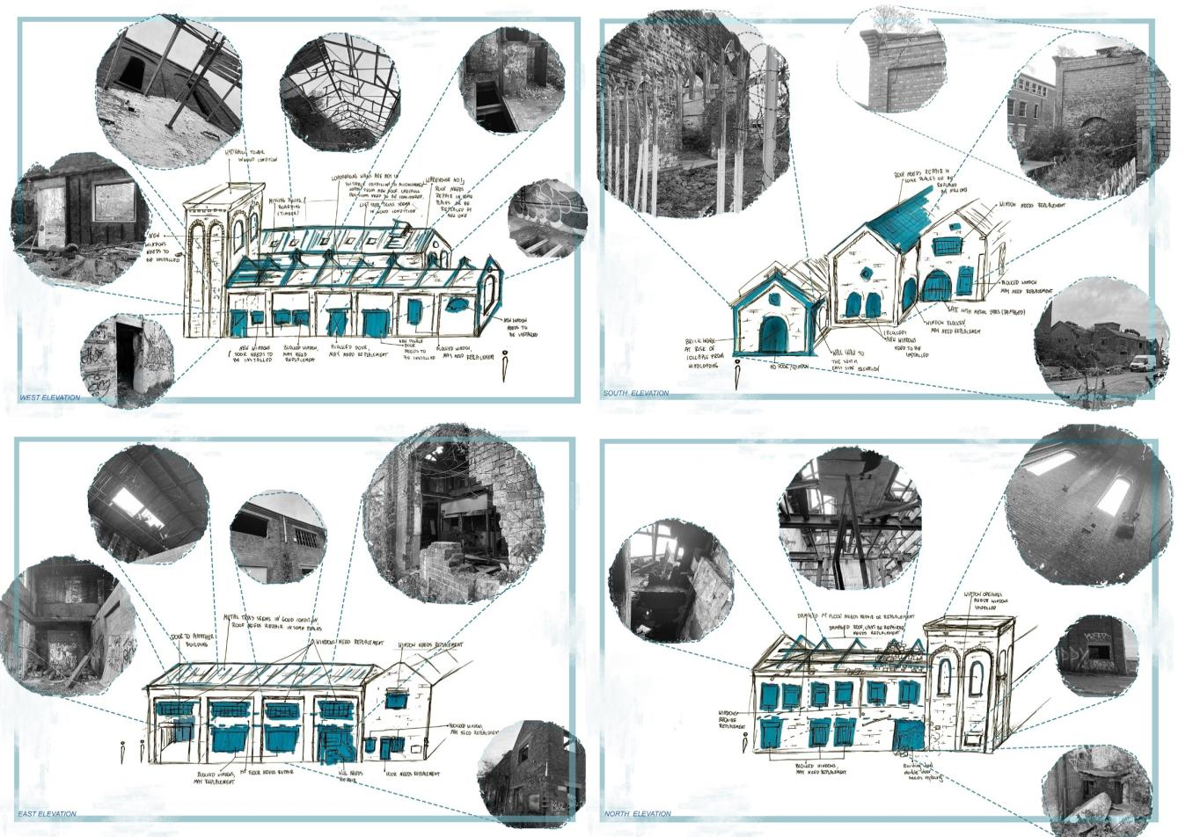

Figure 11: structural analyse of the chosen building (Rabij, 2020)

4.4 CURRENT USE & FUTHER PLANS

At the moment the buildings still remain empty. Although the building is grade 2 listed, it is exposed to vandalism and weather. In 2017, Hull City Council has received an application to demolish the historical building, however the application has been refused by Hull’s City Planning Committee. The Historic England commented regarding the demolition:

” The loss of the grade two listed pump
house would result in irreversible and
cause substantial harm to the heritage
significance of the listed building.”

The policy states that “As heritage assets are irreplaceable, any harm or loss should require clear and convincing justification.” (Babington, 2017) Public comments suggested a strong objection regarding to the proposed demolition (Sellers, 2017). In 2019, an application to restore and refurbish the Hydraulic Tower and Pump House and demolition of adjoining warehouses has been submitted, the status of application remains unknown. Some public comments mainly agreed on the repair of the building but disagreed with the demolition of warehouse buildings as they are part of it (Wright, 2019). Fresh international design plans to restore the listed Lord Line buildings including the Hydraulic Tower and Pump House and turn them into residential spaces (Fresh, 2019). The Hydraulic Tower and Pump House would be restored and reused as provider of heating by using Humph Boilers (Farrell, 2019).

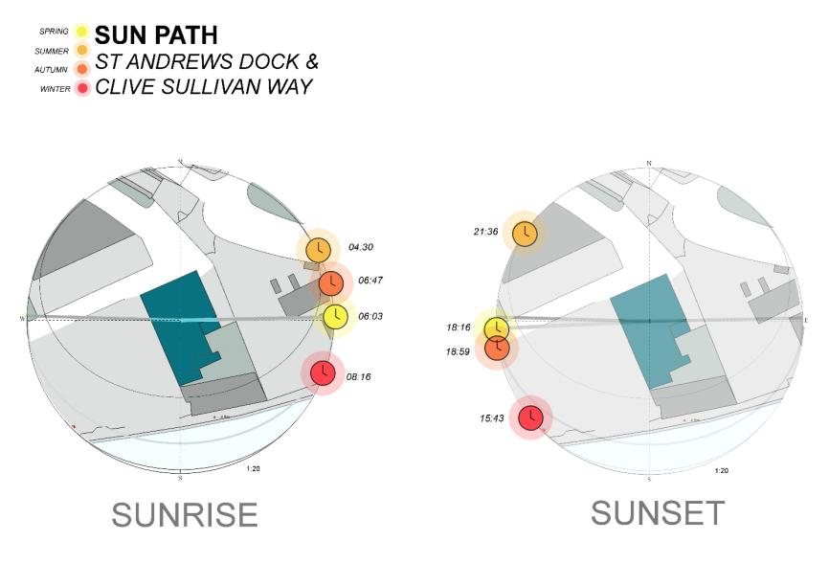
4.5 SUN PATH
Figure 13: Sun path (Rabij, 2020)
Figure 12: Sun path diagrams (Rabij, 2020)

Sun path is a very important factor which should be considered while designing any space. The knowledge of the sun travel will impact on the design decisions as it shows where and at what time there will be the most natural lighting. Above diagrams (see Figure 12) show the sun path of sunrise and sunset for the chosen location and how the building will be affected by it (see Figure 13).

4. 6 WIND ‘LOAD’
The same as sun path, it is important to know wind loading, especially in the areas where wind speed can get really high. The site which I have chosen is quite isolated and located just opposite Humber River, which means that wind can easily affect the building. Hull is orientated in Wind Zone 2, which means that wind speed can get up to 23 metres per second. This means that there can be severe gale which will create high waves coming from the sea. Larger branches of trees may break and there is risk of small tress being blown over. Temporary or weak constructions may get damaged or blown over (Windfinder).
As Hydraulic Tower and Pump house is not in it’s the best condition it may be easily affected by the wind. Structural inspection report from 2015 demonstrates that the building has already suffered from wind loading which resulted in demolishing a part of it (MJM Consulting Engineers Limited).

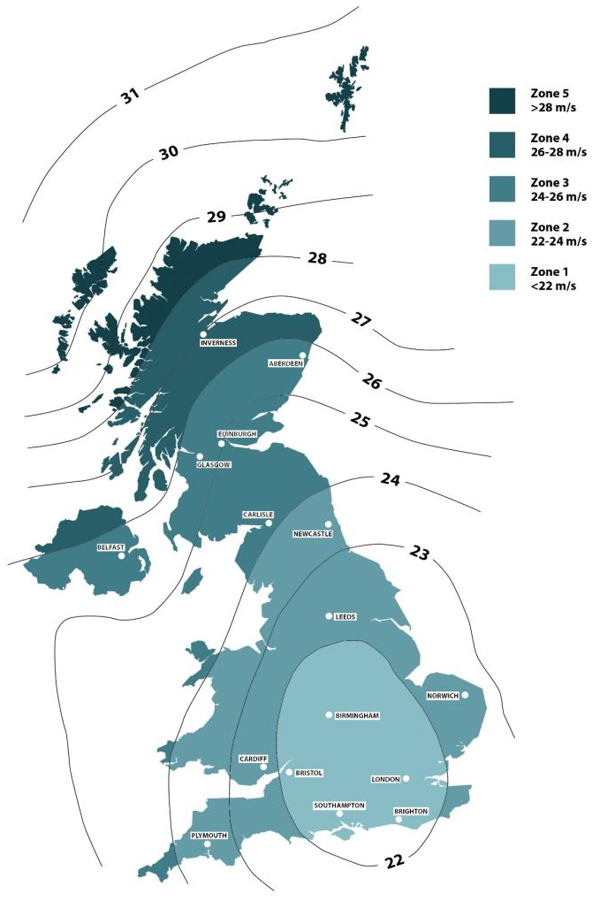
Figure 14: Recreation of “the effect of wind uplift on roofs” diagram by Barbour, 2018.

0.5 design proposal

5.1 ADAPTIVE REUSE
There are many different ‘solutions’ to any abandoned buildings such as conservation, restoration, preservation, etc. However, adaptive reuse will allow us to bring building back to life and use for a new purpose, providing it with a fresh start without the need to completely demolish it and replace it with new construction (Dell’Ovo et al., 2020, 107 -108). Historic industrial buildings and lands are a tangible form of past, they store it for us and as long as we keep them, the history related to them or the site will stay with us as well. They give us a sense of place; they form our communities and by reusing them we can make them serve a practical purpose (Australian Government, 2004, 2).
Adaptive reuse can be very beneficial not only for our cultural heritage, but it can also offer environmental benefits (Australian Government, 2004, 2). We can say that by reusing the buildings we are doing a favour for our planet. As mentioned before in the literature review, the construction and operation of a new building requires loads of energy. Even more, the process of constructing, transporting, and maintaining a building produces a large amount of carbon dioxide. The demolition of a whole building contributes to climate change as well. It produces loads of waste which then needs to be taken care of (Merlino, 2018, 5-6). We can take advantage of adaptive reuse to avoid these environmental issues that building industry may create (Australian Government, 2004, 2).

It is said that adaptive reuse of historic buildings must not affect the building itself and the surrounding site as much. In this way the reuse will cause a minimal change to the cultural heritage and its importance. It is important to understand the building and its context before starting any work on the existing fabric to avoid violating the heritage significance. A successful adaptive reuse will respect the building’s values and past which can be done by forming an invisible contemporary coat which will then provide significance for the future generations. This technique does not only apply for derelict buildings, but it can be used on others which functionality of current use has finished and no longer can be practical, an option of a new purpose and reuse can be considered to keep the building (Australian Government, 2004, 3).

“A PROCESS THAT CHANGES A DISUSED OR INEFFECTIVE ITEM INTO A NEW ITEM THAT CAN BE USED FOR A DIFFERENT PURPOSE”
(Department of Environment and Heritage, 2004,3)

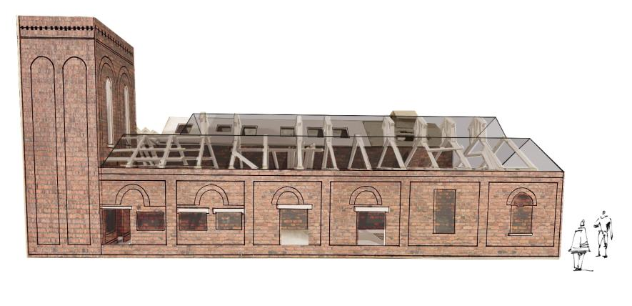
5.2 BRIEF INTRODUCTION TO DESIGN STRATEGY
Figure 15: conceptual collage of design idea (Rabij, 2020)

Literature review helped to discover a potential strategy and own opinion regarding what could be done with the Hydraulic Tower and Pumphouse. As mentioned above there are many options for abandoned industrial buildings. However, after reading the books, the decision to alter the building in form of Adaptive Reuse like the most suitable solution for the chosen building. Taking into consideration its history and significance, bring the building will be brought back to life as the building itself and the site has a big potential. The chosen site consists of another three buildings which have been abandoned and Hydraulic Tower and Pump House may perform as the beginning of a successful regeneration of this area, which locals would benefit from. The main goal is to bring the building back to life, by using architectural techniques such as insertion or intervention. Reusing the building without changing its heritage significance but highlighting it even more.

STRATEGY- Stages of alteration by Fred Scott…

▪ STRIPING BACK
Preparing the building for new use by stripping it back. Stage of recalling the original state of the existing building by cleaning it, removing decaying elements such as old paint, mould, or unwanted growths (Scott, 2008, 174).

▪ RESTORING & REPLACING
The Repairing areas which are unsafe before applying new work. Repair all the elements which suitable for repair. Demolishing and replacing some of the elements which cannot be repaired such as windows, roof in a poor state or a whole floor construction (Scott, 2008, 174).

▪ APPLYING NEW WORK/ DESIGN
Eliminating the remaining elements which cannot be repaired because the damage is too bad, or they cannot be replaced because they are not there anymore. After, enabling works, new use can be finally implemented. New staircases, doors and flooring can be added, walls can be painted or left in original stated, simply new design can begin (Scott, 2008, 174).

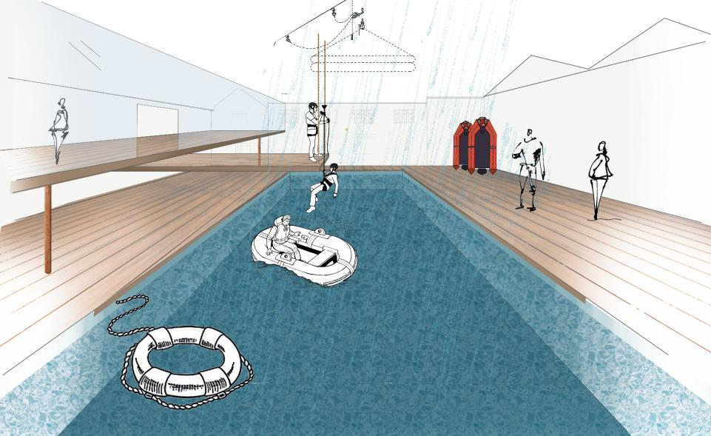

Figure 16: Conceptual collage of design proposal (Rabij, 2021)

5.3 DESIGN MOTIVATION

The key to successful adaptive reuse is respecting the building’s values and previous life (Australian Government, 2004, 3). Each building is different and holds different history and values, that’s why results of reuse will vary on these factors (Merlino, 2018, 80). The land the building was constructed on is very important as well as it serves as base of the particular building and it’s now an inseparable part of it and its history which was forming together with it. If we want the design to be fruitful, we need to consider these different elements related to the existing building and take appropriate actions. The design must not disrespect the history of the building nor its value but emphasise it (Merlino, 2018, 80). That is why I am proposing an adaptive reuse of Hydraulic Tower and Pump House located in Hull. Offering a Health and Safety Training Centre for those interested in fishing industry. The training centre will consist of the theory study space and spaces for practical training such as sea survival pool and firefighting training. A small canteen will be also included for the users and members of staff.

5.4 USER AND CLIENT

USER
T main user of the design proposal for health & safety while fishing centre will be anyone aged 16+ interested in the fishing industry. As there are no courses both at colleges and universities related to fishing, it would make a great place where students can begin their journey with fishing. The centre will be also perfect for those who plan to start their journey in fishing industry as well as people already working in this industry. People whose hobby is angling would also be able to learn about health & safety at the centre. Once the proper training is finished, the centre will be providing its users with certificates which may be necessary in future career in fishing industry.
It’s stereotypical to think that only men can do fishing, both women and men will be able to use the facilities. There are less women involved in the fishing industry than men (University of Exeter). I matter will be will bring up in the next sub- section. There may be some separate courses/lessons created which would be adapted only for women. The centre will try to promote and encourage not only males but females to fishing.

“It’s a man thing to do, women don't go fishing.”
(cited in Kerley, 2020)

CLIENT
Figure 17: ECMT LOGO (ECMT)

East Coast Maritime, formerly the Yorkshire & Humber fishermen’s training association an industry- led association. The company has been providing fishing industry trainings for over 40 years. east coast maritime training is one of the 18 UK’s sea fish industry authority group trainings associations. Their training facilities is only located in Withernsea. However, the company delivers necessary training courses all around the UK, as well as in hull (ECMT).
The proposed health & safety training centre may work together with East Coast Maritime Training to create another facility which would be located in hull. The location will be an advantage as people can be shown some of the safety issues at the nearby docks, meaning they will have real life experience. Another facility of East Coast Maritime Training would be beneficial as there would be enough space to have any bigger equipment needed at the place and outside would also be open to use. Having the facility in Hull would make it easier for those interested in fishing industry as there would more trainings options and times available to the locals.

5.5 FISHERWOMEN
In 2012 women made up to 15% of the UK’s fishing industry, however the data doesn’t say in which section of fishing industry their women were involved in. Women have been always been a part of fishing industry, but because they are doing less visible work such as processing, management, trading and administration, their work is seen as help rather than actual work. Only smaller part of women works on boats doing more heavier physical work. (University of Exeter) In processing, women account for somewhere between 30%-50% of the workforce. (Iris Consulting and Greenwich Maritime Institute) In the EU Women hold around 27% of all jobs in fisheries, aquaculture, processing and auxiliary combined (FARNET SUPPORT UNIT, 2018).
From the diagram we can see that only 1% of women in the whole UK works in the Fisheries section. Majority of women works in the Processing sector of the fishing industry. The number of women involved in fisheries in the UK is drastically low, comparing to how many active fishermen there are in the UK. In Hull the population of women and men is almost equal, so in this case we cannot say that the reason behind that is the population amount.
Figure 18: Number of fishermen in the uk diagram. (Rabij, 2020)
Figure 19: Recreation of “women employed in fisheries and aquaculture in the EU” chart by FARNET Support Unit, 2018

- “You can get observed and questioned by other fishermen:
- 'So, what exactly do you do on the boat?
- Wouldn't you rather be in a shop behind the counter?'
- But I think many women would be capable if they weren't busy with their families.”
- Lorna Lawrence, 2017
ISSUES:
There a few issues why there is only minority of women working in the ‘visible’ part of fishing industry which includes working on a boat. In most cases women are discouraged by the cultural prejudice. There is a saying that ‘woman on a boat brings bad luck’. Women simply feel like they’re not welcome on the boat because they are not expected to be there as the majority of men works on the boats. Very often women come across discrimination and sexism. Stereotypically, women should only be involved in light work such as paperwork or management. There are only little opportunities for women to work at the sea. And if there is any, the fishing industry is not fully adapted to women’s body. Women have reported that there are missing toilets that’s why situations such as periods discourage women to come and work at the sea. If it comes to financial matters, women are not treated fairly. There are many women who claim that they are getting paid less than men or in some cases, they are not paid at all. Another issue is that there is lack of women role models who would navigate women and help them entry the fishing industry by mentoring them using their own experiences. Majority of women have trouble working as they simply need to look after their children when men are working. From this information we can say that women are underestimated and that the fish industry is not fully prepared for them (University of Exeter).

WHAT CAN BE DONE?
There are a few things that can be done to increase the number of women working in the fishing industry…
▪ One of them is to normalise the fact that women can be a part of fishing industry not only doing the paperwork. Presenting it as a career that women can do in their life’s as well.

▪ Changing working conditions and patterns which would be more adapted to women needs.

▪ Valuing women’s work by providing them with fair payments for the job that has been done.

▪ Promote women by including them in meetings, policy makings and official statistics.

▪ Creating programmes which would guide and provide women with experience needed women on how to work on boats. (University of Exeter)

All this research has led to decision of why promote women in fishing within the proposal. The goal will be to encourage more women to work in the fisheries sector of the fishing industry. It will intend to show diversity by allowing men and women learn together the same lessons which would be adapted for both genders. Some of the lessons may be created only for women as there are some aspects of the training which relate only to women’s body.

0.6 precedent studies

6.1 INTRODUCTION
This chapter will mainly focus on examining different derelict pump houses and their new life. Discover designer’s intentions and approaches to the issue of building’s abandonment. It will narrow down the design problem from abandoned industrial buildings to more specific problem of derelict pump houses. The aim is to discover different potential ways of bringing this particular type of building back to life. Helping to answer the question what might be the future of abandoned pump houses ? This process will help to inform the design actions and form new ideas. Analysing how the buildings were handled may shape new perceptions and suggestions which will be taken forward into new design intentions. The chapter will outline the similarities and differences of each building and different strategies that has been used.
Additionally, the chapter will also include some other examples of buildings in order to discover broader range of design approach possibilities and theories which then can be taken forward to help with my own design decisions.

COMMON FEATURES OF A PUMP HOUSE:
Figure 20: Pump House Features (Rabij, 2021) Images taken from various sources

6.2 THE OLD PUMPHOUSE, NOTTINGHAM

Figure 21: Before (Left) and after restoration (right), Pump House in Nottingham (ng and nbpt, 2019 & 2020)

DESCRIPTION:
Restored and extended Victorian Pumphouse in Nottingham.

BACKGROUND:
The pumphouse on the rope walk in Nottingham was formerly designed by famous engineer named Thomas Hawskley. The pump house has stopped working and serving its function in 1895. The building has been closed in 1900 and then served many different purposes. The old pumphouse has been purchased by Hooleys’ Garage Ltd. in 1970 and used as a garage. Later, after 33 years of usage by the company, the building has been abandoned. It has been derelict for 8 years since 2003. In 2008 the Franklin Ellis Architects restored and added an extension to the old pump house. The transformation consists of three floors dedicated to the office space, reception area and two meeting rooms. The whole completion of the project took around 3 years and costed around 700 thousand ( FE, 2011).

THE ALTERED OLD PUMP HOUSE HAS WON NOTTINGHAM BUILDING PRESERVATION TRUST – THE HARRY JOHNSON AWARD FOR BEST RESTORED BUILDING IN 2012.

Location: Nottingham, UK

Former Architect: Thomas Hawskley

Alteration Architect: Franklin Ellis Architects

Year Constructed: 1850

Year Altered: 2011

Former Use: Pumphouse

Altered Use: Offices

Listing: Grade 2

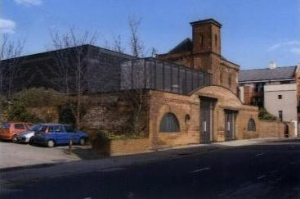
DESIGN APPROACH:

The old pump house conversion was mainly focused on restoring the building and then adding an extension to it. For this project the architects have been working with what’s already there. This was not the only project where Franklin Ellis Architects have decided to reuse an old building, in the past they have been awarded for design excellence of amongst others the regeneration and historic restoration.(RIBA)
Looking at the project we can see Fred Scott’s strategy in use. The alteration stages which he has described within his book ‘Altering Architecture’. The alteration of a building which is based on three main steps: stripping back, making good and enabling works. The first step was to strip back the whole building, meaning to bring it back to its original state (Scott, 2008, 174). In this case I can only assume that the brick work has been cleaned, any decaying elements removed, and building tidied up, ready to be transformed. According to the Scott’s theory the second step is making good. This includes repairing or replacing the original fabric (Scott, 2008, 174). The building has been repaired where necessary and the elements such as old windows and doors has been replaced with new ones. The third crucial step was to demolish any unwanted or unsafe elements. The part of Holley’s Garage from 1970 has been removed and other elements around the building such as the brick wall has been removed. Once, these steps were completed, the building was ready for the implementation of new work to the existing structure. The special alteration can come in different forms, within this project the architects chosen to create an intervention, mixing old with new by merging it together. The intervention* sits partly within the old ruins of the former garage which extends beyond the original structure of the pump house. The intervention structure comes in a form of three cubes/boxes joined together to create a whole. The choice of ‘modern ‘materials which are black metal cladding, large panels of glass and steel construction, create a great contrast between the original fabric of the pump house and the new work. This approach allows to clearly distinguish the original from the new, even though the old and new has been connected together.

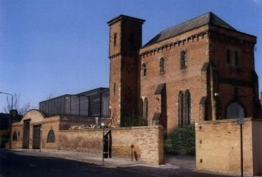
Figure 22: The perspective views on restored pump house (FE, 2010)

As Merlino (2018:80) suggested, the successful reuse of a building should not disrespect the buildings past but instead emphasise it. Looking at the finished work of Franklin Ellis architects, I can say that the new work has been carried out respectfully. However, I am not sure if the new narrative emphasises the history of the building. More likely, the building has been linked with the it’s past throughout its tangible aspects.

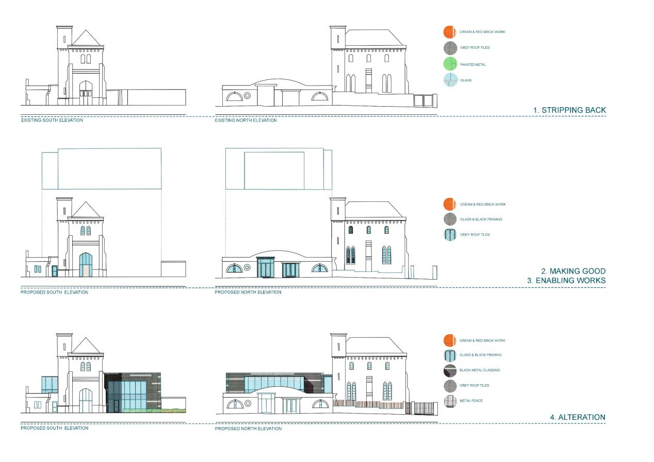
Figure 23: the process of altering the unused pump house in Nottingham (Rabij, 2021) Images from FE, 2010

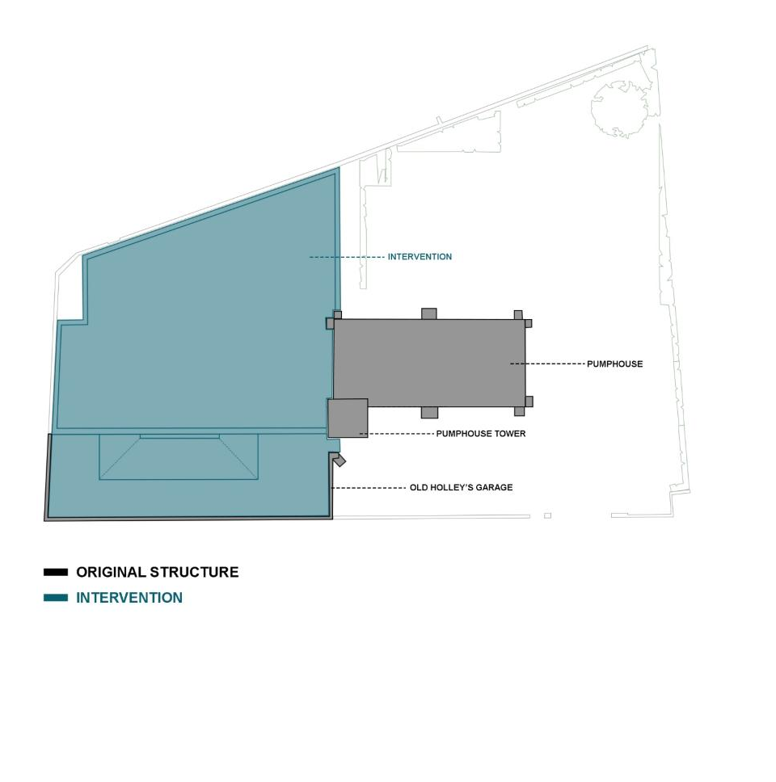
Figure 24: Original structure and intervention diagram (Rabij, 2020) original source (FE, 2010)

RELEVANCE:

STRATEGY, FORM & MATERIALS
Within this case study we have explored how Franklin Ellis Architects have extended building’s life by altering the existing structure. In ‘Building Reuse’, Merlino stated that the whole demolition of a building should be the last option when considering creating a new development (Merlino, 2018, 5). Cantell suggest the same approach. Suggesting that the adaptive reuse of an abandoned building should be the first and preferred alternative over the demolition (Cantell, 2005, 3). It looks like Franklin Ellis Architects had the same point of view when reusing the pumphouse, the point of view that I also agree with and would like to take forward.
The analysis of the design approach has given an insight on how the intervention may be implemented possibly using Fred Scott’s strategy. How to work with the existing structure without violating the building’s past. The architects decided to leave the most of original structure and demolish some of the parts in order to implement new work. This particular approach of part demolition slightly changed my view if it comes to keeping the existing structure and working with what’s already there. In order for a design to be successful now and especially in the future, its functionality needs to be carefully considered. It cannot be something temporary which is going to be continuously changed by other designers/ architects in the future. Therefore, if there is a belief that design is going to be functional for the future generations, we should not be affair of compromising and demolishing some elements in order to implement new design. Not only the past and presence of the chosen building should be taken into consideration but its future as well. Every work which is done on the same building then changed into something else, may damage the existing fabric and risking its future. As Pevsner said, we may want to take care of the building now in order to avoid restoring it later (Scott, 2008, 93- 94).
Also, the design approach of Franklin Ellis Architects towards the choice of materials used within the intervention gives an idea of which materials work well when wanting to distinguish the original fabric from the new work. This knowledge will be taking forward when altering the old Hydraulic Tower and Pumphouse. The cube shaped intervention may be one of the options to consider as it’s neutral and interacts well with the existing form of the former pumphouse.

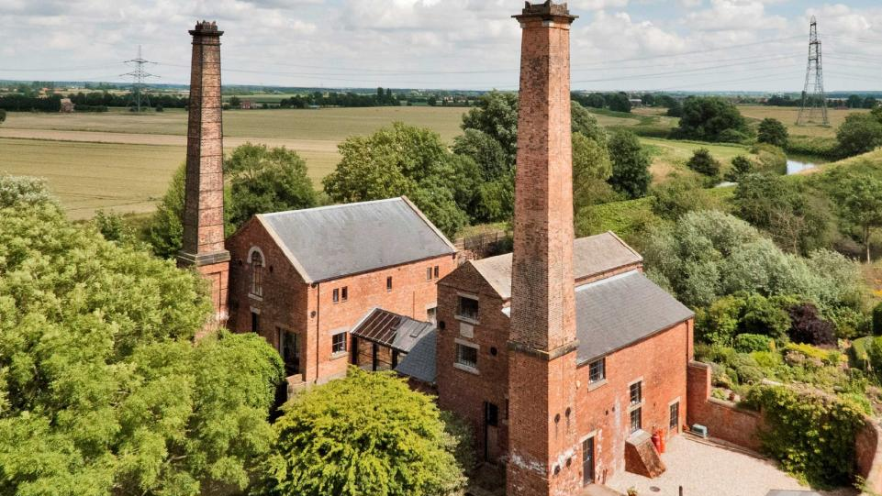
6.3 Georgian Pumphouses, Misterton

Figure 25: The Pumphouse, Misterton, Nottinghamshire (Jackson- stops)
DESCRIPTION:
Contemporary conversion of two former Georgian pumphouses.

Background: The once local landmarks have been constructed parallelly on both sides of the River Idle. The steam-powered beam engines inside were a main part of the ‘Mother Drain’ channel drainage system for the surrounding fens which were also operating the guillotine sluice gates (Jackson- stops). The south pumphouse was the first one to build in 1828 and then in 1839 the north pumphouse has been added (Rust, 2011). The buildings’ functionality has come to an end in 1941, when the pumps were supplied somewhere else, since that time the two pumphouses has been unused for multiply years (Rust, 2011). The current owners have begun the alteration in 1992. The project took three years to complete and was really challenging as the owners had to comply with English Heritage conditions. Now the buildings hold a residential purpose. (Redwood, 2016)

have begun the alteration in 1992. The project took three years to complete and was really challenging as the owners had to comply with English Heritage conditions. Now the buildings hold a residential purpose. (Redwood, 2016)

Location: Misterton, UK Former Architect: Unknown Alteration Architect: Gemma, Tony and Chris Brownson Year Constructed: 1828&1839 Year Altered: 1995 Former Use: Pumphouses Altered Use: Residential Listing: Grade 2

DESIGN APPROACH:
Before carrying any design works Gemma and Tony had to carefully restore the original fabric of the buildings. The chimneys had to be made safe, thermal insulation had to be upgraded, some parts of the buildings had to be rebuilt (see Figure 26 for a reference). Once the restoration work was completed, the new work could be implemented.
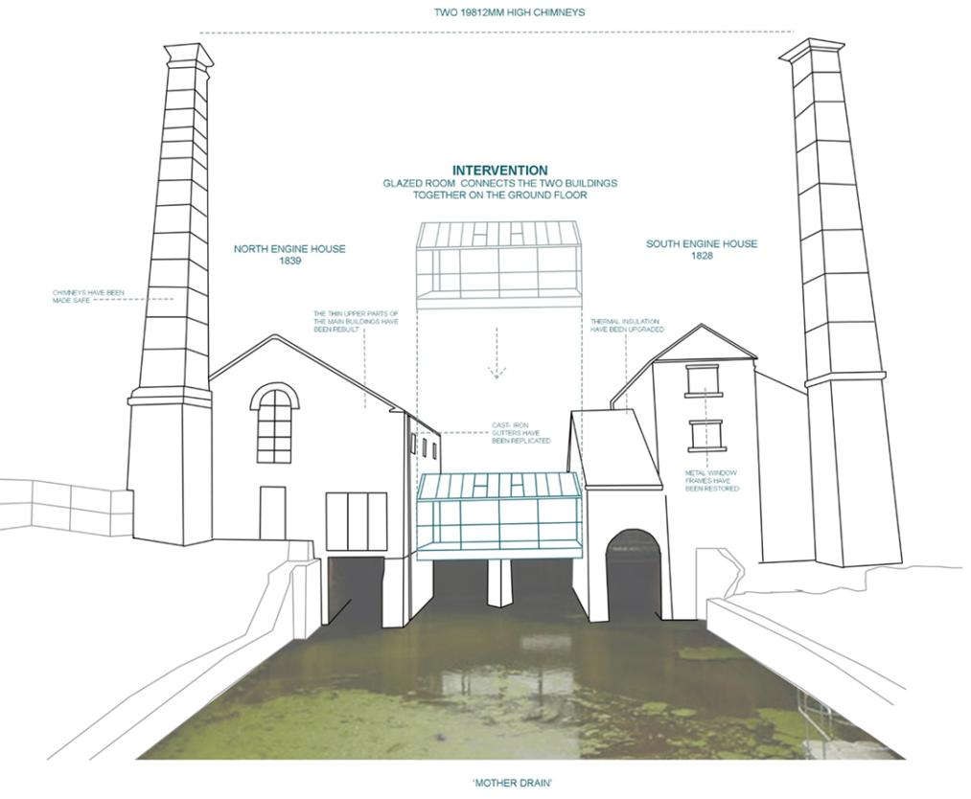
The owners have created an extension to the existing buildings by joining them together using a glazed room. The intervention sits perfectly between the two old pumphouses and connects them together just above ‘Mother Drain’. The buildings are situated parallel to each other and also ‘Mother Drain’.

The extension is just in the middle of it which creates an interesting, synchronised composition. The use of glass for the intervention allows us to see the gap and the original separation between the two buildings. Also, it lets us see the track of ‘Mother drain’, almost like there is nothing between the two buildings.

Figure 25: the intervention diagram (Rabij, 2021)

Figure 26: insertion diagram (Rabij, 2021)

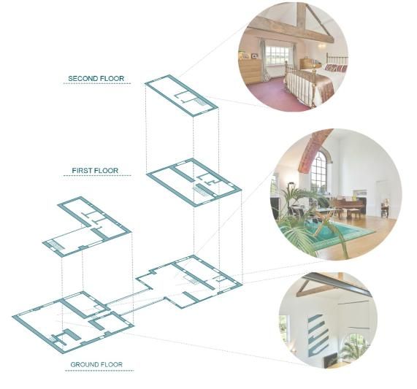
Figure 27: Spatial arrangement and materials (Rabij, 2020) ORIGINAL SOURCE (Jackson stops)

The spaces have been transformed into residential purpose which is not something that links us with the spirit of the past use. It seems like the owners plastered the old brick work from the inside and painted them white, however some of the elements such as beams, brick work around the windows have been kept and exposed within the interior. This kind of approach here connects the new work with the old work. This has created some sort of narrative of the building’s past within the new interior, giving the users and open space for imagination of how the space might have looked before. Rather than of covering the elements to have a fully modernised interior without any trace of the ‘old’ work, the owners decided to showcase them as a part of the new interior.
The white walls create a contrast between new and old, allowing us to clearly see some of the elements of the old pumphouses interior. The image below shows how the owners decided to divide the space and apply new materials with conjunction of the old ones.

Figure 26: Recreation of floor plans ( Redwood, 2016)
Figure 26: space and materials diagram ( Rabij, 2021)

RELEVANCE:

RESTORATION PROCESS & MATERIALS: The main part of converting the twin pumphouses was the actual restoration of them. Tony’s and Gemma’s journey of restoring the old buildings, gives an insight of what to consider or not while restoring a listing building. While converting the houses, the owners came across a few difficulties which they found inconvenient. First of all, the whole restoration of the old buildings where they had to comply with English Heritage conditions. As Gemma said, some of the elements had to be restored in the manner of including even the smallest marks which have been on the original element when replacing would be less complicated option. The whole process took more time than the owners have planned it would actually take (Redwood, 2016). This kind of restoration lead to something Ruskin was really against. As I mentioned withing literature review, Ruskin stated that the deception is bigger, when the restoration is closer to the original building (Ruskin, 2001, 252 ). The owners did not intend to restore the building to the extent of having it almost the same appearance as it was in the past but instead to alter it, so it can have a new life. Work with what’s already there and don’t let the building disappear with time. I must agree with Ruskin here as he said that the energy which has been given by the builder will never be the same, only new spirit can be added (Ruskin, 2001, 252). However, it is not always in architects intention to try and recreate what’s have already existed before but to compromise and alter the building by restoring it with the intentions of simply reusing the building so it does not go to waste.
Within Gemma’s and Tony’s design we can see a connection with the past through materials they have used or built fabric they decided to keep. This is something to consider when dealing with an unused historic building. It is one of many options which is worth considering when wanting to create a narrative or some sort of spirit of the building’s past.

6.4 Pratt Institute, NEW YORK

DESCRIPTION:
Figure 28: Higgins Hall, before and after alteration (Sundberg & Holl, 2019)
A new construction of a Higgs Hall, extension of Pratts Institute.

BACKGROUND:
Higgins Hall is a part of the Pratt Institute's situated at Brooklyn campus. The three-storey building is New York’s landmark which has been built in 1868 and opened as a college of art and design in 1965. I could not get hold of information about its former use. However, I found the building while searching for old pump houses. The construction includes some of the features of a Victorian pump house. Therefore, I can only assume that the building operated as a pump house in its previous life.
In 1970 the new use was dedicated to Pratt Institute’s School of Architecture (Moffat, 2007). The building has suffered several fires in the past, the central part which is the Higgins Hall has been awfully suffered from fire in 1996 while being under renovation works by Rogers Marvel Architects (Abruzzese, 2013). In that time, Steven Holl Architects has been assigned to create a new centre section (Moffat, 2007). In 2004, the Pratt institution demolished the middle building and that is when the new construction of Higgins Hall has begun (School Construction News, 2006).

Location: New York, USA Former Architect: Unknown Alteration Architect: Steven Holl Architects Year Constructed: 1868 Year Altered: 2005 Former Use: Art & College since 1965 Altered Use: School of Architecture Listing:

DESIGN APPROACH:
We can say that this project is similar to the conversion of two pumphouses in Misterton. An insertion has been made between two buildings connecting it with each other. However, in this case to allow the alteration to come to life, the middle building had to be demolished.
The way the building has been approached in terms of forming a relationship with the two other buildings is very powerful. The structure consists of thick metal frame on which the rest of the insertion was built around. The layout of the beams was not random (Maggiora, 2019).
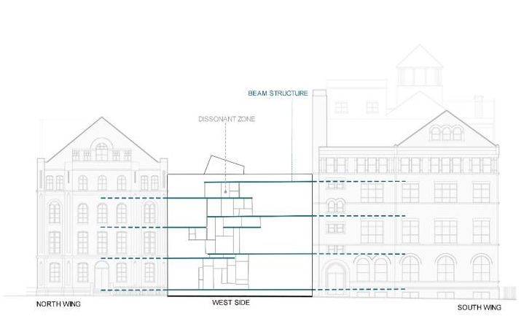

Figure 30: the asymmetry between Floor levels ( Rabij, 2021) ORIGINAL SOURCE (steven Holl architects, 2005)

Figure 31: the ramp spacing (Rabij, 2021) original source (steven Holl architects, 2005)

Figure 29: Beam Structure (Holl, 2019)

The beam structure was formed on the floor level difference between the two other buildings as the floors did not align. The ‘dissonant zone’ represents the middle of the asymmetry, were the different floor levels meet. The front of the construction can be seen on the west elevation as the ‘dissonant zone’ was formed on it (Maggiora, 2019). Pre- cast concrete floor planks lie on this steel construction (AR Editors, 2016).

The architect’s solution for the floor misalignment was creating ramps on each floor, which allowed the two other buildings to be practically connected with each other. The cast in place ramps are aligned inside with the dissonant zone. The spacing of the ramps allowed users to circulate between point A to B while having outlook on the outside (Maggiora, 2019).

RELEVANCE:

APPROACH & SPATIAL PLANNING
This particular ‘urban insertion’ , is not just a random piece of architecture that has been made only for the functional purposes. It is a piece of a missing puzzle which was finally found (Moffat, 2007). As Viollet-le-Duc said, “To restore a building isn’t to maintain it; to repair it or rebuild it, it is to recover a perfection that may never have existed at any given time.” (Scott, 2018) The design intentions from this project have a reasoning behind them which is very important while creating architectural pieces. This process makes a building have a story to tell. The architects looked deeply into the structure of the buildings and how they can create a relationship between them. Their findings were plotted into the design which was exposed to others throughout the insertion’s structure. The new modernised Higgins Hall creates a great connection between the two historic buildings. What’s important is that the connection was not only made physically but it also became an intangible link to the history of the buildings (Moffat, 2007). The insertion reunites the two structures back together forming a narrative within the space at the same time. This attitude towards a building and its structure may be taken forward to help form a relationship between the old and new.

.

.

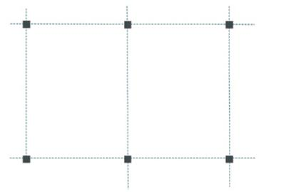

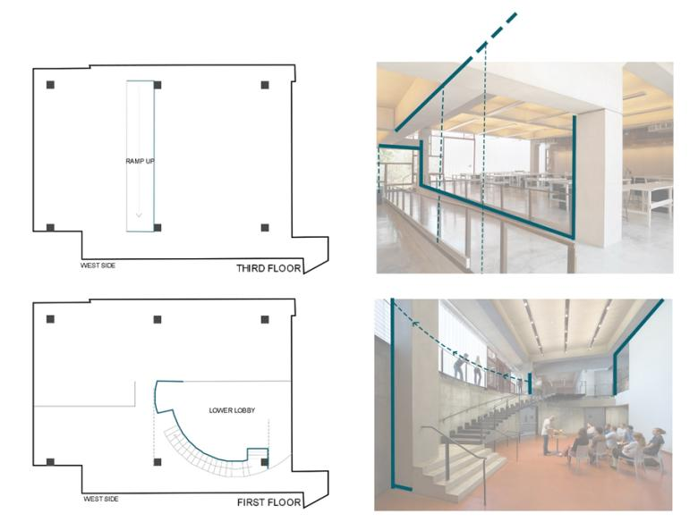
Figure 32: Grid Structure (Rabij, 2021)
Figure 33: column relationship towards design diagram (Rabij, 2021)ORIGINAL SOURCE (MOFFAT, 2007

While studying the building, I came across a strategy which was not mentioned. The building also consisted of 6 concrete columns which were linked by the steel frame running through all floors (AR Editors, 2006). Looking at the plans, I spotted that the invisible structural grid, which was created by the 6 columns, potentially informed some of the design decisions (see Figure 32). On the images we can see how the design interacts with the columns. This kind of approach may be very helpful when making design decisions.

6.5 VILLA SAVOYE, POISSY
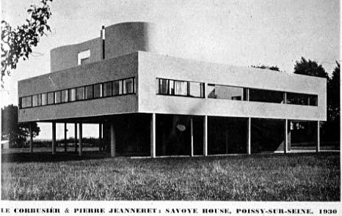

DESCRIPTION:
The application of ‘5 points of architecture‘ within Villa Savoye

BACKGROUND:
The famous Villa Savoye is one of the most significant buildings from 20th century. This piece of architecture has made a remarkable development of the Modernism in early 20s (Kroll, 2010). The most iconic example of extremely successful implementation of ‘5 points of architecture’ (Les Coulreus, 2018). Due to damage left from WW2 and continuous malfunctions of the house the owners decided not to work on the house anymore. At one point the building was ready to be demolished but the town of Poissy bought the building in 1958. French state owned the building since 1962. Villa Savoye has been through a several restoration processes between 1963 and 1997. The Modernist Historic Monument was finally reopened to public in 1997 (Gatier, 2013 and Bianchini, 2019).

Figure 34: Villa De savoye, 1930 ( Arch4444)

Location: Poissy, France Former Architect: Le Corbusier & Pierre Jeanneret Alteration Architect: Year Constructed: 1929-1931 Year Altered: 1977 Former Use: Residential Altered Use: Historic Monument Listing: Public building

Figure 35: 5 points of new Architecture ( Rabij, 2021)

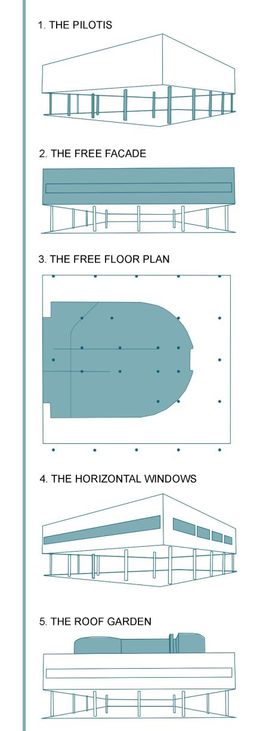
DESIGN APPROACH:
Villa Savoye was built on ‘5 points of architecture.’ It serves as a reflection of Le Corbusier’s theory which points out the main principles of Modern Architecture (Gibson, 2016).
1. The pilotis were used to lift the building above the ground. This allowed the automobile movement and land flow (Stinga).
2. Free façade was separated from the load- bearing structure mask it’s functional purpose (Stinga).
3. Open plan floor was achieved by relieving the building from its structural restrictions. Working around the pilotis to create partitions which can be easily formed and changed (Stinga).
4. Ribbon windows were horizontally placed around the building to allow spaces to be equal lit and functional ventilation (Stinga).
5. Flat roof was created, so it could be used as a garden (Gibson. 2016). Giving back the green space which was taken by the ground floor (Stinga).
Le Corbusier’s application of ‘5 points of architecture’ within Villa De Savoye created a very functional ‘machine for living’ which is used as an example of successful modern architecture (Nancy, 2017).

RELEVANCE:

SPATIAL PLANNING
The building was constructed on a very accurate square grid which was formed from 25 columns (Bianchini, 2019). The free floor plan spaces were achieved by using the pillars in order to create both tangible and intangible partitions within the interior (Stinga). Using free standing columns rather than placing load-bearing walls, allowed the architect to play around with the space. Treating columns like guidance spots which helped to make decisions regarding spatial panning, similarly to Higgins Hall.
The strategy used within Villa Savoye, especially the free floor plan may highly influence how the spatial planning will be carried out. The spatial language demonstrated by Le Corbusier, may become a crucial element of the design process which may help forming rational design decisions. The same as Higgins Hall, I feel like the usage of columns may be used as a base for any design which will guide some of the design decisions regarding space planning.
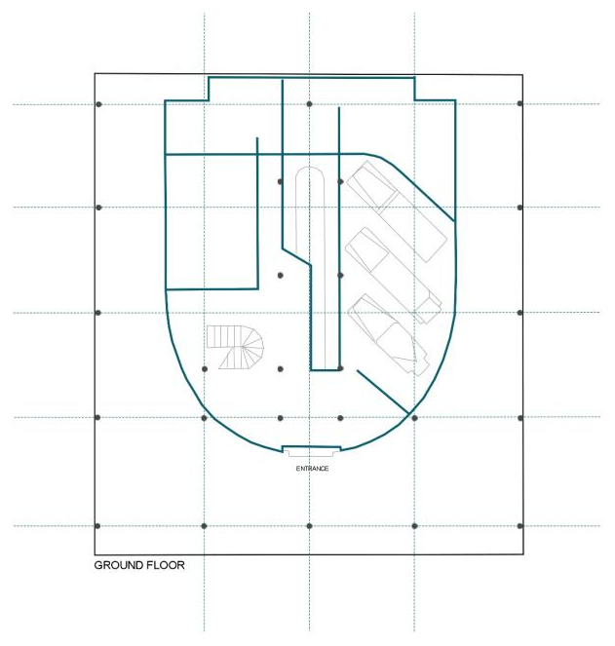

Figure 36: Structural Grid of Villa Savoye ( Rabij, 2021)

The rectangular/square geometry was broken by the use circular shaped forms which created a great contrast between line and curve(Bianchini, 2019). The curved wall was not random as they were inspired by Corbusier’s Purist paintings (Murphy,2002,69). Villa de Savoye is a very thoughtfully designed architectural masterpiece, were every aspect has been considered and backed up with sensible reasoning.

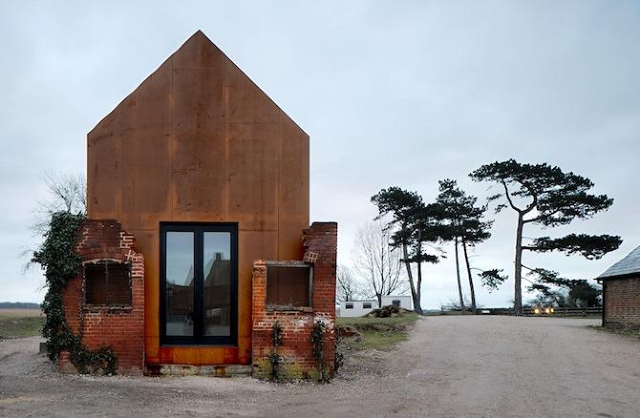
6.6 DOVECOTE STUDIO, SNAPE

DESCRIPTION :
Renovation and reuse of an old Victorian, industrial building.

BACKGROUND:
The Dovecote studio is one of the buildings which was included within the regeneration of old industrial buildings located in Snape Malting with the aim to expand the music campus. The project was carried out within the ruins of a formerly two- storey Victorian dovecote. The building has been neglected and left to decay which resulted in its collapse in the early 70s. All that has been left is the 2-3 meters high brickwork boundaries of the building (Haworth Tompkins).

ARCHITECTS JOURNAL SMALL PROJECT AWARD: DOVECOTE STUDIO QUALITY OF PLACE AWARD - DESIGN: DOVECOTE STUDIO

Figure 37: Dovecote Insertion (Vile, 2010)

Location: Snape, Suffolk, England, UK Former Architect: Unknown Alteration Architect: Haworth Tompkins Year Constructed: Year Altered: 2009 Former use: Dovecote Altered use: Music campus Listing:

DESIGN APPROACH: The strategy for this renovation was aiming to reuse the building in the manner that would respect the old built.

“It concentrated on preserving existing fabric, with all its patina of age and use, and adding to it – where necessary- In a legibly contemporary architectural language that should be as uncompressing and industrial as the original buildings, and should age gracefully to unite with the existing structures. “

Reconstructing the former dovecote would be incompatible with the planned strategy. Therefore, architects left the ruins almost untouched and designed insertion which would allow a functional reuse of the old dovecote. Only minor, necessary repair works have been carried. This approach made the existing structure safe to use without significantly changing its appearance (Haworth Tompkins).
Figure 38: Dovecote studio renovation process diagram (RABIJ, 2021) original source (VILE, 2010)

RELEVANCE:

RENOVATION PROCESS AND WORKING WITH THE EXISTING
The conceptual language of keeping the old and adding the new is a great approach which respects the building itself no matter what state it is in. The two structures are completely separate but act like a whole. A single piece of the red Cor-ten steel form almost matches the colour of the existing bricks (Haworth Tompkins). It seems like the new structure grows out of the ruin’s foundations and has been decaying together with the original building (Cilento, 2010).
Unlike the old pumphouses in Misterton, here architects have left what’s has already been there. Instead of restoring and recreating the old building, architects kept the original structure and worked around it. The old brick work has been repaired using a new material which can be easily distinguish from the existing fabric. The original windows have been retained as they were not interfering with the new work. Even the vegetation growing on the side of the ruins have been hold on to in order to allow the natural process of extinction. The new structure came in a simple, plain form which only highlights the beauty of the old ruins (Haworth Tompkins, 2009).

Figure 39: Close up view on new brick work (Vile, 2010)

The way architects dealt with the existing structure and its past life is a strategy worth acknowledging when working with a delicate old structure. Although, the building has not been reconstructed, architects managed to give us a sense of the past through the application of new work.

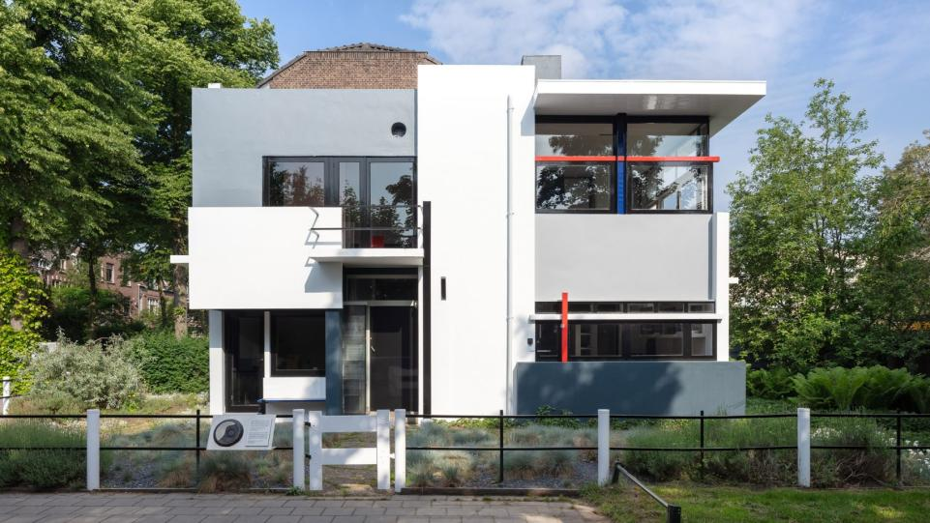
6.7 SCHRODER HOUSE, UTRECHT
Figure 40: The exterior of Schroder House (Poelstra, 2018)

DESCRIPTION:
The famous Schroder House.

BACKGROUND:
Schroder House is an iconic architectural piece which impacted significantly on the modern architecture in 1925 (Zorn, 2017). The house was unlike any other in these times. It was one of ‘modern’ houses ever built (World Heritage Journey). For many the house serves as great example of modern architecture, due to its clever solutions, spatial planning, and unique design (Sveiven, 2010). Designed by furniture designer Gerrit Rietveld building has been created in the De Stijl style. The house construction was requested by Truss Schroder, a widow with three kids who wanted something more than just a regular house. At the time, Rietveld wasn’t an architect nor interior designer, but a successful furniture creator famous from his red and blue chair. Schroeder impressed with the Stiil art movement that Rietveld was a part of, decided to give the furniture maker an opportunity to design his very first building (Block, 2018). The house has been restored in 1985, not long after Schroder death and then open to public (Mulder, Zijil, Rietvield, 1994, 4).

Location: Utrecht Former Architect: Gerrit Rietveld Alteration Architect: Bertus Mulder Year Constructed: 1924 Year Altered: 1985 Former Use: Private Residence Altered Use: Public Listing: UNESCO World Heritage Site

DESIGN APPROACH:
Rietveld came up with many ambitious solutions to meet Schroders requirements. All of the design components within this house were not accidental (Saldago,2018). The flexibility, functionality and open space were created by using sliding and revolving planes (Mulder, Zijl and Retvield,1999, 8). The flexible flow of the circulation was achieved by thoughtful analyse of the floor plans and subdivisions which allowed a ‘perfect’ positioning of staircase and ramp (Saldago, Sal2018).
The exterior of the house is a large cube combined with horizontal and vertical elements sitting all the way around it, creating voids and volumes (Mulder, Zijl and Rietvield,1999, 8). The house is free from three sides, only the fourth side is adjoined with the neighbouring dwelling. Therefore, large windows have been added to frame the surrounding view. One widow has been made differently. In order to give a sense of being outside, Rietveld deprived the corner window from its frame. Resulting it being in two parts which allowed both of them swing out (Block, 2018).

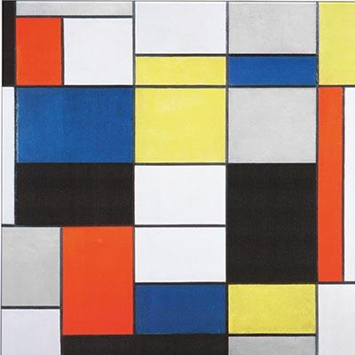

Figure 41: De Stijl- Combination A (Mondrian, 1920)

THE THREE MAIN FEATURES OF HOUSE INCLUDE:
▪ Bold primary colours with the addition of white, grey, and black.
▪ Clean, solid straight lines both horizontal and vertical (Block, 2018).
▪ Smooth transition between exterior and interior (Bintu, 2018).
KEY CHARACTERISTISC:
▪ Lines
▪ Planes
▪ Slabs
▪ Volume
▪ Posts
▪ Beams
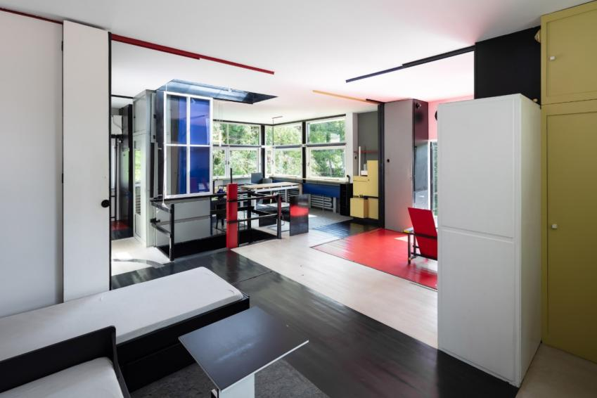

Figure 42: The inside of Schroder House – sliding partitions (Poelstra, 2018)

Figure 43: recreation of the floor division achieved through colour (Rietveld, 1924)

Relevance:

SPATIAL PLANNING AND CIRCULATION
Schroder house is another example of how free floor plan can be achieved within a domestic space. Rietvield’s proposed a fully functioning system within his design that allowed an open space during the day which then could become private during the night just like Schroder wanted. Rather than using regular interior walls, mobile partitions were used on the first floor. This approach created a flexible circulation around the whole floor which could be easily changed in any way and at any time (Saldago, 2018).
The other strategy which was applied within the spatial planning was the use of colour. Very simple but effective method which was used to divide the spaces. Rietveld demonstrated that space separation doesn’t have to be made by only using walls. The floor consists of different colours which indicate different spaces and divisions. The large space has been divided into different sections, but the open plan was still there (Saldago, 2018).

7.8 PUMPHOUSE, BOCHUM
Figure 44: Pumphouse at the Jahrhunderthalle, before(left) and after reuse image (right) (Holl and Mayer)

DESCRIPTION:
The conversion of an old pumphouse situated in an old industrial area.

BACKGROUND:
This large, old industrial building was formerly a pumphouse located near Bochum’s West Park. The building used to be involved with the huge steel works situated right in the city centre. Its new life is dedicated to visitors of the site, providing restaurant services and entertainment. Not only this only building has been reused but the whole industrial site has been regenerated. The old pumphouse is adjoined to the massive industrial hall ‘Jahrhunderthalle‘ which used to be a steam blower house but has been repurposed and is now used for performing arts (Heinrich Böll Architekt, 2012).

Location: Bochum, Germany Former Architect: Unknown Alteration Architect: Heinrich Boll Architekt Year Constructed: Year Altered: 2012 Former Use: Pumphouse Altered Use: Restaurant & Visitor Centre Listing:

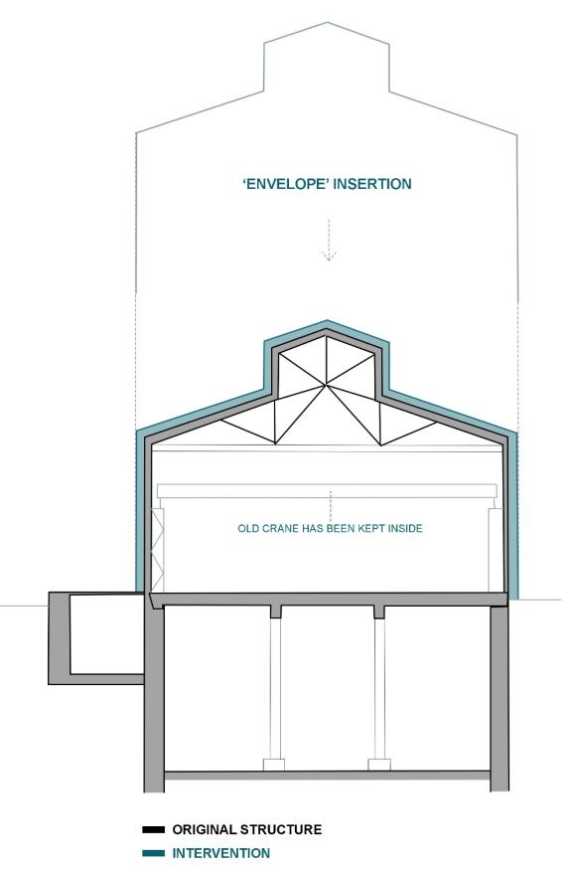
DESIGN APPROACH:

Figure 45: The application of new work diagram- Section BB (RABIJ, 2021)ORIGINAL SOURCE (Boll, 2012)

The way the architects have approached the building is quite simple but very effective. Comparing to other approaches such as the one in Misterton pumphouses or the old pumphouse in Nottingham, here the architects have gone into an opposite direction. On the outside the building look like a fresh, new constructed warehouse. However, on the inside there is a hidden structure. The other examples have shown us an insertion being made into the inside of an old structure. Within this project the architects have changed the game and instead inserting something inside, they have inserted something new on top of the old. The old industrial building has been trapped inside of the new construction which acts like a protecting shield. This approach allowed the architects keep the old building and use it again without having to carry heavy restorative works and worry about the insulation problems (Heinrich Böll Architekt, 2012).

RELEVANCE:

INSERTION STRATEGY
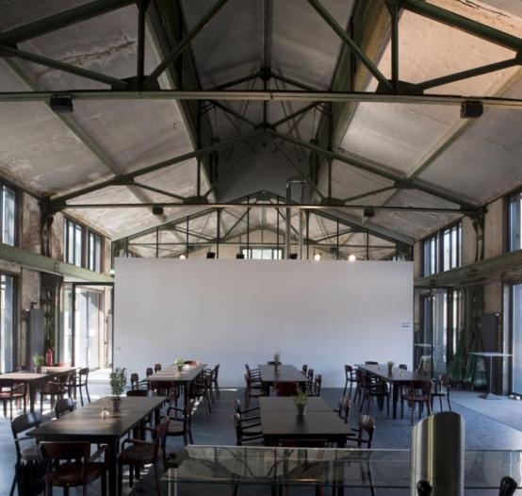
Figure 46: The inside of Bochum Pumphouse (Mayer)

The language of enclosing a building within a new structure is a different way of preserving a building. It is a rare solution to an old building which structure is too delicate to handle any new work. The exterior of the industrial building has been concealed by the new ‘shell’, leaving a faint outline of the old behind the new. However, the former building atmosphere has been captured inside where the ruins are exposed to the public (Heinrich Boll Architekt, 2012). It is like a box within a box strategy which has also been applied to create private spaces within the building. This approach is unlike any ‘traditional’ insertions which where ‘thinking outside of the box’ has took a literal meaning.

7.8 CONCLUSION

Briefly to conclude, analysing both the contemporary and historic precedents have given a new insight on which direction I might want to take the old hydraulic tower and pumphouse in Hull. Different meaning of reuse has been identified within different design approaches, theories , solutions, and strategies.
By choosing mostly old pumphouses as examples, I could relate to my chosen building. The pumphouses consist of structural similarities which allowed me to explore different potential design strategies which can also be applied to my chosen building. The Old Pumphouse in Nottingham identified the Fred Scott’s alteration strategy which I intended to follow. The example gave me a deeper understanding on how strategy works. The Devote Studio have presented a ‘working with the existing approach’ and the renovation strategy.
Although, the historic examples such as Villa Savoye and Schroder House are not the type of building I am working with. However, they brought some new considerations into my design as well. Spatial planning strategy is the main influential aspect which I have examined within these projects. These approaches may be very beneficial when taken forward into my project, as I am working with a small building in comparison to the big idea which I got for it.
To sum up, all of the case studies have been inspirational, and I have learnt something different from each of them. This will be covered more in depth within the next chapters. Last but not least, the chapter helped me to find an answer to my question. My findings suggest and prove that adaptive reuse if the most suitable future for abandoned industrial buildings. No matter what kind of a building it is or what condition the building is in there is always a way to bring it back to life. It may be through Renovation , Insertion or Restoration that Ruskin really hates and Viollet- Le- Duc agrees to (Scott, 2018). Going back to the introduction, there seems to be no golden meaning because as John Lydgate said, “…you can’t please all people all of the time”(Gordon, 2018).

0.7 DESIGN STRATEGY AND APPLICATION

7.1 INTRODUCTION

Within this chapter the design concept and process will be discussed regarding the future of unused Hydraulic Tower and Pumphouse in Hull. The following sub section will demonstrate how the findings have implemented some of the design decisions and created a conceptual language for the project. The key influential information gathered from the research will be projected through the strategy and application process. The previous chapters from the ‘Literature Review’ to ‘Precedents Studies’ will be used as a supporting evidence which guided the design decisions.

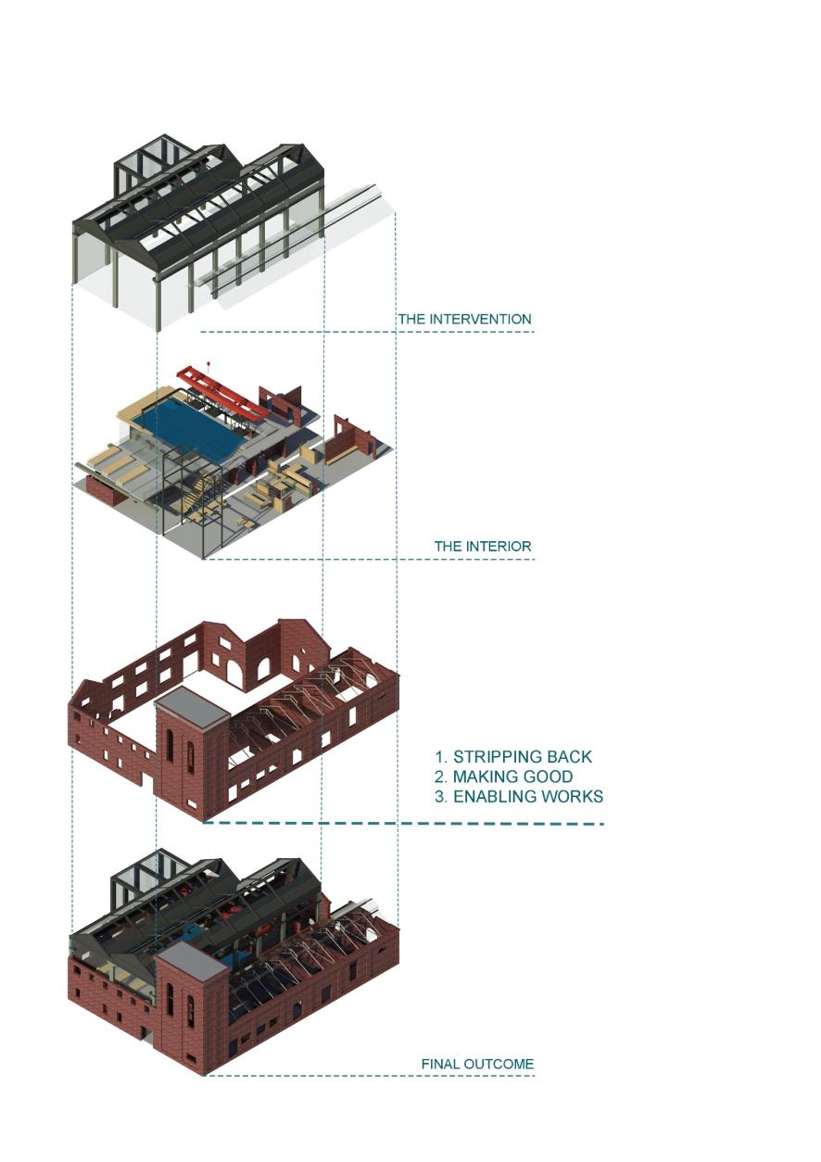
7.2 WORKING WITH THE EXISTING

The analyse of different perceptions which literature review has provided led to the choice of reusing the old Hydraulic Tower and Pumphouse. The building has a facilities to be re- purposed, therefore it would be a waste to demolish it. DeSilvey in her book ‘Curated Decay’ have said that a building or an object which is left to decompose, doesn’t particularly loose on its significance (DeSilvey, 2017, 5). Waterson in his book ‘Rescue and Reuse’ argued that reviving a building won’t result in the building becoming less significant, instead it will affect positively on the industrial sites regeneration (Waterson and Morrison, 2019, v). Both of the sources have a valid point, the same opinion regarding different paths a derelict object can be taken into. However, an adaptive reuse will allow the historic industrial buildings to be brought back to life and be used again. Rather than decaying isolated from the present and slowly being forgotten their importance can be highlighted within a new design. Decay will result in the loss of narrative once the building disappears completely, at this stage it cannot be taken back anymore (Merlino, 2018).

“The recovery of properties, which many are in ruins, allows architects to create new concepts and their combination with the existing ones, reinterpreting to fit the reality full of unique stories and experiences that differ from place to place”
(Campos, 2014, 2)

7. 3 FORMING A CONCEPTUAL LANGUAGE

At this stage it is clear that the reuse of Hydraulic Tower and Pumphouse will take place. However, what will be a conceptual design which will guide the project?
‘Working with the existing’ subchapter is underpinning the idea. The ideology of working with what is already there and mixing old with the new will be driving the project. The reasoning for that is to cherish the history, rather than let it go away. Respect the original fabric which have been left and work with it in order to extend the life of the remaining history. This approach will allow a new purpose which will preserve the history at the same time.

THIS CONCEPTUAL LANGUAGE WILL AIM TO:
▪ Combine old with new
▪ Connect past with the presence
▪ Create a narrative within the space

The project will be following a language which will emphasise the original fabric which has been left by using new work as a tool which will help to point it out. Devote studio is a good example of this kind of approach whereas Pumphouses in Misterton are more like a reverse direction which would mislead. The language which will connect past with presence, mix old with new. And create a narrative within the space which will allow users to get a feeling of the history.

7.4 CONCEPT IMPLEMENTATION

Figure 47: conceptual strategy and application diagram ( Rabij, 2021)

The above diagram presents a strategy of working with the existing. The conceptual language which was planned to be followed for this project. The application of this strategy will be explained more in depth within the next sub-chapters.

7.4.1 MIXING OLD WITH NEW

“The old is not the new”, “the new can never be old”.
(Bechnish, cited in Campos, 2014)

This is what Bechnish thinks about the modern architecture. Explaining that old and new are two separate periods and should not interfere with each other. Old will stay old and new will be established (Campos, 2014, 3). And this is what the proposal will aim to achieve. Rather than recreate the old and deceive ourselves as Ruskin would say, a new will be introduced.
He once said that it is pointless trying to restore what once has existed because the whole meaning was trapped in that particular element (Ruskin, 2001, 252 ). What is gone it’s gone, therefore what is left will be kept with this project. The building will be worked with to restore a perfection which might not been discovered before (Duc, cited in Scott, 2018).
Within this concept, a new and old will be combined together to achieve both, a successful amalgamation between past and presence through the built fabric. Although, the old and new will be separate pieces, they will be creating a whole at the same time. A whole with a clear contrast between old fabric and new will be depicted. The existing fabric will seek to create a harmony together with the new intervention (Scott, 2008, 22).

Figure 48: old + new combinations (Rabij, 2021)

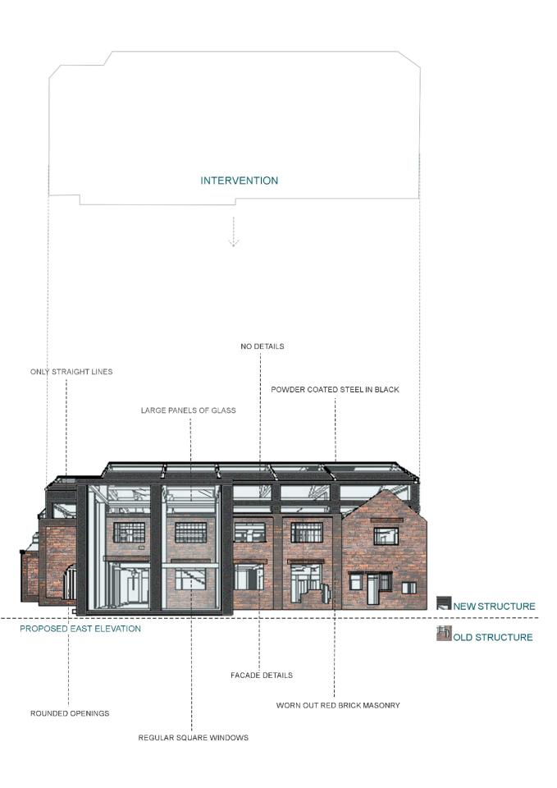

Figure 49: Combining old with new diagram (Rabij, 2021)

Figure 49 presents a combination of the old fabric and new structure. The line between old and new have been added to act like a mirror which gives us a reflected opposite.

A new will come in a form of architectural intervention which will be used to support the existing structure as well. The alteration will mainly use materials such as steel and glass which is going to be combined with concrete. Although, concrete is a traditional material which now a day became a choice it will be presented in different finishes and forms (Cantell, 2005, 3). Introducing new materials within the intervention is a part of bringing a building back to life which gives an existing a contemporary twist (Scott, 2008, 275).
Brick load - bearing walls have been slowly replaced by steel frames at the end of nineteen century, therefore the new will be opposite of the original structure (Cantell, 2005, 3). It will come as a frame construction rather than structure with load- bearing masonry walls. The simple form which uses straight lines in order to provide a modern touch to the building. This way the intervention will not distract from the beauty of the old ruin, its materials, shapes and ornament.
Small windows of the original building will be replaced with the large glass panels. The panels will be used to enclose the new structure and act like windows at the same time.

7.4.2 CONNECTING PAST WITH PRESENCE

Keeping and reusing the building itself connects the past with the presence. A conserved building will form questions such as ‘what is this building?’ , ‘what happened here before?’ .Instantly, the discussion will lead to the previous life of the building and site, it’s heritage and significance and new life. (Cantell, 2005, 5) This section will focus on demonstrating the bond between old and new life throughout the new design concept. Demonstrating how the new purpose links back to building’s original use.

“We must learn to cherish history and to preserve worthy old buildings . . . we must learn how to preserve them, not as pathetic museum pieces, but by giving them new uses.”

(Huxtable, cited in Cantell, 2005, 2)

This is a very strong statement that Huxtable have given about the reuse of historic buildings. Museum, residential units, offices, school, etc. are the common transformations of the historic industrial buildings. A fruitful regeneration should bring something new to the community. (Cantell, 2005, 3) Therefore, the project will offer something less common but something more unusual for the St Andrews surroundings. Something refreshing which will bring a new spirit to the area which would also take us back to the past of the place.

Figure 50: Surrounding areas to St Andrews dock (Rabij, 2021)

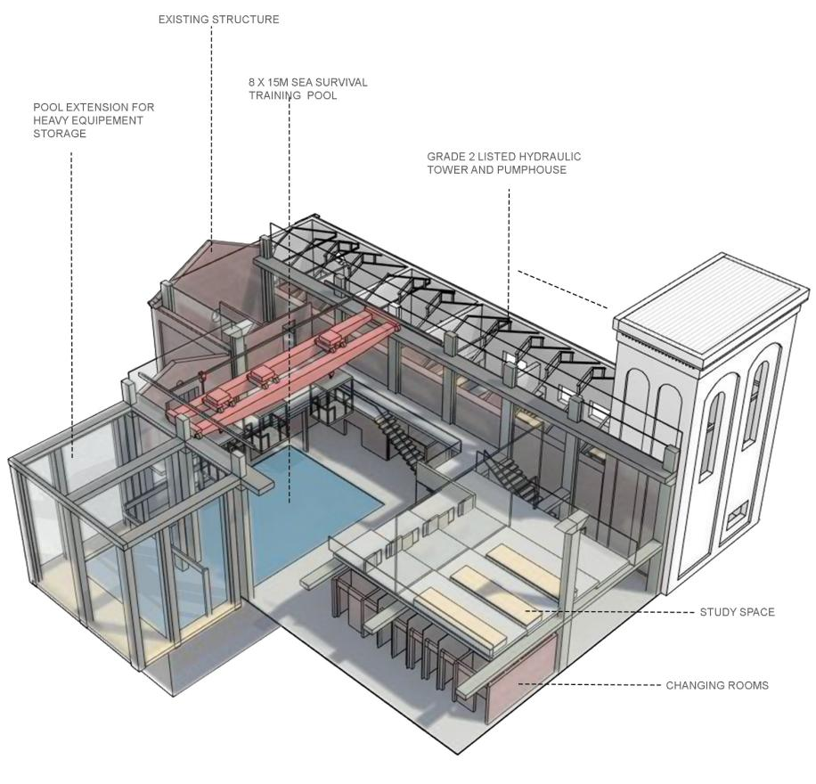

Figure 51: A 3D view of the new use

The building will be repurposed for the Health and Safety Training centre dedicated to fishing. The chosen new life links back to the site and building history. After the Triple Trawler Tragedy, a campaign was created by Lilian Billoca to improve safety and conditions of trawlermen (Hull Marine Museum). Following the steps of Billoca, a space will be created where people can be taught about the Health & Safety while fishing either on the land or offshore. The new purpose will aim to improve the safety of fisher women and men. Also, it might help to reduce the risk of such a tragedy occurring in the future knowing that the number of active fishermen in Hull is high (see Figure 18 for a reference)

7.4.3 CREATING A NARRATIVE WITHIN THE SPACE

The following concept aims to repurpose the building in the way the user can connect with it through the intangible. This can be done by creating a narrative within the space. Relating to Merlino (2018:80), narrative within the space is one of the key aspects of forming a successful design.

The majority part of the building will be allocated for sea survival pool training space. Meaning that the former function of the building as a pumphouse will be recreated and come in a form of a narrative. The use of water, the pumps, and all the heavy machinery will act like a ghost of the former purpose. This approach of relating back to the building’s former use will help us link with past spirit and create the narrative of its previous purpose. A spirit of an industrial use as a pumphouse will be made.

Figure 52: Proposed use shown on Long Section (Rabij, 2021)

COMMON FEATURES FOUND INSIDE OF A PUMHOUSE:
▪ Cranes
▪ Water pumps
▪ Platforms/balconies
▪ Open spaces
▪ Raw materials
▪ Floor ‘voids’
These are some of the features which will be brough back to the building as it can be seen on the diagram below.

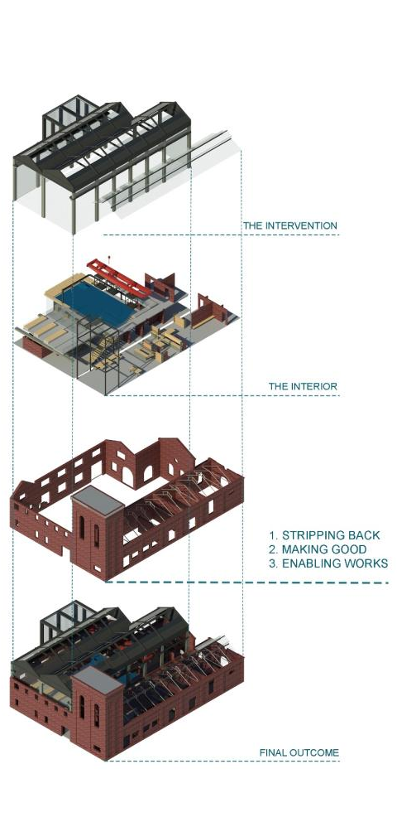
7. 5 FRED SCOTT’S ALTERATION STRATEGY
Figure 53: Axonometric diagram showing proposed process OF INTERVENTION (Rabij, 2021)

Fred Scott comments that alteration is an activity which can extend the life of an existing structure and not losing on its value at the same time (Scott, 2008, 24). Demolition may be exchanged to alteration so as to expand existing building’s life (Scott, 2008, 38). Intervention is also an act of alteration which allows to hold on to the existing and keep it in use (Scott, 2008, 23-24). The undertaking of intervention is quite demanding processes. It requires loads of answers regarding to the life of the existing fabric and also, its surroundings. Meaning the existing should be studied and understood in order to set the most suitable alteration strategy (Scott, 2008, 187).
The building and its history together with the site have been studied in “The unused St Andrews Dock “ chapter. The current state of the existing has been analysed while on the visit to the site and demonstrated within the “Building Analysis “ sub-chapter. A detailed model has also been made in order to understand better the existing structure and its current state throughout the 3D form. All of this allowed to see clearly which areas are damaged and need to be taken care of.
Once that was completed, the process of alteration to be finally planned in detail. As stated in “Potential Strategy” chapter the building will be dealt with using Fred Scott’s alteration strategy which has been briefly explained within the chapter. Therefore, this section will focus on expanding the strategy and discussing it more in depth.

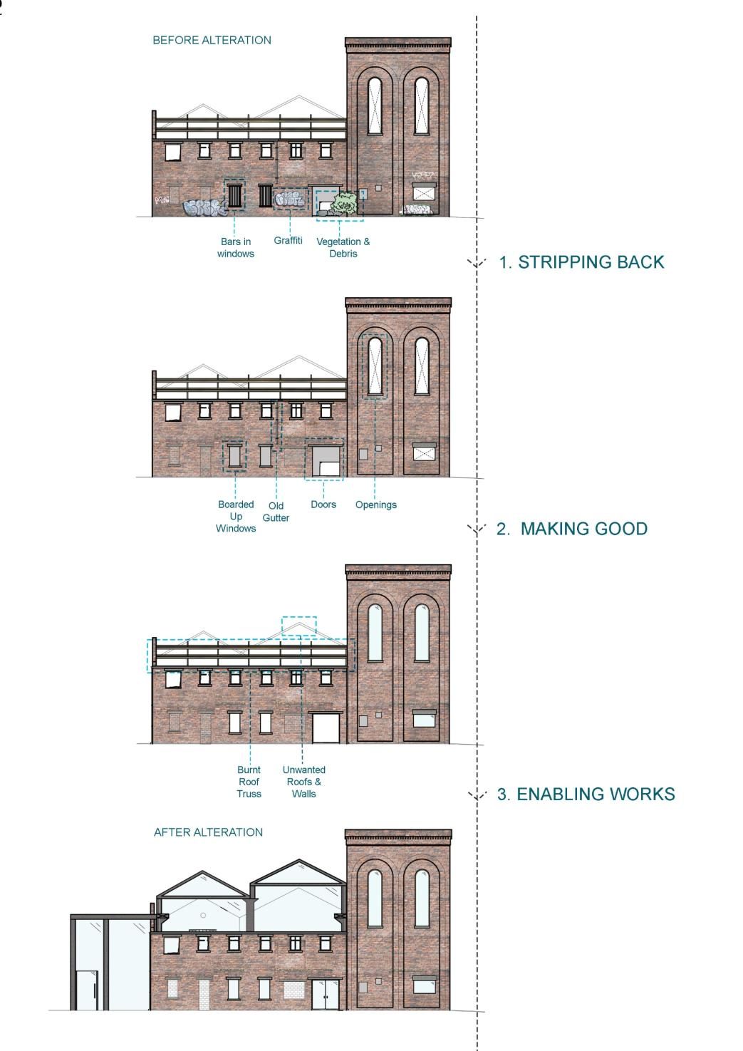

Figure54: Stages of Alteration diagram – North Elevation 1:300 (Rabij, 2021)
According to Scott there are three stages to alteration…

1. STRIPPING BACK

2. MAKING GOOD

3. ENABLING WORKS

This strategy is going to be used as a base to alter the old Hydraulic Tower and Pumphouse. How it is going to be approached is an individual matter which depends on its past, presence and the future plans. Figure 54 demonstrates a diagram of the steps for the planned alteration which are explained below:
1. Firstly, the building will be stripped back to its original state. Meaning that all the not invasive work will be carried out. The fabric will be cleaned from any rotting fabric, old peeling off paint and especially the graffiti. The unwanted vegetation and any debris will be taken care off. Any addition such as bars in the windows will be take out. This procedure will not guarantee that the building will go back to its original state.
2. The restorative, replacement and repair work will happen at this stage. Anything old which is changed to new is labelled as restoration (Scott, 2018). The burnt or boarded windows or doors will be replaced with new ones. Missing windows or doors will be installed. Any unsafe elements will be made safe or removed if necessary. Any damaged fabric such as cracks in the brick work or holes will be repaired. However, the repair work will not try to imitate the original fabric through the use of old fabric remains, but new materials will apply.
3. The final stage focuses on enabling the intervention to come to life. All the elements which do not allow the alteration to begin will be removed. Referring to Brooker (2021) as you put something in a building you can as well take something away. Adding is as important as subtracting. In this case, three of the walls from adjoined workshops will be demolished. As well as the unsafe, roof tops and floor which is in a critical condition. This process created a space for the new structure. The intervention will be inserted into the shell of the ruins and extend beyond it. The insertion will be touching the original structure in order to act like a frame which supports this delicate structure.

GRADE TWO LISTED HYDRAULIC TOWER AND PUMPHOUSE
The analyse of the building revealed that the Grade 2 listed Hydraulic Tower and Pumphouse is in a good condition. Therefore, the decision to keep it as it has been made. As there is no roof top, the metal roof truss will be enclosed within a glass structure which resembles the old shape of the original roof.

ADJOINED WORKSHOPS
However, the adjoined workshops are in an unsafe state therefore the alteration process will be mostly proceeded on them. This is where the intervention will come to life.

This strategy procedure will not guarantee that the building will go back to its original state. The reasoning for that is that it is difficult rather impossible to guess how the existing looked originally. The work of the former craftsman could’ve been altered in the past (Scott, 2008, 187). Within this case clear traces of previous alteration works such as changed window or door positioning has been noticed.

7. 5 SPATIAL PLANNING AND CIRCULATION

SPATIAL PLANNING
A structural grid of the existing has been used to guide the new structure. As we can see on figure 49, the new column alignment is parallel to the old positioning of the brick pilasters. The positioning of the columns was not random. It was purposely made I that way, as so the new columns seem like are running along with the existing ones (see Figure 55 for reference) This approach allowed creation of relationship between old and new. Although these are two separate structures, they became a whole because of this process.
The free floor plan has been created by using free columns instead of load- bearing walls like it has been done within Villa Savoye. This approach allows to easy forming of partitions and their change (Stinga). This method has introduced multiple spatial planning options which will be serving in the future as well without causing changes to the structural grid.
The language of using structural grid as a guidance for spatial planning have been introduced within this design as it has been done within the Higgins Hall and Villa Savoye. The grid was used to help decide on the space partitioning. Some spaces and elements such as pool and changing rooms have been aligned with the grid or the columns themselves. The purpose of this was to again create a relationship with the existing but this time throughout the interior. This procedure helped to guide the first floor as well.

CIRCULATION
All of the door openings and windows will be left in the same place and used again for the purpose of this project. Except of the ones located on the elements to be demolished. The old circulation is limited to the inside journey within individual the buildings, as they were not open to each other. However, demolishing the walls from adjoining workshop will allow a free journey around the space which will change the circulation dramatically. Bricked-out door from the Grade two Hydraulic Tower and Pumphouse will be reused again. This will allow an easy access to the new structure without the need to go around the building.

“An altered building is something that somebody maybe before you have worked on and somebody after you will work on it. So, an altered building is something that is continuously in process.”
(Scott, 2018)
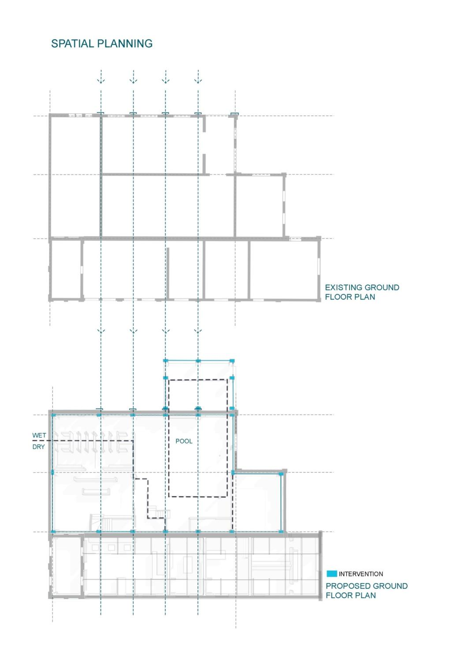
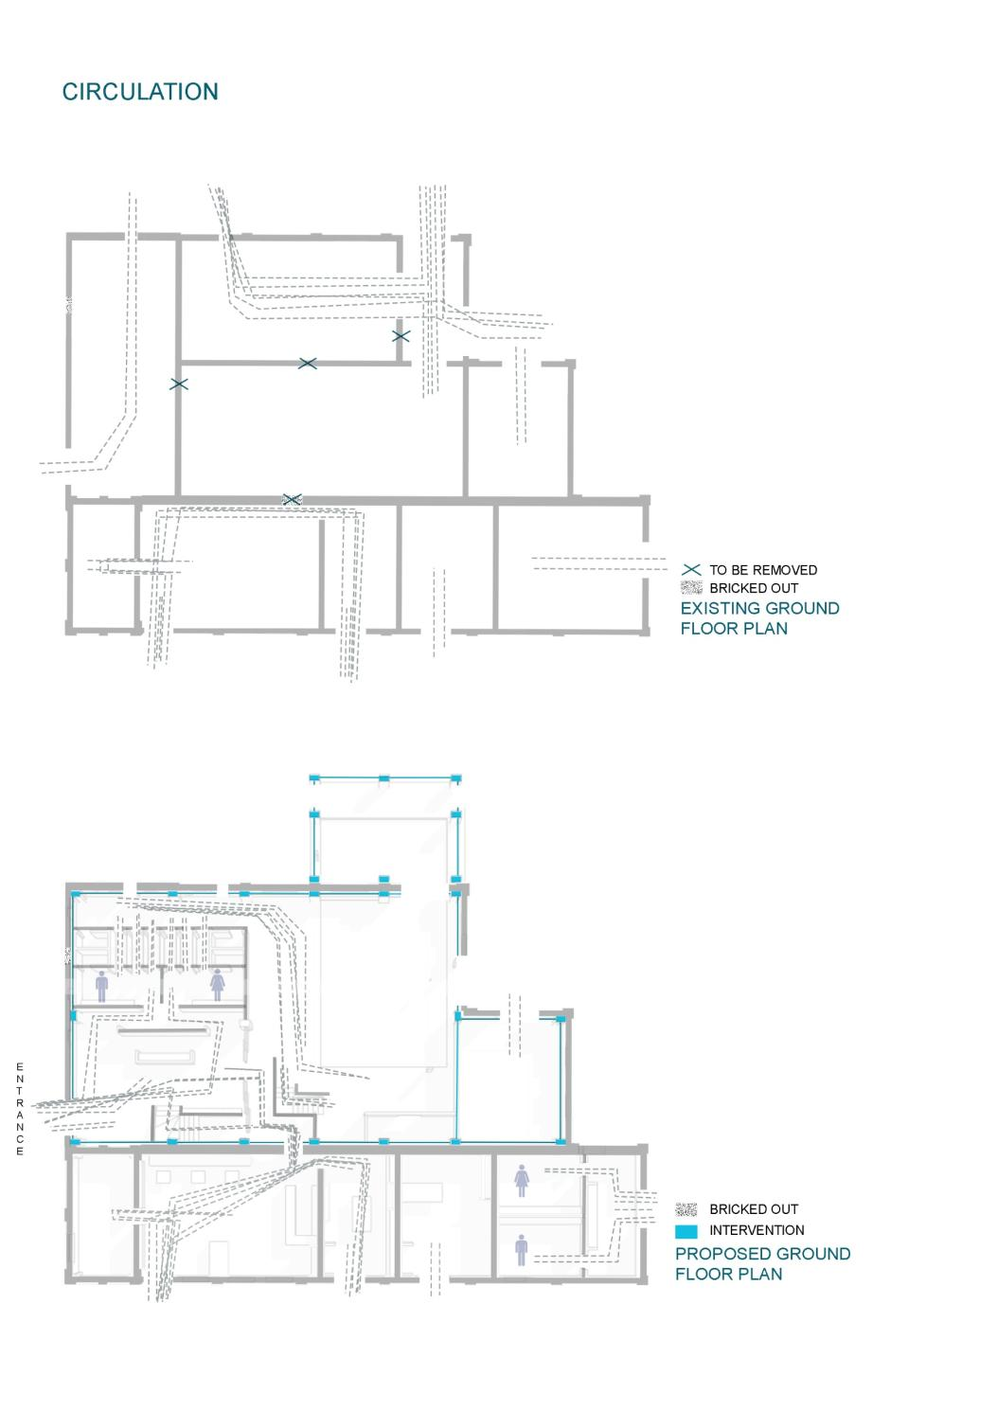

Figure 55: SPATIAL PLANNING AND CIRCULATION DIAGRAMS - FLOOR PLANS 1:300

7.6 CONCLUSION

The chapter has covered the strategy and application process planned for the Hydraulic Tower and Pumphouse. The thought process behind the design decisions and any influential precedents has been identified in order to support the final decisions. The conceptual approach has been demonstrated throughout diagrams at the beginning of the chapter and then demonstrated more in depth throughout conceptual images. The conceptual language was based on:
▪ Combining old with new
▪ Connecting past with presence
▪ Creating a narrative with the space
This strategy was created based on the findings from previous chapters that allowed to create a personalised, individual strategy for chosen building.
Also, within this chapter the initial plan of using Fred Scott’s strategy for alteration have been explained more in detail. The strategy has been studied and analysed throughout conceptual diagrams which have explained how it is going to be applied within the old Hydraulic Tower and Pumphouse.
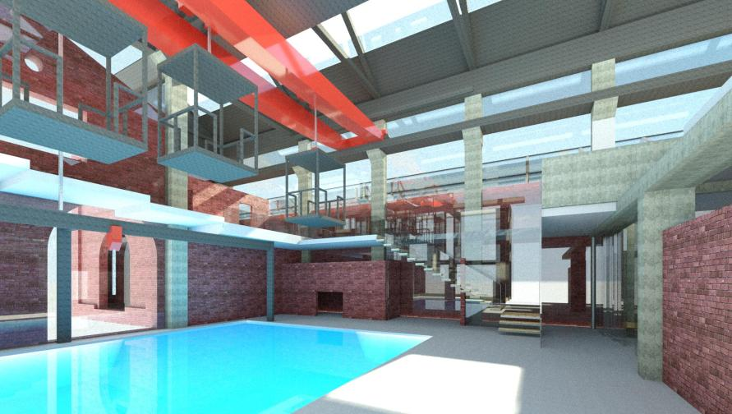
Figure 56: interior Visual of final design ( Rabij, 2021)

0.8 REFLECTIVE PRACTICE

8.1 INTRODUCTION
The following chapter will discuss and also critique my research and design process during the project. It will include a personal reflection on my work, myself, and the final outcomes. Analysing the stages I have been through in order to complete the project. The steps from the very start until the point I am at right now. Comments will be made on the challenges I have faced and how I have overcome them. Looking back at the project will help to see how my own work have developed and have an insight of how successful it has been. Also, it will help to see areas of the project which are strong and others which needs more development. A further action plan will be also introduced to help me complete the project successfully until the end.
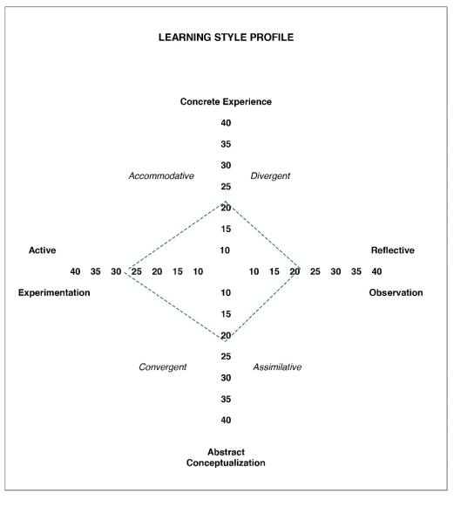
Additionally, during the project a had a chance to explore of what type of learner I am using Kolb’s learning inventory.

Figure 57: learner inventory (Kolb, 1984) individualised by (Rabij, 2021)

The created diagram (Figure 56) showed that my dominant learning style is Active Experimentation which has convergent and accommodative characteristics. Demonstrating that I focus more on the practical aspects, problem solving and making decisions. Having a preference of accomplishing task and being productive. Putting emphasis on doing more rather than observing. I don’t really know how to reflect on this because I don’t fully agree with this theory (Kolb, 1984).
Within my learning I put observing first, treating it like a base for my learning. I feel like for this characteristic, Reflective Observation relates to my learning style better. Where I focus more on understanding, observing, and describing particular situations or matters. Putting reflection and understanding before practicality (Kolb, 1984). This kind of learning style may be beneficial as before completing a task I will have a good understanding of what I am dealing with and why I am doing it. On the other hand, it means that I produce work which is less practical. Perhaps suggesting that I put emphasis on quantity rather than quality. Simply meaning that I may be writing and describing a lot, but it’s done chaotically. Instead, I might try to write less but be clearer about what I want to tell through my writing.
The other characteristic of Active Experimentation learning style is looking for what work rather than what is absolute truth. Discarding plans or theories when I feel like they don’t fit the facts. (Kolb, 1984) I can totally agree with this characteristic. Sometimes, I find myself undermining some theories which I feel like are truth but not completely. I try to find my own answers and see if a particular theory can be perhaps broken into different types, so it covers all the facts. This can also lead me to a confusion sometimes and slowly move me away from what i was trying to find. In this case I can simply keep checking up on what I’m doing and reminding myself what my goal is. This will help me to avoid finding myself in a position where i wasted my time doing something which doesn’t even make sense.
The above findings not only helped me to explore what type of learner I might be but what are the benefits and negatives of the particular learning style. It was helpful as I could see what areas I need to improve in order to make my work better.

8. 2 FORMING A RESEARCH PROBLEM

The project required choosing a building which I would be working with for the whole duration of the project. The task was not easy as not many of the primarily chosen buildings had much information about them. The building had to tell something about it and include all the information needed to start the work on it such as existing plans or sections.
During the search for a ‘perfect’ building, I have realised that all I have been looking at were old, abandoned buildings. These have always intrigued me as I found them mysterious. Thinking about why they are abandoned, what is their history and most importantly why nobody does anything about them. Derelict buildings formed many questions and were engaging my imagination. These were making me visualise how they have looked before and how I could re design them. I also found their decay beautiful.
After a while I questioned myself, if I like them so much why I don’t link my research problem with it. And this is where my journey with derelict industrial buildings have started. The problem of abandoned buildings became the topic I wanted to go forward with. In order to get familiar with it and why the fact that these buildings are derelict may be problematic in many different ways, the chapter “ Design problem” have been created.

8. 3 FORMING A RESEARCH QUESTION

In order to reassure myself if the choice of topic was something, I would like to base my project on I decided to read ‘On Altering Architecture’ by Fred Scott. The book appealed to me as it included working with the existing, something that I am interested in. Rather than seeing a building go to waste, although its decay is beautiful, I prefer the reusing option.
Within the book Scott was examining the alteration process as a substitution for demolition. Scott (2008, 38) stated that alteration may be the key to keep existing architecture in use and still remain important to heritage. The book gave me an insight of different point of views of other architects regarding the future of an abandoned existing building. The opinions were divided; Ruskin and Morris were against Restoration where Viollet-le-Duc thought is not a bad idea to alter a building. Price wanted obsolete buildings to be demolished as their functionality has come to end. Pevsner wanted to replace Restoration with Protection from the start to avoid any restoration work. Fred Scott was in the middle of it all with the proposal for Alteration strategy (Scott, 2008, 26-94).
While reading the book, I have come to conclusion that the future of abandoned buildings is actually unknown as there are many different opinions about it. This intrigued me to dig even deeper into the topic looking for an answer to the question ‘What might be the future of abandoned industrial buildings?’. The reason for that was to discover different ways an abandoned building may be approached. What kind of future there might be for unwanted buildings? Therefore, the literature review was the next step to finding the answer.

8.4 THE INFLUENCE OF LITERTURE REVIEW

Literature Review played a huge role within the project. “On Altering Architecture” was the starting point which made me want to discover even more about the topic. The initial motive was to find out even more about what others think about the future of obsolete buildings. How others see them and what they consider as appropriate approach towards them.
The research was successful as it gave me plenty of insight on the possible future of unwanted existing buildings. I found out that the future of the unused buildings depends on many factors and it is an individual matter. The books were carefully chosen in order to provide me with variety of information which I could analyse and use to form my own opinion. I have learnt something different from each of the books…

CURATED DECAY
A book by Caitlin DeSilvey where the author addresses the matter of natural decay. Pointing out that building conservation may come in form of the decay. She states that as it is natural process, we should not be affair of it. The built heritage can be protected and kept by simply letting the natural process of decay take over. DeSilvey states that objects not only create value through their conservation but also through the decay (UPress, 2017).
I also think that the beauty of unused buildings lies within its decay and that the decay does not make building less significant. Although, I also think that there is a difference between letting building naturally decay and letting it decay while being abused by the humans. Within the book, she mentioned a grade two listed chimney which is being kept preserving the English Heritage, however no work is being done to save it or keep it safe (DeSilvey, 2017, 2-3) Proving that a building may be important to cultural heritage and kept as a memorial, but it doesn’t not save it from the harm of humans. Therefore, I think the natural decay will be always disrupted if there is no actual protection of the existing in order to let it decay in peace. The question aroused who will be willing to keep a building safe without making any conservative work on it just to let it decay? The answer to this question is unknown and it may seem absurd to protect an object just to let it naturally deteriorate. Therefore, came to conclusion that if the building is exposed to the potential harm from humans, the conservation in the form of natural decay is pointless.

BUILDING REUSE
After reading “Curated Decay”, I wanted to something more than letting once significant to community building naturally decay. I went into the direction of recycling. “ Building Reuse”, appealed to me more as it was based on working with the existing. The author argued that demolition should be the last option in the new development. Stating that once object it’s gone it won’t come back. (Merlino, 2018, 4) This is a fact not an opinion which means that if we let building to be demolished, its history will disappear together with it. This is something I believe in that we should choose to keep the buildings not only for the sake of keeping is as these are significant to the cultural heritage but also reuse them, so they can serve a purpose again.
Merlino also wants to serve the planet whilst reusing the building and saving the heritage. The author addressed the negative issues regarding to making new constructions rather than working with what’s already there. This approach only proved to me that reuse of a building has many benefits for the community, heritage, and the planet as well.

RESCUE AND REUSE
As the option of the building reuse appealed, I decided to find out more about the topic. I found “ Rescue and Reuse” by Waterson and Morrison which is also dedicated to the reuse of the existing. The book only reassured me of how beneficial the reuse can be. What I learnt from authors is that reviving process of a building won’t make it less significant. What more the process will add to the communities while preserving the architectural heritage. The other thing which caught my attention was that the authors presented the negatives of not reviving a building as well. From that I learnt that the abandonment of old historic buildings will make the narrative and the character of the site disappear within the time. Which might be problematic because we as a community when listing the buildings, we aim to save the history rather than abandon it.
To briefly conclude, the literature review helped me to decide what direction I would like to go into. Each of the authors had a valid option on the matter and explained their thought process. However, it did not mean that what they think is right thing to do will be right to me as well. And therefore, the sources helped me to form my own opinion based on these findings. An opinion which tells me that adaptive reuse is the most suitable approach towards abandoned buildings. The reason for that is because not only the building and its heritage will be kept but it will serve a purpose as well.

8.5 FINDING A SITE AND A BUILDING
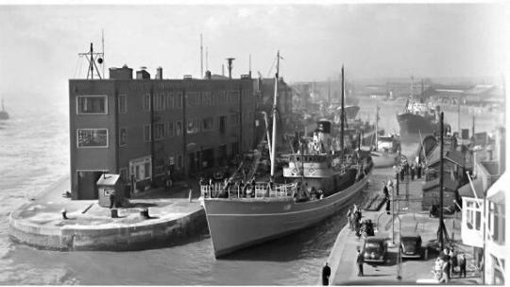

Figure 58: st Andrews dock (Scrivener)

8.5.1 ST ANDREWS DOCK
St Andrews dock has been found randomly while looking for an abandoned building for my project. The site aroused many questions mostly regarding why such a plenty of land is being unused and what the place used to be ? Finding it was like a jackpot for me. It came out that the site is perfect for my project as it has a rich history and has a big potential for the future.
The main benefits of the site are:
▪ History
▪ Location
▪ Plenty of unused land
▪ Surroundings
St Andrews dock used to be a very busy place and a heart of the fishing industry in Hull. The site has a background related to the fishing and holds a big grief from triple trawler tragedy which happened in 1968 (Hullwebs, 2004). Now, it is a conservational area with the remains of the old times in form of the buildings. The area is abandoned, and no work is being done on it to bring it back to use. This made me decide to work with it as I could use one of its buildings as a beginning of the St Andrews Dock regeneration. There is plenty of land which can be used, beautiful scenery, view over the river, surrounding shopping and industrial sites and a great story that needs to be told. By reusing the site, I could protect the heritage and highlight the history related to this place, which needs to be remembered rather than forgotten.

8.5.2 VISIT TO THE SITE AND ACCESS
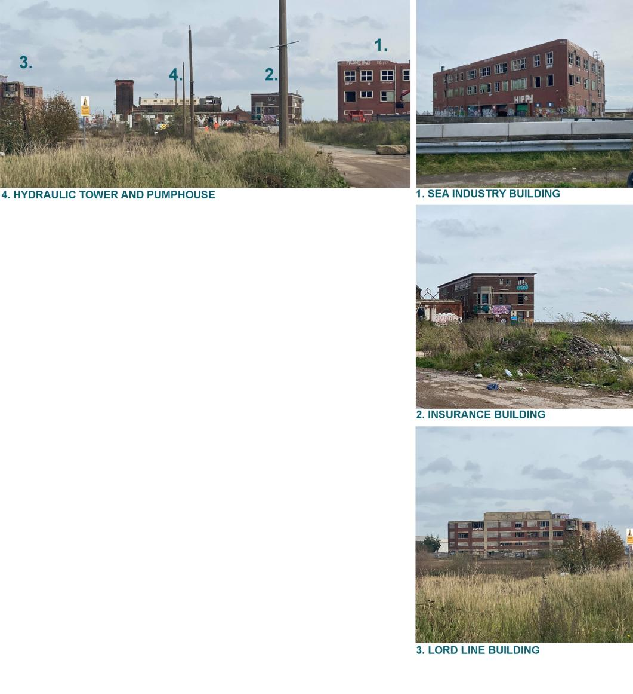

One of the reasons why the site was a jackpot for me is its location. The site is located in Hull which is not far away from the place I live in. This allowed me to travel and visit the site myself. Even during the pandemic, I treated the site visit as a requirement for my project. Luckily enough, even in the current situation with Covid- 19, I had an opportunity to still come and visit.
The visit of the site was beneficial as I could understand it better and get a feeling of its character, scale, and its surroundings. Having my own photos allowed me to capture what I thought me be important and useful for the project. Things such as surroundings, buildings, land, materials, and details related to the chosen building. Some of the information which I would not be able to find from the internet.
During the visit, I could also get familiar with my chosen building and create a building survey based on my findings. This was an important part of my project which helped me to understand my chosen building. The building was nothing like I have imagined looking at the pictures found online. The actual scale of it surprised me and made me realise what space exactly I am going to be dealing with.
I was not able to take pictures of all the things I wanted, especially inside of the building as there was limited access due to the condition of the building and locked gates. However, I was working my way around it trying to use other openings which allowed me to see more and seizure it on the photos.
Figure 59: collection of Photos from St Andrews Dock (Rabij, 2020)

The only downside of the site is its access as it was limited due to the site location. The St Andrews area is quite isolated site situated between main road and the Humber river. On my visit I found it hard to find the site and its entrance. I have been going around to find the public access, however most of the surroundings were fenced as there were industrial areas with no access to unauthorised personnel. Additionally, the main road which was full of cars didn’t make the job easier as there were only a few crossings leading to the other side. Finally, after a long time of exploring the unknow streets of Hull, I have managed to find an entrance. As we can see on Figure 60, the access to the site is quite hidden and limited. Walking from well-developed St Andrews Quay shopping area into the abandoned site, which was right next to it, felt like stepping into a different dimension. It seemed like the site got stuck in its 80s. There is a great contrast between the modernised shopping area and the old dock site.

Figure 60: Access to disused st Andrews dock (Rabij, 2021)

What I think could improve the site access is installing a jetty as the facilities allow me to do that. The boat access will open the site to its surroundings more and allow easier access as well. Rather than travelling by a car and struggling to then find the site, people could access it from the heart of the city where Hull waterside and marina are located. This approach would also create a tighter relationship between the existing land and new work. Additionally, the jetty can be used for training purposes.
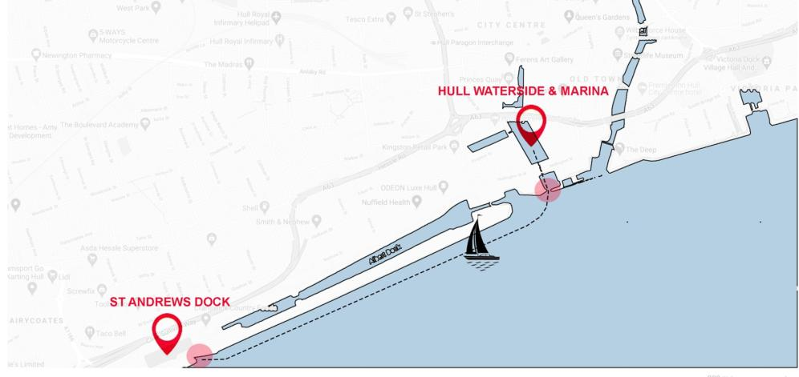
Figure 61: Boat access from hull waterside to st Andrews dock (Rabij, 2021)

8.5.3 HYDRAULIC TOWER AND PUMPHOUSE
As mentioned before the task of finding an appropriate building was not easy. What I was particularly looking for was:

▪ Industrial
▪ Derelict
▪ Medium scale, not too small but not too large
▪ Historical background and a story to tell
▪ Interesting location

The chosen site consists of a couple abandoned buildings. However, the Hydraulic Tower and Pumphouse appealed to me as its form was different from the other buildings. It is a classical pumphouse with around 3 storey tall tower, different levelled adjoined warehouses, and the beautiful remains of the roof at the west side, therefore I found it the most interesting. It is also an industrial building, the type of building I was looking for. The reasoning behind that is that this type of construction usually consists of a relatively large open space which would give me loads of freedom when designing (Cantell, 2014) Additionally, buildings from industrial era have a story to tell based on their previous purpose and changes.
I think that the choice of the old Hydraulic Tower and Pumphouse was an appropriate selection to which my project will benefits from. Its location is attractive due to the Humber river and its industrial surroundings mixed with modernised shopping centre. The size of it is not overwhelming comparing to the Lord Line building to its north side. Finally, the building has an interesting historic background of providing water to the whole dock and has been through a lot since the abandonment.
Of course, there was a time when I had doubts about the choice. While visiting the site I realised that the building is much larger than I thought which made me rethink if I can handle such a space. I was also worried about the condition of the adjoined workshops as they were in a despair state. At the end I have accepted the challenge and have no regrets about it.
While having a brief idea what I would like to transform the building into, I ironically realised that the space may actually too small for this project. The new challenge came based on working with small spaces which took plenty of thought process in order to

make the space serve its purpose but not be cramped at the same time. Loads of experimentation with the spatial planning and solution ideas resulted in satisfying outcome.
If it comes to the state of the building, I went looking for help to Fred Scott’s book. The Scott’s strategy for alteration helped me to understand the steps I need to take in order to work with the existing. I had to understand the structure in order to work with it, therefore a detailed analyse of the building has been made. This helped me to see which areas are dangerous, needs repair or replacement and restoration.

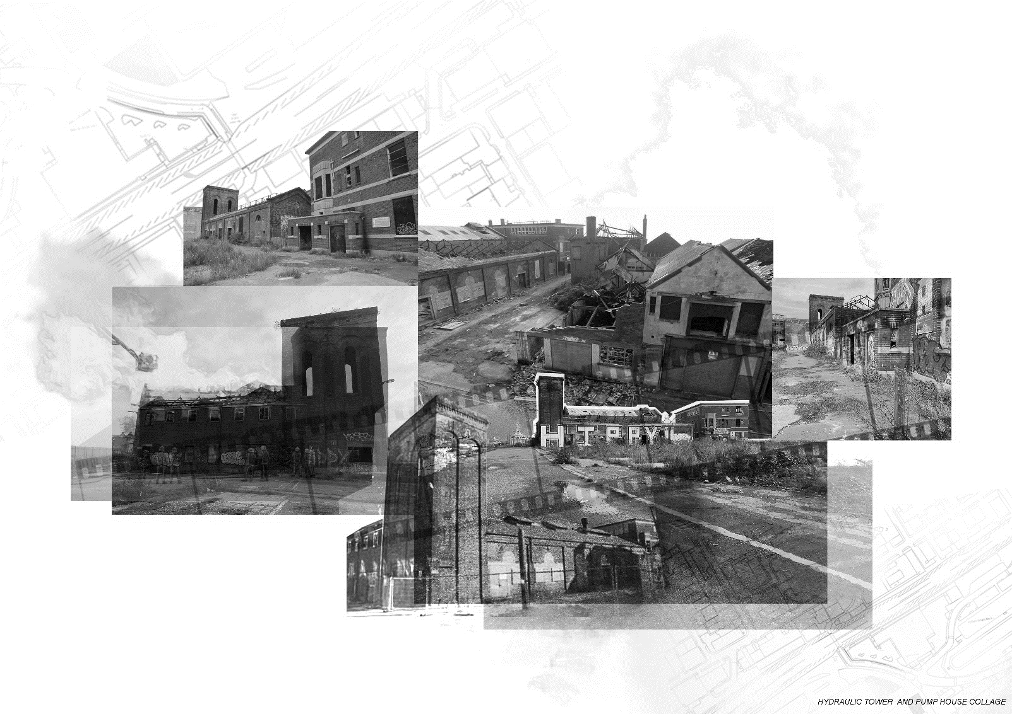
Figure 62: A timeline collage of hydraulic tower and pumphouse (Rabij, 2020) images come from variety of sources

8.6 THE DEVELOPMENT OF INITIAL DESIGN IDEA

Coming up with a new purpose for the old Hydraulic Tower and Pumphouse was the most challenging part for me within this project. In order for it to be successful I had to create a strong design which would cherish the history and not violate the existing fabric.
INITIAL IDEA:
The initial idea for this project was multi - purpose facility consisting of a fish restaurant, small gallery space and a health and safety training centre dedicated to fishing. The initial plan was also to keep the old circulation and layout. The choice for the new purpose was no random, there was a reason behind every space.

▪ HISTORIC GALLERY
Through historic gallery, I wanted to celebrate and remember the history of the site. The aim was to take its users back to the past, within the now conservational site and show how it has changed throughout the time. The gallery theme would then be carried out through all of the spaces in form of pictures or artefacts.
▪ FISH RESTAURANT
Fish restaurant was planned to be a place where the users can connect with the past through smell and taste. The site used to be a home for fishing industry where many kinds of fishes were available. The kitchen would get their products from local fisheries and wholesales in order to produce fresh seafood-based dishes like back in the old days.
▪ TRAINING CENTRE
Training Centre for fisher women and men was about to take the most space. The idea behind that was improve health and safety of fisher women and men and reduce the reduce the risk of a tragedy like the ‘triple trawler disaster’ happening again. The location would be beneficial as there are 2 other docks next to the site which are still in use and could’ve collaborated together with the project.

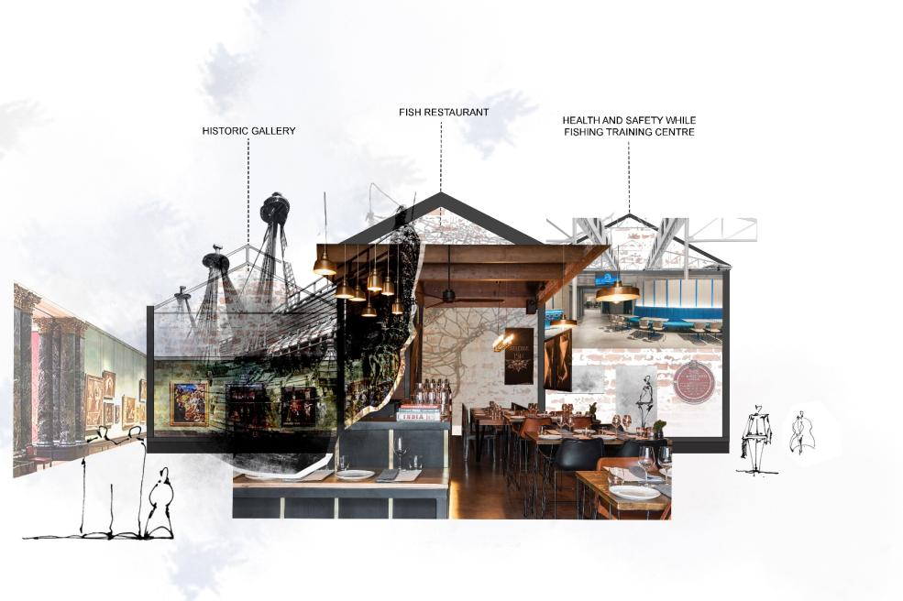

Figure 63: conceptual collage of the initial idea (Rabij, 2020)

At the moment it seemed like a good idea, however I wasn’t fully satisfied with it. I wanted to create something less obvious and more unique for the area, as there are plenty restaurants nearby and gallery space seemed like too obvious way to cherish the history. At the end, I decided to only focus on the Health and Safety Centre and develop the idea further in order to create something special and new for the area. More behind the new idea have been described within the “Strategy and Application” section.

FINAL IDEA:
The success of the project lies within the connection between past and presence and working with the existing fabric. The improved concept allowed me to create a link between old and new and create a narrative within the space, which I think is an important feature of any reused buildings.
On the other hand, what is weakening the project is the not fully developed idea of mixing old with new. I think that the relationship between new and old needs to be developed, as it’s not very clear what my intentions are. There needs to be more obvious relationship between existing and new intervention including the connection with the site, therefore I need to expand on how the intervention will work together with the existing. Clearer contrast between old and new would also make my project stronger and this could be done by rethinking the material or perhaps form choices.

Figure 64: a render of short section depicting the new idea (Rabij, 2020)

8.7 THE INFLUENCE OF PRECEDENTS STUDIES

Within the research into precedent studies I focused more on the pumphouse type of a building. This allowed me to see how the type of building I am working with can be approached in different ways. On the other hand, this move narrowed down my research problem from derelict industrial buildings to derelict pumphouses. Applying this strategy allowed me to focus on one type of building which was more relevant to my project. Additionally, there were a few historic examples included within the chapter to explore different design strategies and applications.
I have learnt something new from every single precedent. To conclude briefly, the old pumphouses in Nottingham demonstrated how a building can be approached using Fred Scott’s alteration strategy. What more, the project made me rethink the decision regarding keeping the existing spatial layout. It also gave me the courage to compromise and remove some of the walls in order to get the most of my project and complete it successfully. Georgian pumphouses in Misterton revealed some of the issues which needs to be considered when restoring a historic building and dealing with English Heritage. Spatial planning techniques and design solution ideas were inspired by Schroder House. The architect’s methods taught me how to create an open space which can be divided into private any time. The converted pumphouse in Bochum, presented how installing a simple box within a space can create a division and privacy without touching the existing fabric. The process of this strategy has also show how internal walls which aren’t going all the way to the celling create more of an open space. This method was applied within the Hydraulic Tower and Pumphouse where the internal walls aren’t going all the way up to the celling and none of them are touching the existing fabric.
There were precedents which influenced my design process the most and these were:

▪ PRATT INSTITUTE
Pratt Institute was a very good example for me on how to create a narrative within the space. How to connect the dots in order to create relationship between the old and new. The interesting façade and layout of the institution comes with a narrative and this is what inspired me the most. The thinking process behind the design and its application resulted in a space which is not random but has something to say.
The architects’ design intentions have influenced my thinking, therefore I tried to use their strategy within my proposal. Comparing to first year where I was randomly designing space just to make it functional, this time I was trying to have reason behind every design decision in order to create a narrative. Let’s take the new intervention column alignment as an example. Their layout was not random as it was reflecting the layout of the existing pilasters. This approach not only created a relationship between old and new but created a system which was carried through and guided the new work.

▪ VILLA SAVOYE
Villa Savoye influenced mainly the new layout of the space. I have created a free floor plan using one of the points of new architecture by Le Corbusier. This strategy worked for me as my goal was to create an open space which would be flexible as well. Having free floor plan created many spatial planning options which can be applied now or in the past as well without affecting the new and existing structure.

▪ DEVOTE STUDIO
The approach towards existing in within the Devote Studio by Haworth Tompkins architects finalised my decision regarding how I would like to handle the old pumphouse. I must admit that I have been struggling to decide how I am going to handle the existing fabric which I was dealing with. Within this project the architects decided to leave the existing untouched. This resulted in having a new facility which highlights the beauty of the existing ruins. That attitude made me decide to leave the grade two listed old Hydraulic Tower and Pumphouse almost untouched, with only minor works being done on it such as the removal of graffiti. Of course, to make the space function any necessary repair work will be carried and new glass roof top which will allow the exposure of the beautiful existing truss.

8.8 CONCLUSION

To sum up this chapter reflects on my journey and progress throughout this project. It analyses the strengths and weakness of the project. Most importantly, it reflects my own weaknesses and strengths as a designer. Throughout the chapter I have been analysing which parts of project are strong and shouldn’t be changed. The reflection also gave me an opportunity to step back and reflect on the project. Being critical now about my own work will help me to realise what I might be doing wrong before it’s too close to the deadline.
Additionality, throughout learning inventory I discovered what type of learner I am. As a Reflective Observer, it realised that I focus more on observing and reflecting rather than being practical. After getting to know that I have actually realised that it is the case which may not only impact the project positively but negatively as well. This indicated that I needed to do something about it. I have experienced the negatives of this type of learner while writing this exegesis, therefore I begun producing less work which was more practical and better quality.
The outlined findings within this chapter will help me to take a step forward in my project. I will be able to overcome my weakness and improve my work knowing which areas I need to develop more. Time management and organisation are very important when completing any project. In order to improve my work and be more efficient I have created a further action plan (see Figure 62) which starts with the last module “ Technical Design and Communication “. The action plan demonstrates what needs to be done in a dedicated timeframe to get most of the time and complete the project on time.

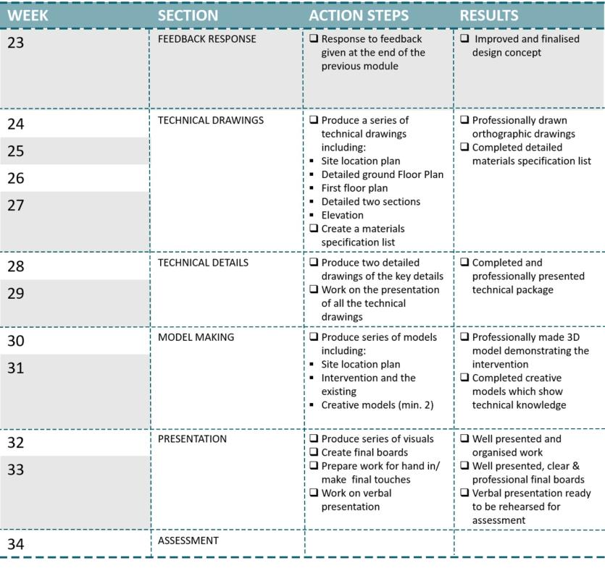
Figure 65: Action plan (Rabij, 2021)

0.9 Conclusion

To conclude “Abandoned History “has addressed the issues regarding to the abandonment of historic industrial buildings within the UK and their unknown fate. The document outlines the key aspects of the matter and provides potential solutions. The information collected regarding to the design problem formed a question which then was leading the design exegesis.

What might be the future of abandoned industrial buildings?

The paper aimed to find an answer to the following question. Different literature and other sources have been analysed in order to find some sort of clues. The design problem was then narrowed down to derelict pumphouses and their future. Although the research has been narrowed down, I cannot state that the paper managed to find the answer. What more I cannot assure that such an answer exists. The gathered information identifies only potential solutions to the problem; however, it seems like there is no one correct answer to the question.
There are many different types of buildings and each of them is different, it may be impossible to find a generic solution relating to all of them. There are many factors that may impact on the building’s future. I cannot assume what is right or wrong nor use one building as an example of the ‘perfect solution’. Literature review allowed to understand different point of views regarding to the abandoned historical buildings and their future. It helped to form my own opinion which then was used to guide the project.
The Design Proposal intends to suggest a solution rather than state what is right to do. Design decisions were informed by findings and their analyse. The knowledge gained led to a decision that reusing the old Hydraulic Tower and Pumphouse will be the best solution to save the existing and the related to its history. It is important for me to highlight that reuse is one of the solutions but not the only one. This option allowed to bring the building back to life and give it a new purpose which will serve not only in the presence but in the future as well.
Working with the original fabric depicted the potential of old industrial buildings. The proposal may be used as a starting point of regenerating such a beautiful site as St Andrews Dock is.

To finalise, the document demonstrates that there is definitively a future for the abandoned industrial buildings. It may be in form of restoration, conservation, decaying and even demolition. However, what the future may look like of a particular building is an individual matter which depends on many factors such as its condition or heritage significance.

10. REFERENCE LIST:

Abruzzese, R. (2013) Fire-ravaged Pratt will pull through. Brooklyn: Brooklyn Daily Eagle. Available from https://brooklyneagle.com/articles/2013/02/18/fire-ravaged-pratt-will-pull-through/ [ accessed [03 February 2021]
AR Editors (2006) Pratt Institute Art School Extension, New York by Steven Holl Architects. London: Architectural Review. Available from https://www.architectural-review.com/buildings/pratt-institute-art-school-extension-new-york-by-steven-holl-architects [accessed 04 February 2021]
Arch4444 (Undated) Villa Savoye, Poissy-sur-Seine, France (1930).Arch4444. Available from https://www.ou.edu/class/arch4443/ConArchModArchAlmostNothing/ConArchModArchAlmostNot.htm [accessed 07 February 2021]
Australian Government (2004) Preserving our past, building or future. Canberra: Australian Government- Department of the Environment and Heritage. Available from https://www.environment.gov.au/system/files/resources/3845f27a-ad2c-4d40-8827-18c643c7adcd/files/adaptive-reuse.pdf [accessed 05 December 2020]
Babington, K. (2017) Comments from Historic England Arrangements for handling Heritage Applications Direction 2015. Hull: Hull City Council. Available from https://www.hullcc.gov.uk/padcbc/publicaccess-live/files/691C0634D6C95D0D6429A49B1DAC7FD3/pdf/17_00774_LBC- COMMENTS_FROM_HISTORIC_ENGLAND-695064.pdf [accessed 24 October 2020]
Bianchini, R. (2019) Le Corbusier – Villa Savoye | part 2, architecture. Cremona: In exhibit. Available from https://www.inexhibit.com/case-studies/le-corbusier-villa-savoye-part-2-architecture/ [ accessed 07 February 2021]
Bintu, N. (2018) Rietveld schroder house [video]. Available from https://www.slideshare.net/NurjahanBintu/rietveld-schroder-house [accessed 19 February 2021]
Block, I. (2018) Stijn Poelstra photographs Mondrian-esque elements of the Rietveld Schröder House. London: Dezeen. Available from https://www.dezeen.com/2018/08/29/stijn-poelstra-photographs-mondrian-rietveld-schroder-house-architecture/ [ accessed 19 February 2021]
Boll, H. (2012) Pump House. Centreville: Archdaily. Available from https://www.archdaily.com/283917/pump-house-heinrich-boll-architect [accessed 24 February 2021]
Brooker, G. (2021) Emu-dia webinar series 02 : '50 words for reuse' [video]. Available from https://www.youtube.com/watch?v=abPPEsOfZ5Y [accessed 23 March 2021]
Weaver, M. (2001) Urban regeneration - the issue explained. London: The Guardian. Available from https://www.theguardian.com/society/2001/mar/19/regeneration.urbanregeneration1 [accessed 23 March 2021]
Campos, I. D. de, C. (2015) Rehabilitation of the [Portuguese] Traditional Heritage in conjugation with Steel Architecture. European Scientific Journal. Available from https://www.researchgate.net/profile/Ines-Campos-4/publication/318883259_Rehabilitation_of_the_Portuguese_Traditional_Heritage_in_conjugation_with_Steel_Architecture/links/598330ab0f7e9b2ac353f5c1/Rehabilitation-of-the-Portuguese-Traditional-Heritage-in-conjugation-with-Steel-Architecture.pdf [ accessed 10 March 2021]
Cantell, F.C. (2005) The Adaptive Reuse of Historic Industrial Buildings: Regulation Barriers, Best Practices and Case Studies. Blacksburg: Urbanisosevilla. Available from http://sig.urbanismosevilla.org/Sevilla.art/SevLab/r001US1_files/r001_US_1.pdf [ accessed 24 January 2021]
Cilento, K. (2010) Dovecote Studio / Haworth Tompkins. Centreville: Arch daily. Available from https://www.archdaily.com/89980/dovecote-studio-haworth-tompkins [accessed 18 February 2021]
Dell’Ovo, M., Bassani, S., Stefaninia, G., Oppio, A. (2020) Memories at risk. How to support decisions about abandoned industrial heritage regeneration. Valori e valutazioni, 25, 107-115. Available from https://siev.org/wp-content/uploads/2020/06/09_DELLOVO-et-al.pdf [accessed 27 November 2020]
Department of Environment and Heritage (2004). Adaptive Reuse. Canberra: Department of Environment and Heritage. Available from https://www.environment.gov.au/system/files/resources/3845f27a-ad2c-4d40-8827-18c643c7adcd/files/adaptive-reuse.pdf [accessed 28 November 2020]
DeSilvey, C. (2017) Curated Decay- Heritage Beyond Saving [ebook]. London: University of Minnesota Press. Available from https://ebookcentral-proquest-com.proxy.library.lincoln.ac.uk/lib/ulinc/reader.action?docID=4745550&query= [accessed 19 November 2020]
East Coast Maritime Training (Undated) Training for all Seafarers. Withernsea: ECMT. Available from http://www.eastcoastmaritimetraining.co.uk/index.php [accessed 08 November 2020]
ELG (2017) Heritage Statement. Hull: Hull City Council. Available from https://www.hullcc.gov.uk/padcbc/publicaccess-live/files/6D0D45444BC8DE654F893BC4125D06B0/pdf/19_00949_LBC-HERITAGE_STATEMENT-827696.pdf [ accessed 24 October 2020]
FARNET Support Unit (2018) Women employed in fisheries and aquaculture in the EU. Lyon: Euronews. Available from https://www.euronews.com/2019/09/13/the-invisible-women-of-europe-s-fishing-industry [accessed 13 November 2020]
Farrell, S. (2019) Plans in to bring historic dock buildings back into use. Manchester: Insider. Available from https://www.insidermedia.com/news/yorkshire/plans-in-to-bring-historic-dock-buildings-back-into-use [accessed 24 October 2020]
FE (2011) The old pumphouse Nottingham. Nottingham: Franklin Ellis Architects. Available from https://www.franklinellis.co.uk/blog/portfolio/the-old-pumphouse/ [ accessed 21 January 2021]
FE (2011) The restoration of old pumphouse in Nottingham. Nottingham. Nottingham: Franklin Ellis Architects. Available from https://www.franklinellis.co.uk/blog/portfolio/the-old-pumphouse/ [ accessed 21 January 2021]
Fresh (2019) St Andrews Dock Conservational Area. Hull: Fresh. Available from https://www.freshdesigninternational.com/work/st-andrews-dock [accessed 24 October 2020]
Gadd, D. (2020) Pub to pump via muddy Mother. Doncaster: Free Press. Available from https://www.doncasterfreepress.co.uk/lifestyle/outdoors/pub-pump-muddy-mother-2044447 [ accessed 27 January 2021]
Gatier, P.A. (2013) The Villa Savoye: A Manifesto for Modernity. Los Angeles: Getty. Available from https://www.getty.edu/conservation/publications_resources/public_programs/villa_savoye.html [accessed 07 February 2021]
Gordon, G. (2018) Pleasing all the people all the time. Epsom: Praxity. Available from https://www.praxity.com/insights/blogs/posts/2018/september/pleasing-all-the-people-all-the-time/ [accessed 24 February 2021]
Haworth Tompkins (2009) Dovecote Studio, 2009— the re-purposing of an industrial ruin on the coast. London: Haworth Tompkins. Available from https://www.haworthtompkins.com/work/dovecote-studio [accessed 18 February 2021]
Haworth Tompkins (2010) Dovecote studio by Haworth Tompkins. This paper. Available from http://cargocollective.com/thisispaper/Haworth-Tompkins-Dovecote-Studio [ accessed 18 February 2021]
Historic England (Undated) Hydraulic tower and pump house 50 metres south east of St Andrews Dock. Swindon: Historic England. Available from https://historicengland.org.uk/listing/the-list/list-entry/1197632 [ accessed 30 January 2021]
Heinrich Böll Architekt (2012) Pump House. Centreville: Archdaily. Available from https://www.archdaily.com/283917/pump-house-heinrich-boll-architect [accessed 24 February 2021]
Hull City Council (2019) Urban Conservation and Design- St Andrews Dock. Hull: Hull City Council. Available from http://www.hullcc.gov.uk/pls/portal/docs/PAGE/HOME/PLANNING/CONSERVATION/CONSERVATION%20AREAS/ST%20ANDREW'S%20DOCK%20CACA.PDF [ accessed 18 October 2020]
Hull Maritime Museum (Undated) Local Heroes: Hull's Trawlermen. My learning. Available from https://www.mylearning.org/stories/local-heroes-hulls-trawlermen/resources [accessed 18 October 2020]
Hullwebs (2004) Hullwebs history of hull- St. Andrews Dock. Hull: Hullwebs. Available from http://www.hullwebs.co.uk/content/l-20c/industry/fishing/heritage/st-andrews-dock.htm [accessed 03 December 2020]
Iris Consulting and Greenwich Maritime Institute (2010) Women in Fisheries Final Report. London: Iris Consulting and Greenwich Maritime Institute. Available from file:///C:/Users/wikto/Downloads/FC1302_9823_FRP.pdf [accessed 13 November 2020]
Jackson stops & Staff (Undated) The Pumphouse, Misterton, Nottinghamshire. Arundel: Jackson- Stops. Available from https://media.onthemarket.com/properties/685782/doc_0_1.pdf [accessed 27 January 2021]
Kerley, P. (2017) When the boat comes in. London: BBC. Available from https://www.bbc.co.uk/news/resources/idt-sh/fishing_when_the_boat_comes_in [accessed 13 November 2020]
Kolb, D. (1984) Experiential learning: Experience as the source of learning and development. Englewood Cliffs, NJ: Prentice- Hall.
Les Coulreus (2018) Le Corbusier´s five points of a new architecture. Zurich: Les Coulreus. Available from https://www.lescouleurs.ch/en/journal/posts/the-five-points-of-a-new-architecture/ [ accessed 07 February 2021]
Loures, L. (2008) Industrial Heritage: the past in the future of the city. Wseas transactions on environment and development, 4(8)1790-5079. Available from http://www.wseas.us/e-library/transactions/environment/2008/27696.pdf?fbclid=IwAR2LzC_2vm05Leu4lL2i7Hpv3npiyafV3TfEbzNgxEkU1c9bIS3176ZcXaY [accessed 27 November 2020]
Maggiora, M.V, (2019) Pratt Institute, Higgins Hall Insertion / Steven Holl Architects. Centreville: Archdaily. Available from https://www.archdaily.com/920948/pratt-institute-higgins-hall-insertion-steven-holl-architects [accessed 04 February 2021]
Mayer, T. and Boll, H. (Undated) Pumpenhaus Bochum - Umbau zum Besucherzentrum mit Gastronomie. Düsseldorf: Bauforum stahl. Available from https://bauforumstahl.de/bauprojekte/pumpenhaus-bochum-umbau-zum-besucherzentrum-mit-gastronomie/ [accessed 24 February 2021]
Merlino, K.R. (2018) Building Reuse – Substantiality, Preservation and the Value of Design [ebook]. South Korea: University of Washington Press. Available from https://web-b-ebscohost-com.proxy.library.lincoln.ac.uk/ehost/ebookviewer/ebook/bmxlYmtfXzE4MjQzMjBfX0FO0?sid=dec54161-3898-4081-8620-3d9cdbeaa905@pdc-v-sessmgr05&vid=0&format=EB&rid=1 [accessed 22 November 2020]
MJM Consulting Engineers Limited (2015) Structural inspection Lord - Line site. Hull: Hull City Council. Available from https://www.hullcc.gov.uk/padcbc/publicaccess-live/files/18B0A509691A1185CFF330E315FF72F4/pdf/19_00949_LBC-STRUCTURAL_INSPECTION-827707.pdf [accessed 04 December 2020]
Morris, W. (1877) The SPAB manifesto. London: The SPAB. Available from https://www.spab.org.uk/about-us/spab-manifesto [accessed 12 November 2020]
Moffat, S. (2007) Highlight: Higgins Hall. Washington: Architect Magazine. Available from https://www.architectmagazine.com/technology/lighting/highlight-higgins-hall_o [accessed 03 February 2021]
Mulder, B., Zijl, I.V. and Rietveld, T. (1999) Rietveld Schroder House [ebook]. New York: Princeton Architectural Press. Available from https://books.google.co.uk/books?id=YLDpLElsswwC&printsec=frontcover&dq=Rietveld+Schr%C3%B6der+house&hl=pl&sa=X&ved=2ahUKEwiz9vKvt_buAhXeSxUIHZK2DhQQuwUwAHoECAUQCw#v=onepage&q=Rietveld%20Schr%C3%B6der%20house&f=false [accessed 19 February 2021]
Murphy, K.D.(2002) The Villa Savoye and The Modernist Historic Monument. Journal of the Society of Architectural Historians, 61(4) 68-89. Available from https://www-jstor-org.proxy.library.lincoln.ac.uk/stable/991812?seq=1#metadata_info_tab_contents [ accessed 11 February 2021]
NBPT(2020) Nottingham, Old Pump House. Southwell: Nottinghamshire Building Preservation Trust. Available from https://nbpt.co.uk/photo-archive/nggallery/archive/nottingham-old-pumphouse [accessed 21 January 2021]
NG (2019) The offices of Franklin Ellis Architects on the Ropewalk. Nottingham: Nottingham and Beyond. Available from https://twitter.com/ngandbeyond/status/1129729560499675137 [accessed 21 January 2021]
Nottingham city council (2010) Planning- application summary. Nottingham: Nottingham city council. Available from http://publicaccess.nottinghamcity.gov.uk/online-applications/applicationDetails.do?activeTab=summary&keyVal=L4KIRRLY00L00 [ accessed 24 January 2021]
Nowogonska, B. (2020) Consequences of Abandoning Renovation. Design and Construction of Civil Engineering Structures Appropriate for Sustainable Development, 12(16)6441. Available from https://www.mdpi.com/2071-1050/12/16/6441/htm [accessed 28 November 2020]
Poelstra, S. (2018) Stijn Poelstra photographs Mondrian-esque elements of the Rietveld Schröder House. London: Dezeen. Available from https://www.dezeen.com/2018/08/29/stijn-poelstra-photographs-mondrian-rietveld-schroder-house-architecture/ [ accessed 19 February 2021]
Redwood, F. (2016) Living the steam dream: Dedicated couple convert Georgian engine houses into a stunning home. London: Dailymail. Available form https://www.dailymail.co.uk/news/article-3435124/Living-steam-dream-Dedicated-couple-convert-Georgian-engine-houses-stunning-home.html [ accessed 28 January 2021]
RIBA (Undated) About Franklin Ellis LLP. London: RIBA Architecture. Available from https://jobs.architecture.com/employer/1392/franklin-ellis-llp/ [ accessed 24 January 2021]
Rietveld, G.T (1924) Schröder House, 1924, Utrecht, The Netherlands. San Francisco: Twitter. Available from https://twitter.com/areasvellas/status/982621726948421633 [accessed 19 February 2020]
Rietveld Schroderhuis (Undated) Welcome to the Rietveld Schröder House. Available from https://www.rietveldschroderhuis.nl/en [ accessed 19 February 2021]
Rogers Partners (Undated) Higgins Hall front elevation drawing. Wolverhampton: Roger Partners. Available from https://www.rogersarchitects.com/pratt-institute-school-of-architecture/ [accessed 04 February 2021]
Ruskin, J. (2001) The Seven Lamps of Architecture [ebook]. London: Electric Book Co. 2001. Available from https://eds-a-ebscohost-com.proxy.library.lincoln.ac.uk/eds/detail?sid=d28afec9-0ca4-446e-9b60-f76eba9c9c0a@sessionmgr4007&vid=0&format=EB&rid=1#AN=470675&db=nlebk [accessed 12 November 2020]
Rust, A. M (2011) Misterton Soss pumphouses. Geograph. Available from https://www.geograph.org.uk/photo/2343716 [ accessed 28 January 2021]
Salgado, T,G. (2018) The Rietveld-Schröeder House and the Fifth Element. Nexus Network Journal, 20, 417-435. Available from https://link-springer-com.proxy.library.lincoln.ac.uk/article/10.1007/s00004-018-0372-1#Sec4 [accessed 19 February 2021]
School Construction News (2006) New Higgins Hall at Pratt Institute Completed. San Rafael: School Construction News. Available from http://schoolconstructionnews.com/2006/02/01/new-higgins-hall-pratt-institute-completed/ [accessed 03 February 2021]
Scott, F. (2018) Fred Scott: Building on the Built. London: Building on the built. Available from https://www.buildingonthebuilt.org/archive-fred-scott-kings-cross [accessed 04 February 2021]
Scott, F. (2008) On Altering Architecture [ebook]. London: Tylor & Francis Group. Available from https://ebookcentral-proquestcom.proxy.library.lincoln.ac.uk/lib/ulinc/reader.action?docID=178810 [accessed 12 November 2020]
Scrivener (Undated) St Andrews Dock. San Francisco: Pintrest. Available from https://www.pinterest.co.uk/pin/320600067216679364/ [accessed 24 March 2021]
Sellers, D. (2017) Public Comments. Hull: Hull City Council. Available from https://www.hullcc.gov.uk/padcbc/publicaccess-live/files/8138A3420CFEA5149A135A1A98C7C4E0/pdf/17_00774_LBC-PUBLIC_COMMENT-697176.pdf [accessed 24 October 2020]
Shane, J.M. (2012) Abandoned buildings and lots. Affiliation: US Department of Justice, 64, 1-65) Available from https://popcenter.asu.edu/content/abandoned-buildings-and-lots-0?fbclid=IwAR1TOiSbXNRJ_9ZGTXUO03q3xsfOtv1o4a4xKDoS2txpzgfeBuG9IQnr8ZE [accessed 27 November 2020]
Sundberg, D., Holl, S., Ryan, A. and Warchol, P. (2019) Pratt Institute, Higgins Hall Insertion. Centerville: Arch daily. Available from: https://www.archdaily.com/920948/pratt-institute-higgins-hall-insertion-steven-holl-architects?ad_medium=widget&ad_name=navigation-prev [accessed 03 February 2021]
Sveiven, M. (2010) AD Classics: Rietveld Schroder House / Gerrit Rietveld. Centreville: Arch daily. Available from https://www.archdaily.com/99698/ad-classics-rietveld-schroder-house-gerrit-rietveld [accessed 19 February 2021]
University of Exeter- Medical School. (Undated) Women in Fisheries. Cornwall: Squarespace.com. Available from https://static1.squarespace.com/static/5b1101477e3c3a82885aed01/t/5e621d8db379015277a8e14e/1583488407284/WiF+Policy+Brief.pdf [accesses 13 November 2020]
University of Minnesota Press (2017) Curated Decay – Heritage beyond saving [ebook]. Minneapolis: University of Minnesota Press. Available from https://www.upress.umn.edu/book-division/books/curated-decay [accessed 19 November 2020]
Vile, P. (2010) the front of Dovecote Studio. Centreville: Archdaily. Available from https://www.archdaily.com/89980/dovecote-studio-haworth-tompkins [accessed 18 February 2021]
Waterson, M. (ed.) (2019) Rescue & reuse – communities, heritage and architecture [ebook]. London: RIBA Publishing. Available from https://ebookcentral-proquest-com.proxy.library.lincoln.ac.uk/lib/ulinc/reader.action?docID=5806918 [accessed 22 November 2020]
World Heritage Journey (2017) Rietveld-Schroder House - UNESCO World Heritage Site [video]. Available from https://www.youtube.com/watch?v=6upIVqzZ8Mc [accessed 19 February 2021]
Wright, J. (2019) Comments for Planning Application 19/00949/ LBC. Hull: Hull City Council. Available from https://www.hullcc.gov.uk/padcbc/publicaccess-live/files/DAFFF22DBC24332184C0185352124FDE/pdf/19_00949_LBC-PUBLIC_COMMENT__PA_-840932.pdf [accessed 24 October 2020]
Zorn, A.(2017) Diagrams of the Rietveld Schroder House Reveal its Graphic and Geometric Brilliance. Centerville: Arch daily. Available https://www.archdaily.com/875223/diagrams-of-the-rietveld-schroder-house-reveal-its-graphic-and-geometric-brilliance [accessed 19 February 2021]

11. BIBLIOGRAPHY

Abruzzese, R. (2013) Fire-ravaged Pratt will pull through. Brooklyn: Brooklyn Daily Eagle. Available from https://brooklyneagle.com/articles/2013/02/18/fire-ravaged-pratt-will-pull-through/ [ accessed [03 February 2021]
Arch4444 (Undated) Villa Savoye, Poissy-sur-Seine, France (1930).Arch4444. Available from https://www.ou.edu/class/arch4443/ConArchModArchAlmostNothing/ConArchModArchAlmostNot.htm [accessed 07 February 2021]
AR Editors (2006) Pratt Institute Art School Extension, New York by Steven Holl Architects. London: Architectural Review. Available from https://www.architectural-review.com/buildings/pratt-institute-art-school-extension-new-york-by-steven-holl-architects [accessed 04 February 2021]
Australian Government (2004) Preserving our past, building or future. Canberra: Australian Government- Department of the Environment and Heritage. Available from https://www.environment.gov.au/system/files/resources/3845f27a-ad2c-4d40-8827-18c643c7adcd/files/adaptive-reuse.pdf [accessed 05 December 2020]
Babington, K. (2017) Comments from Historic England Arrangements for handling Heritage Applications Direction 2015. Hull: Hull City Council. Available from https://www.hullcc.gov.uk/padcbc/publicaccess-live/files/691C0634D6C95D0D6429A49B1DAC7FD3/pdf/17_00774_LBC- COMMENTS_FROM_HISTORIC_ENGLAND-695064.pdf [accessed 24 October 2020]
Barbour (2018) The effect of wind uplift on roofs - diagram. Shepshed: Barbour. Available from https://www.barbourproductsearch.info/the-effect-of-wind-uplift-on-roofs-news074044.html [accessed 04 December 2020]
Bianchini, R. (2019) Le Corbusier – Villa Savoye | part 2, architecture. Cremona: In exhibit. Available from https://www.inexhibit.com/case-studies/le-corbusier-villa-savoye-part-2-architecture/ [ accessed 07 February 2021]
Bintu, N. (2018) Rietveld schroder house [video]. Available from https://www.slideshare.net/NurjahanBintu/rietveld-schroder-house [accessed 19 February 2021]
Block, I. (2018) Stijn Poelstra photographs Mondrian-esque elements of the Rietveld Schröder House. London: Dezeen. Available from https://www.dezeen.com/2018/08/29/stijn-poelstra-photographs-mondrian-rietveld-schroder-house-architecture/ [ accessed 19 February 2021]
Boll, H. (2012) Pump House. Centreville: Archdaily. Available from https://www.archdaily.com/283917/pump-house-heinrich-boll-architect [accessed 24 February 2021]
Brooker, G. (2021) Emu-dia webinar series 02 : '50 words for reuse' [video]. Available from https://www.youtube.com/watch?v=abPPEsOfZ5Y [accessed 23 March 2021]
Weaver, M. (2001) Urban regeneration - the issue explained. London: The Guardian. Available from https://www.theguardian.com/society/2001/mar/19/regeneration.urbanregeneration1 [accessed 23 March 2021]
Callan, B. (2007) Hydraulic tower and pump house 50 metres south east of St Andrews dock. London: Historic England. Available from https://historicengland.org.uk/listing/the-list/list-entry/1197632 [accessed 23 October 2020]
Campbell, J and Russell, S. (Undated) Triple Trawler Tragedy. Hull: Hull Daily Mail. Available from http://tripletrawlertragedy.hulldailymail.co.uk/index.html [accessed 23 October 2020]
Campos, I. D. de, C. (2015) Rehabilitation of the [Portuguese] Traditional Heritage in conjugation with Steel Architecture. European Scientific Journal. Available from https://www.researchgate.net/profile/Ines-Campos-4/publication/318883259_Rehabilitation_of_the_Portuguese_Traditional_Heritage_in_conjugation_with_Steel_Architecture/links/598330ab0f7e9b2ac353f5c1/Rehabilitation-of-the-Portuguese-Traditional-Heritage-in-conjugation-with-Steel-Architecture.pdf [ accessed 10 March 2021]
Cantell, F.C. (2005) The Adaptive Reuse of Historic Industrial Buildings: Regulation Barriers, Best Practices and Case Studies. Blacksburg: Urbanisosevilla. Available from http://sig.urbanismosevilla.org/Sevilla.art/SevLab/r001US1_files/r001_US_1.pdf [ accessed 24 January 2021]
Cilento, K. (2010) Dovecote Studio / Haworth Tompkins. Centreville: Arch daily. Available from https://www.archdaily.com/89980/dovecote-studio-haworth-tompkins [accessed 18 February 2021]
Dave (2014) Lord Line buildings in ruins. 28 days later- Urban Exploration. Available from https://www.28dayslater.co.uk/threads/lord-line-and-sea-fish-authority-st-andrews-docks-hull-march-2014.88430/ [accessed 20 October 2020]
Dave (2014) St Andrews Dock buildings- 2014. 28 days later- Urban Exploration. Available from https://www.28dayslater.co.uk/threads/lord-line-and-sea-fish-authority-st-andrews-docks-hull-march-2014.88430/ [accessed 20 October 2020]
Dell’Ovo, M., Bassani, S., Stefaninia, G., Oppio, A. (2020) Memories at risk. How to support decisions about abandoned industrial heritage regeneration. Valori e valutazioni, 25, 107-115. Available from https://siev.org/wp-content/uploads/2020/06/09_DELLOVO-et-al.pdf [accessed 27 November 2020]
Department of Environment and Heritage (2004). Adaptive Reuse. Canberra: Department of Environment and Heritage. Available from https://www.environment.gov.au/system/files/resources/3845f27a-ad2c-4d40-8827-18c643c7adcd/files/adaptive-reuse.pdf [accessed 28 November 2020]
DeSilvey, C. (2017) Curated Decay- Heritage Beyond Saving [ebook]. London: University of Minnesota Press. Available from https://ebookcentral-proquest-com.proxy.library.lincoln.ac.uk/lib/ulinc/reader.action?docID=4745550&query= [accessed 19 November 2020]
East Coast Maritime Training (Undated) Training for all Seafarers. Withernsea: ECMT. Available from http://www.eastcoastmaritimetraining.co.uk/index.php [accessed 08 November 2020]
ELG (2017) Heritage Statement. Hull: Hull City Council. Available from https://www.hullcc.gov.uk/padcbc/publicaccess-live/files/6D0D45444BC8DE654F893BC4125D06B0/pdf/19_00949_LBC-HERITAGE_STATEMENT-827696.pdf [accessed 24 October 2020]
ERNIE99_ UK (2009) A trawler "Stella Polaris" leaves for open sea sometime in the 1960's: 28 days later -Urban Exploration . Available from https://www.28dayslater.co.uk/threads/st-andrews-dock-hull-feb-09.37753/ [accessed 20 October 2020]
FARNET Support Unit (2018) Women employed in fisheries and aquaculture in the EU. Lyon: Euronews. Available from https://www.euronews.com/2019/09/13/the-invisible-women-of-europe-s-fishing-industry [accessed 13 November 2020]
Farrell, S. (2019) Plans in to bring historic dock buildings back into use. Manchester: Insider. Available from https://www.insidermedia.com/news/yorkshire/plans-in-to-bring-historic-dock-buildings-back-into-use [accessed 24 October 2020]
FE (2011) The old pumphouse Nottingham. Nottingham: Franklin Ellis Architects. Available from https://www.franklinellis.co.uk/blog/portfolio/the-old-pumphouse/ [ accessed 21 January 2021]
FE (2011) The restoration of old pumphouse in Nottingham. Nottingham. Nottingham: Franklin Ellis Architects. Available from https://www.franklinellis.co.uk/blog/portfolio/the-old-pumphouse/ [ accessed 21 January 2021]
Fresh (2019) Existing elevations and floor plans of Hydraulic Tower and Pump House. Hull: Hull City Council. Available from https://www.hullcc.gov.uk/padcbc/publicaccess-live/applicationDetails.do?activeTab=documents&keyVal=PVTLULSOIYS00 [accessed 06 December 2020]
Fresh (2019) St Andrews Dock Conservational Area. Hull: Fresh. Available from https://www.freshdesigninternational.com/work/st-andrews-dock [accessed 24 October 2020]
Gadd, D. (2020) Pub to pump via muddy Mother. Doncaster: Free Press. Available from https://www.doncasterfreepress.co.uk/lifestyle/outdoors/pub-pump-muddy-mother-2044447 [ accessed 27 January 2021]
Gatier, P.A. (2013) The Villa Savoye: A Manifesto for Modernity. Los Angeles: Getty. Available from https://www.getty.edu/conservation/publications_resources/public_programs/villa_savoye.html [accessed 07 February 2021]
Gordon, G. (2018) Pleasing all the people all the time. Epsom: Praxity. Available from https://www.praxity.com/insights/blogs/posts/2018/september/pleasing-all-the-people-all-the-time/ [accessed 24 February 2021]
Gov.uk (2006- 2019) UK sea fisheries annual statistics report. Gov.uk. Available from https://www.gov.uk/government/statistics/uk-sea-fisheries-annual-statistics-report-2019 [accessed 20 October 2020]
Haworth Tompkins (2009) Dovecote Studio, 2009— the re-purposing of an industrial ruin on the coast. London: Haworth Tompkins. Available from https://www.haworthtompkins.com/work/dovecote-studio [accessed 18 February 2021]
Haworth Tompkins (2010) Dovecote studio by Haworth Tompkins. This paper. Available from http://cargocollective.com/thisispaper/Haworth-Tompkins-Dovecote-Studio [ accessed 18 February 2021]
Heinrich Böll Architekt (2012) Pump House. Centreville: Archdaily. Available from https://www.archdaily.com/283917/pump-house-heinrich-boll-architect [accessed 24 February 2021]
Historic England (Undated) Hydraulic tower and pump house 50 metres south east of St Andrews Dock. Swindon: Historic England. Available from https://historicengland.org.uk/listing/the-list/list-entry/1197632 [ accessed 30 January 2021]
Hull City Council (2019) Urban Conservation and Design- St Andrews Dock. Hull: Hull City Council. Available from http://www.hullcc.gov.uk/pls/portal/docs/PAGE/HOME/PLANNING/CONSERVATION/CONSERVATION%20AREAS/ST%20ANDREW'S%20DOCK%20CACA.PDF [accessed 18 October 2020]
Hull Maritime Museum (Undated) Local Heroes: Hull's Trawlermen. My learning. Available from https://www.mylearning.org/stories/local-heroes-hulls-trawlermen/resources [accessed 18 October 2020]
Hullwebs (2004) Hullwebs history of hull- St. Andrews Dock. Hull: Hullwebs. Available from http://www.hullwebs.co.uk/content/l-20c/industry/fishing/heritage/st-andrews-dock.htm [accessed 03 December 2020]
Iris Consulting and Greenwich Maritime Institute (2010) Women in Fisheries Final Report. London: Iris Consulting and Greenwich Maritime Institute. Available from file:///C:/Users/wikto/Downloads/FC1302_9823_FRP.pdf [accessed 13 November 2020]
Jackson stops & Staff (Undated) The Pumphouse Misterton, Nottinghamshire. Arundel: Jackson- Stops. Available from https://media.onthemarket.com/properties/685782/doc_0_1.pdf [accessed 27 January 2021]
Kerley, P. (2017) When the boat comes in. London: BBC. Available from https://www.bbc.co.uk/news/resources/idt-sh/fishing_when_the_boat_comes_in [accessed 13 November 2020]
Kingston Upon Hull (2019) Population Overview (Hull). Hull: Kingston Upon Hull - Data observatory Available from http://109.228.11.121/IAS_Live/profiles/profile?profileId=1 [accessed 21 October 2020]
Kolb, D. (1984) Experiential learning: Experience as the source of learning and development. Englewood Cliffs, NJ: Prentice- Hall.
Les Coulreus (2018) Le Corbusier´s five points of a new architecture. Zurich: Les Coulreus. Available from https://www.lescouleurs.ch/en/journal/posts/the-five-points-of-a-new-architecture/ [ accessed 07 February 2021]
Loctier, D. (2020) The invisible women of Europe's fishing industry. Lyon: Euronews. Available from https://www.euronews.com/2019/09/13/the-invisible-women-of-europe-s-fishing-industry [accessed 13 November 2020]
Loures, L. (2008) Industrial Heritage: the past in the future of the city. Wseas transactions on environment and development, 4(8)1790-5079. Available from http://www.wseas.us/e-library/transactions/environment/2008/27696.pdf?fbclid=IwAR2LzC_2vm05Leu4lL2i7Hpv3npiyafV3TfEbzNgxEkU1c9bIS3176ZcXaY [accessed 27 November 2020]
Maggiora, M.V, (2019) Pratt Institute, Higgins Hall Insertion / Steven Holl Architects. Centreville: Archdaily. Available from https://www.archdaily.com/920948/pratt-institute-higgins-hall-insertion-steven-holl-architects [accessed 04 February 2021]
Marshall, P. (1983) St Andrew’s Dock, Lord Line Building and road, 1983 – Docks. Re- photo. Available from http://re-photo.co.uk/?p=7632 [accessed 20 October 2020]
Mayer, T. and Boll, H. (Undated) Pumpenhaus Bochum - Umbau zum Besucherzentrum mit Gastronomie. Düsseldorf: Bauforum stahl. Available from https://bauforumstahl.de/bauprojekte/pumpenhaus-bochum-umbau-zum-besucherzentrum-mit-gastronomie/ [accessed 24 February 2021]
Merlino, K.R. (2018) Building Reuse – Substantiality, Preservation and the Value of Design [ebook]. South Korea: University of Washington Press. Available from https://web-b-ebscohost-com.proxy.library.lincoln.ac.uk/ehost/ebookviewer/ebook/bmxlYmtfXzE4MjQzMjBfX0FO0?sid=dec54161-3898-4081-8620-3d9cdbeaa905@pdc-v-sessmgr05&vid=0&format=EB&rid=1 [accessed 22 November 2020]
MJM Consulting Engineers Limited (2015) Structural inspection Lord - Line site. Hull: Hull City Council. Available from https://www.hullcc.gov.uk/padcbc/publicaccess-live/files/18B0A509691A1185CFF330E315FF72F4/pdf/19_00949_LBC-STRUCTURAL_INSPECTION-827707.pdf [accessed 04 December 2020]
Morris, W. (1877) The SPAB manifesto. London: The SPAB. Available from https://www.spab.org.uk/about-us/spab-manifesto [accessed 12 November 2020]
Moffat, S. (2007) Highlight: Higgins Hall. Washington: Architect Magazine. Available from https://www.architectmagazine.com/technology/lighting/highlight-higgins-hall_o [accessed 03 February 2021]
Mulder, B., Zijl, I.V. and Rietveld, T. (1999) Rietveld Schroder House [ebook]. New York: Princeton Architectural Press. Available from https://books.google.co.uk/books?id=YLDpLElsswwC&printsec=frontcover&dq=Rietveld+Schr%C3%B6der+house&hl=pl&sa=X&ved=2ahUKEwiz9vKvt_buAhXeSxUIHZK2DhQQuwUwAHoECAUQCw#v=onepage&q=Rietveld%20Schr%C3%B6der%20house&f=false [accessed 19 February 2021]
Murphy, K.D.(2002) The Villa Savoye and The Modernist Historic Monument. Journal of the Society of Architectural Historians, 61(4) 68-89. Available from https://www-jstor-org.proxy.library.lincoln.ac.uk/stable/991812?seq=1#metadata_info_tab_contents [ accessed 11 February 2021]
NBPT(2020) Nottingham, Old Pump House. Southwell: Nottinghamshire Building Preservation Trust. Available from https://nbpt.co.uk/photo-archive/nggallery/archive/nottingham-old-pumphouse [accessed 21 January 2021]
NG (2019) The offices of Franklin Ellis Architects on the Ropewalk. Nottingham: Nottingham and Beyond. Available from https://twitter.com/ngandbeyond/status/1129729560499675137 [accessed 21 January 2021]
Nottingham city council (2010) Planning- application documents. Nottingham: Nottingham city council. Available from http://publicaccess.nottinghamcity.gov.uk/online-applications/applicationDetails.do?activeTab=summary&keyVal=L4KIRRLY00L00 [ accessed 24 January 2021]
Nottingham city council (2010) Planning- application summary. Nottingham: Nottingham city council. Available from http://publicaccess.nottinghamcity.gov.uk/online-applications/applicationDetails.do?activeTab=summary&keyVal=L4KIRRLY00L00 [ accessed 24 January 2021]
Nowogonska, B. (2020) Consequences of Abandoning Renovation. Design and Construction of Civil Engineering Structures Appropriate for Sustainable Development, 12(16)6441. Available from https://www.mdpi.com/2071-1050/12/16/6441/htm [accessed 28 November 2020]
Pendleton, J. (2019) Moseley Road Baths. England. Manchester: Obsidian Urbex Photography. Available from https://www.obsidianurbexphotography.com/leisure/moseley-road-baths-england/ [accessed 28 October 2020]
Poelstra, S. (2018) Stijn Poelstra photographs Mondrian-esque elements of the Rietveld Schröder House. London: Dezeen. Available from https://www.dezeen.com/2018/08/29/stijn-poelstra-photographs-mondrian-rietveld-schroder-house-architecture/ [ accessed 19 February 2021]
Redwood, F. (2016) Living the steam dream: Dedicated couple convert Georgian engine houses into a stunning home. London: Dailymail. Available form https://www.dailymail.co.uk/news/article-3435124/Living-steam-dream-Dedicated-couple-convert-Georgian-engine-houses-stunning-home.html [ accessed 28 January 2021]
Rietveld, G.T (1924) Schröder House, 1924, Utrecht, The Netherlands. San Francisco: Twitter. Available from https://twitter.com/areasvellas/status/982621726948421633 [accessed 19 February 2020]
Rietveld Schroderhuis (Undated) Welcome to the Rietveld Schröder House. Available from https://www.rietveldschroderhuis.nl/en [ accessed 19 February 2021]
RIBA (Undated) About Franklin Ellis LLP. London: RIBA Architecture. Available from https://jobs.architecture.com/employer/1392/franklin-ellis-llp/ [ accessed 24 January 2021]
Rogers Partners (Undated) Higgins Hall front elevation drawing. Wolverhampton: Roger Partners. Available from https://www.rogersarchitects.com/pratt-institute-school-of-architecture/ [accessed 04 February 2021]
Ruskin, J. (2001) The Seven Lamps of Architecture [ebook]. London: Electric Book Co. 2001. Available from https://eds-a-ebscohost-com.proxy.library.lincoln.ac.uk/eds/detail?sid=d28afec9-0ca4-446e-9b60-f76eba9c9c0a@sessionmgr4007&vid=0&format=EB&rid=1#AN=470675&db=nlebk [accessed 12 November 2020]
Rust, A. M (2011) Misterton Soss pumphouses. Geograph. Available from https://www.geograph.org.uk/photo/2343716 [ accessed 28 January 2021]
Salgado, T,G. (2018) The Rietveld-Schröeder House and the Fifth Element. Nexus Network Journal, 20, 417-435. Available from https://link-springer-com.proxy.library.lincoln.ac.uk/article/10.1007/s00004-018-0372-1#Sec4 [accessed 19 February 2021]
School Construction News (2006) New Higgins Hall at Pratt Institute Completed. San Rafael: School Construction News. Available from http://schoolconstructionnews.com/2006/02/01/new-higgins-hall-pratt-institute-completed/ [accessed 03 February 2021]
Sciame(Undated) Pratt Institute School of Architecture - Higgins Hall Center Section. New York: Sciame Constructions. Available from https://sciame.com/portfolio/pratt-institute-school-of-architecture-higgins-hall-center-section/ [accessed 03 February 2021]
Scott, F. (2018) Fred Scott: Building on the Built. London: Building on the built. Available from https://www.buildingonthebuilt.org/archive-fred-scott-kings-cross [accessed 04 February 2021]
Scott, F. (2008) On Altering Architecture [ebook]. London: Tylor & Francis Group. Available from https://ebookcentral-proquestcom.proxy.library.lincoln.ac.uk/lib/ulinc/reader.action?docID=178810 [accessed 12 November 2020]
Scrivener (Undated) St Andrews Dock. San Francisco: Pintrest. Available from https://www.pinterest.co.uk/pin/320600067216679364/ [accessed 24 March 2021]
Sellers, D. (2017) Public Comments. Hull: Hull City Council. Available from https://www.hullcc.gov.uk/padcbc/publicaccess-live/files/8138A3420CFEA5149A135A1A98C7C4E0/pdf/17_00774_LBC-PUBLIC_COMMENT-697176.pdf [accessed 24 October 2020]
Shane, J.M. (2012) Abandoned buildings and lots. Affiliation: US Department of Justice, 64, 1-65) Available from https://popcenter.asu.edu/content/abandoned-buildings-and-lots-0?fbclid=IwAR1TOiSbXNRJ_9ZGTXUO03q3xsfOtv1o4a4xKDoS2txpzgfeBuG9IQnr8ZE [accessed 27 November 2020]
Shreeve, D. (Undated) Hull Headscarf Revolutionaries- mural. San Francisco: Pinterest. Available from https://in.pinterest.com/pin/557953841331102226/ [accessed 23 October 2020]
SunCalc (2020) Computation of the sun for Hull. SunCalc.org. Available from https://www.suncalc.org/#/53.7289,-0.3645,3/2020.12.04/19:24/1/0 [accessed 27 October 2020]
Sundberg, D., Holl, S., Ryan, A. and Warchol, P. (2019) Pratt Institute, Higgins Hall Insertion. Centerville: Arch daily. Available from: https://www.archdaily.com/920948/pratt-institute-higgins-hall-insertion-steven-holl-architects?ad_medium=widget&ad_name=navigation-prev [accessed 03 February 2021]
Sveiven, M. (2010) AD Classics: Rietveld Schroder House / Gerrit Rietveld. Centreville: Arch daily. Available from https://www.archdaily.com/99698/ad-classics-rietveld-schroder-house-gerrit-rietveld [accessed 19 February 2021]
University of Exeter- Medical School. (Undated) Women in Fisheries. Cornwall: Squarespace.com. Available from https://static1.squarespace.com/static/5b1101477e3c3a82885aed01/t/5e621d8db379015277a8e14e/1583488407284/WiF+Policy+Brief.pdf [accesses 13 November 2020]
University of Minnesota Press (2017) Curated Decay – Heritage beyond saving [ebook]. Minneapolis: University of Minnesota Press. Available from https://www.upress.umn.edu/book-division/books/curated-decay [accessed 19 November 2020]
Vile, P. (2010) The front of Dovecote Studio. Centreville: Archdaily. Available from https://www.archdaily.com/89980/dovecote-studio-haworth-tompkins [accessed 18 February 2021]
Waterson, M. (ed.) (2019) Rescue & reuse – communities, heritage and architecture [ebook]. London: RIBA Publishing. Available from https://ebookcentral-proquest-com.proxy.library.lincoln.ac.uk/lib/ulinc/reader.action?docID=5806918 [accessed 22 November 2020]
Windfinder (Undated) Wind speed units & wind directions. Windfinder. Available from https://www.windfinder.com/wind/windspeed.htm [accessed 04 December 2020]
World Heritage Journey (2017) Rietveld-Schroder House - UNESCO World Heritage Site [video]. Available from https://www.youtube.com/watch?v=6upIVqzZ8Mc [accessed 19 February 2021]
Wright, J. (2019) Comments for Planning Application 19/00949/ LBC. Hull: Hull City Council. Available from https://www.hullcc.gov.uk/padcbc/publicaccess-live/files/DAFFF22DBC24332184C0185352124FDE/pdf/19_00949_LBC-PUBLIC_COMMENT__PA_-840932.pdf [accessed 24 October 2020]
Young, A. (2017) Fire crews tackle a blaze at the pump house in April this year. Hull :hull Live. Available from https://www.hulldailymail.co.uk/news/hull-east-yorkshire-news/frustrated-councillors-sick-death-critics-213647 [accessed 23 October 2020]
Young, A. (2017) The derelict old hydraulic tower and pump house next to the Lord Line building on St. Andrew's Dock, Hull. Hull: hull Live. Available from https://www.hulldailymail.co.uk/news/hull-east-yorkshire-news/frustrated-councillors-sick-death-critics-213647 [accessed 23 October 2020]
Zorn, A.(2017) Diagrams of the Rietveld Schroder House Reveal its Graphic and Geometric Brilliance. Centerville: Arch daily. Available https://www.archdaily.com/875223/diagrams-of-the-rietveld-schroder-house-reveal-its-graphic-and-geometric-brilliance [accessed 19 February 2021]

12. ADDENDUM

12.1 SUPPORTING FORMS

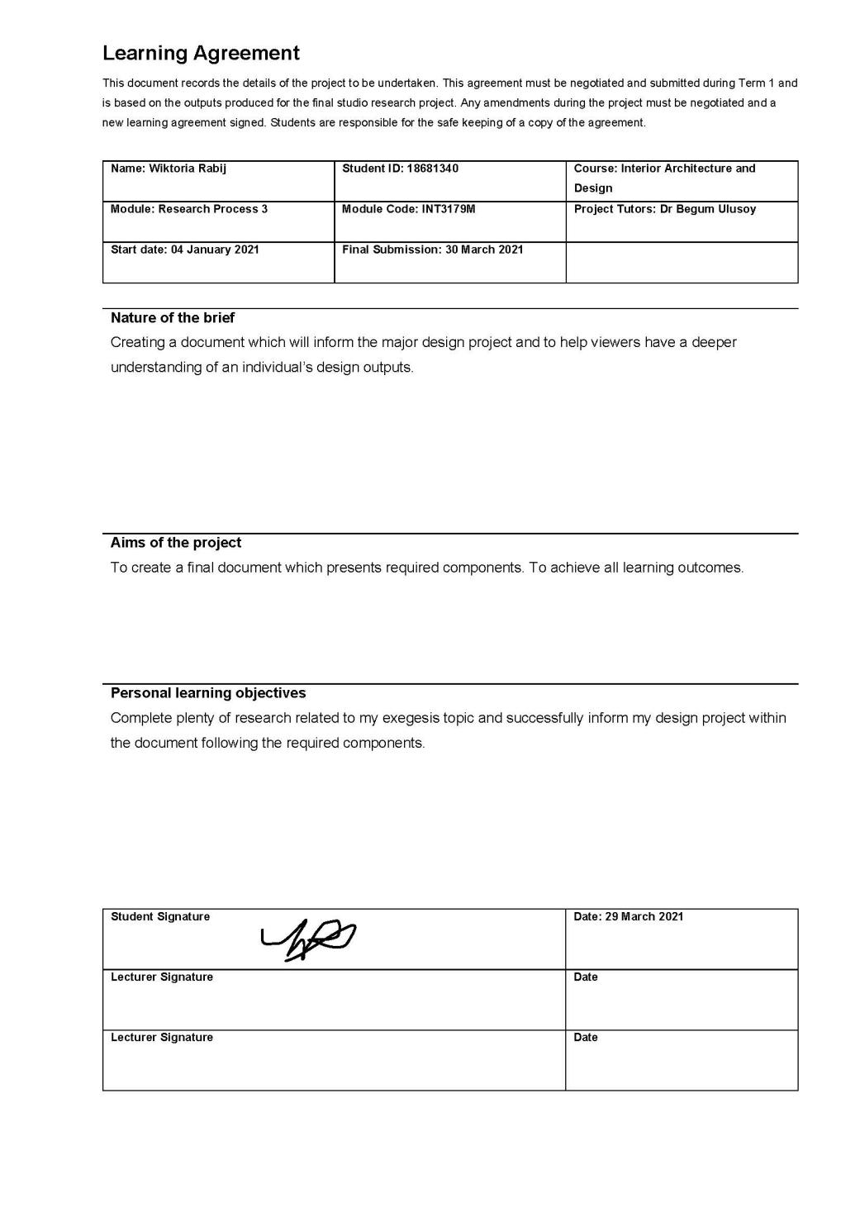

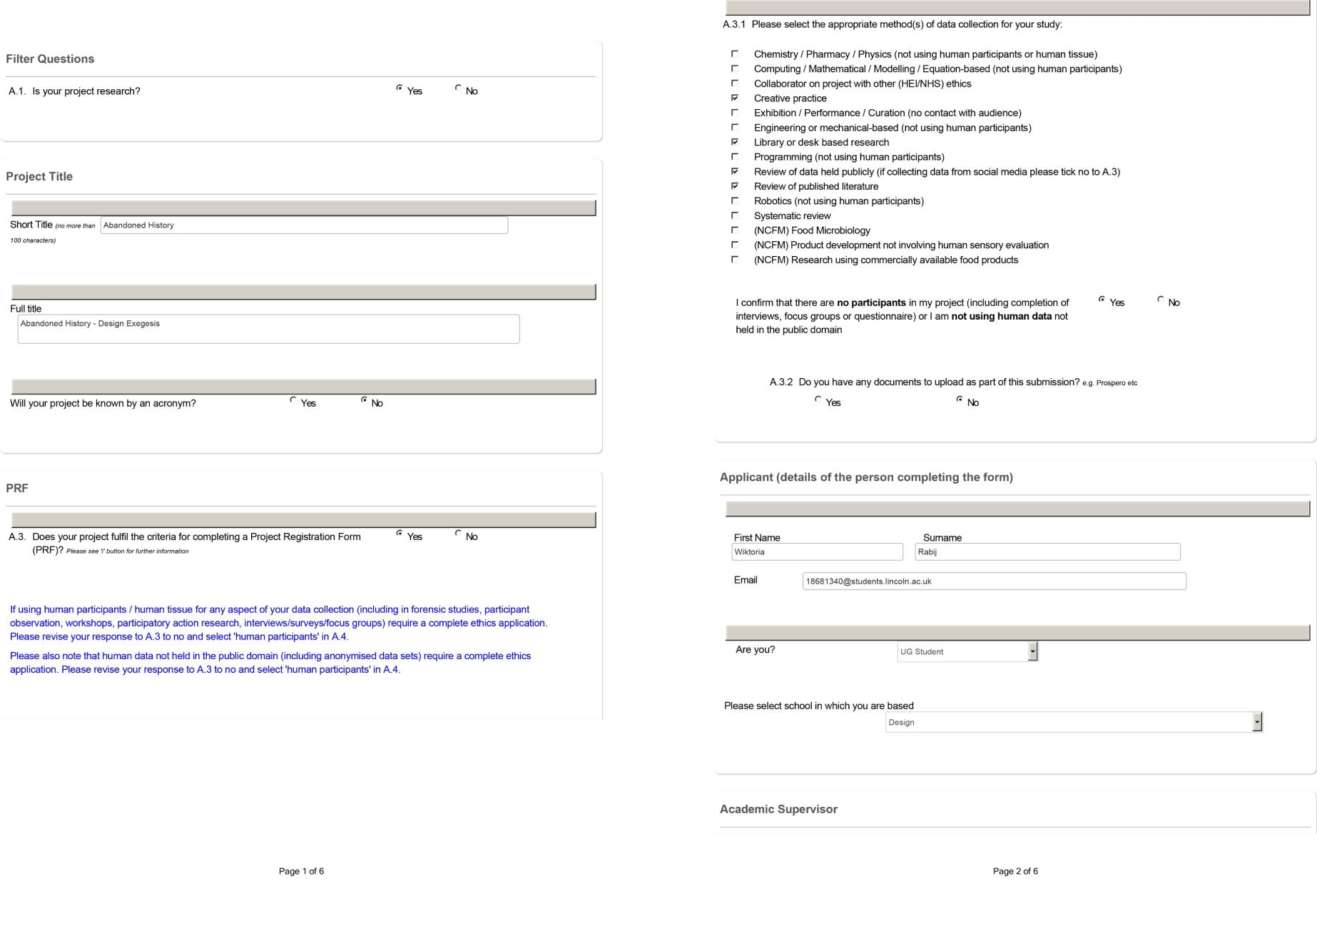

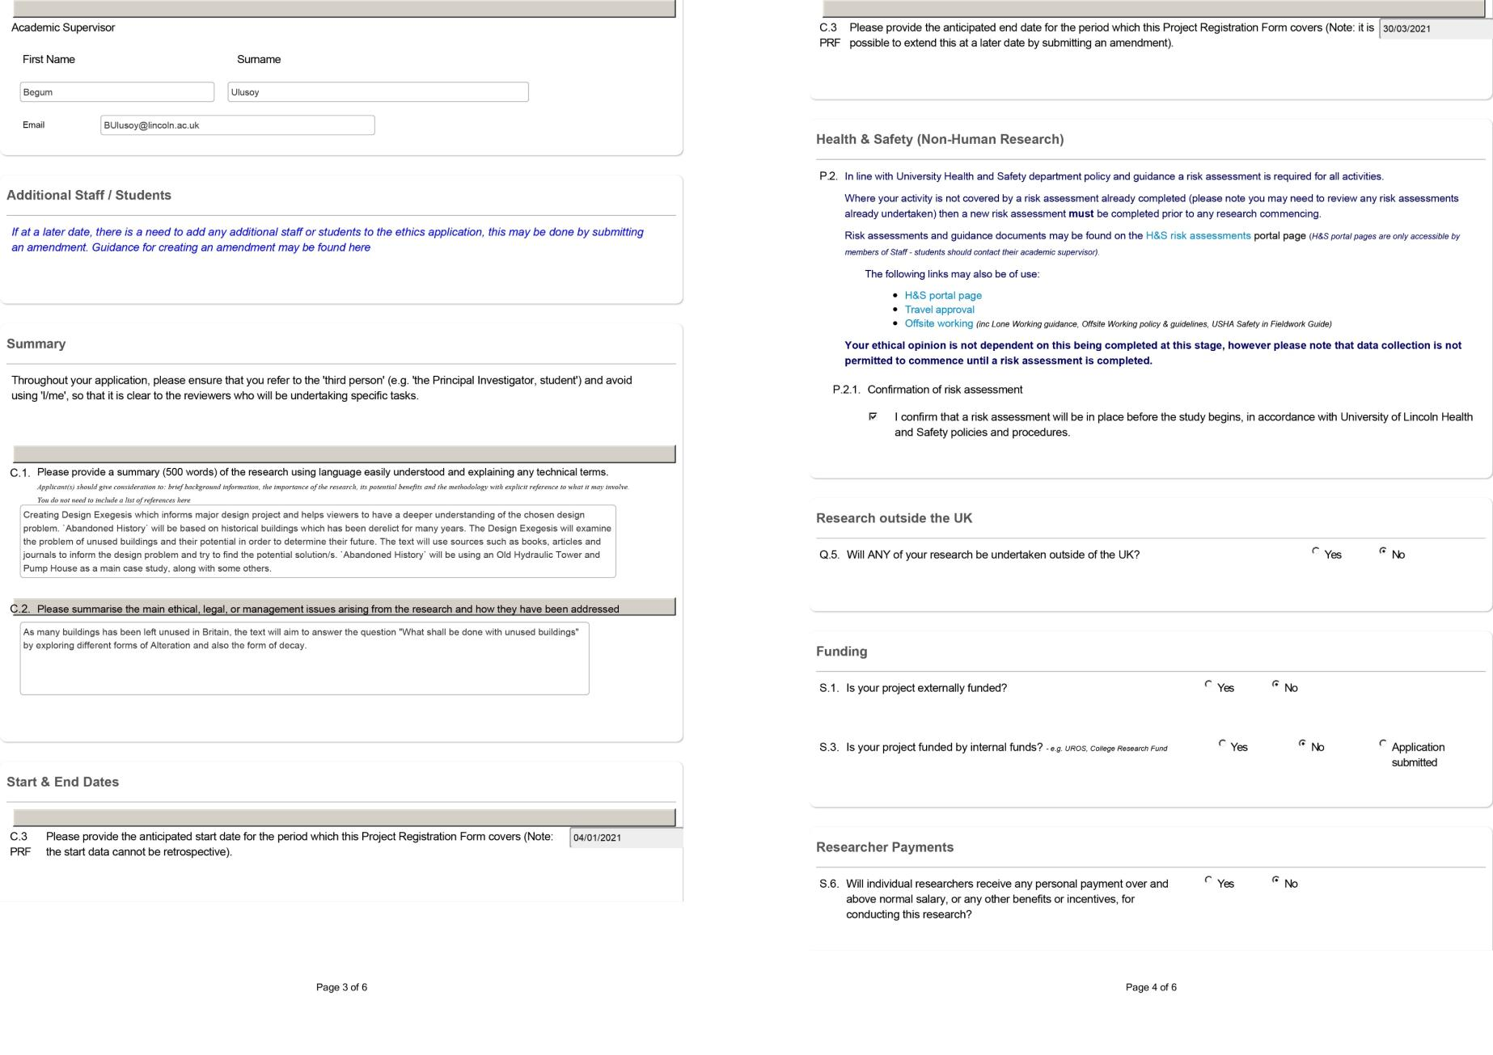
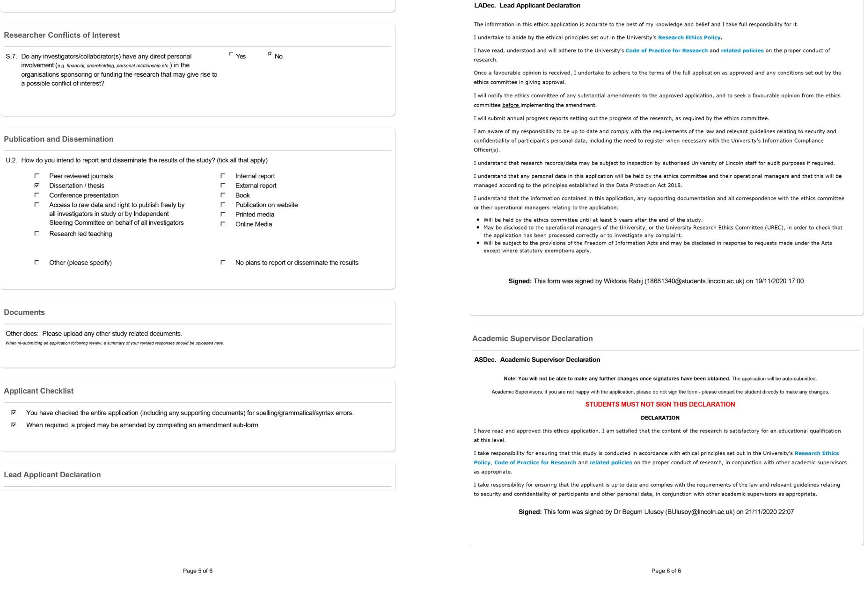

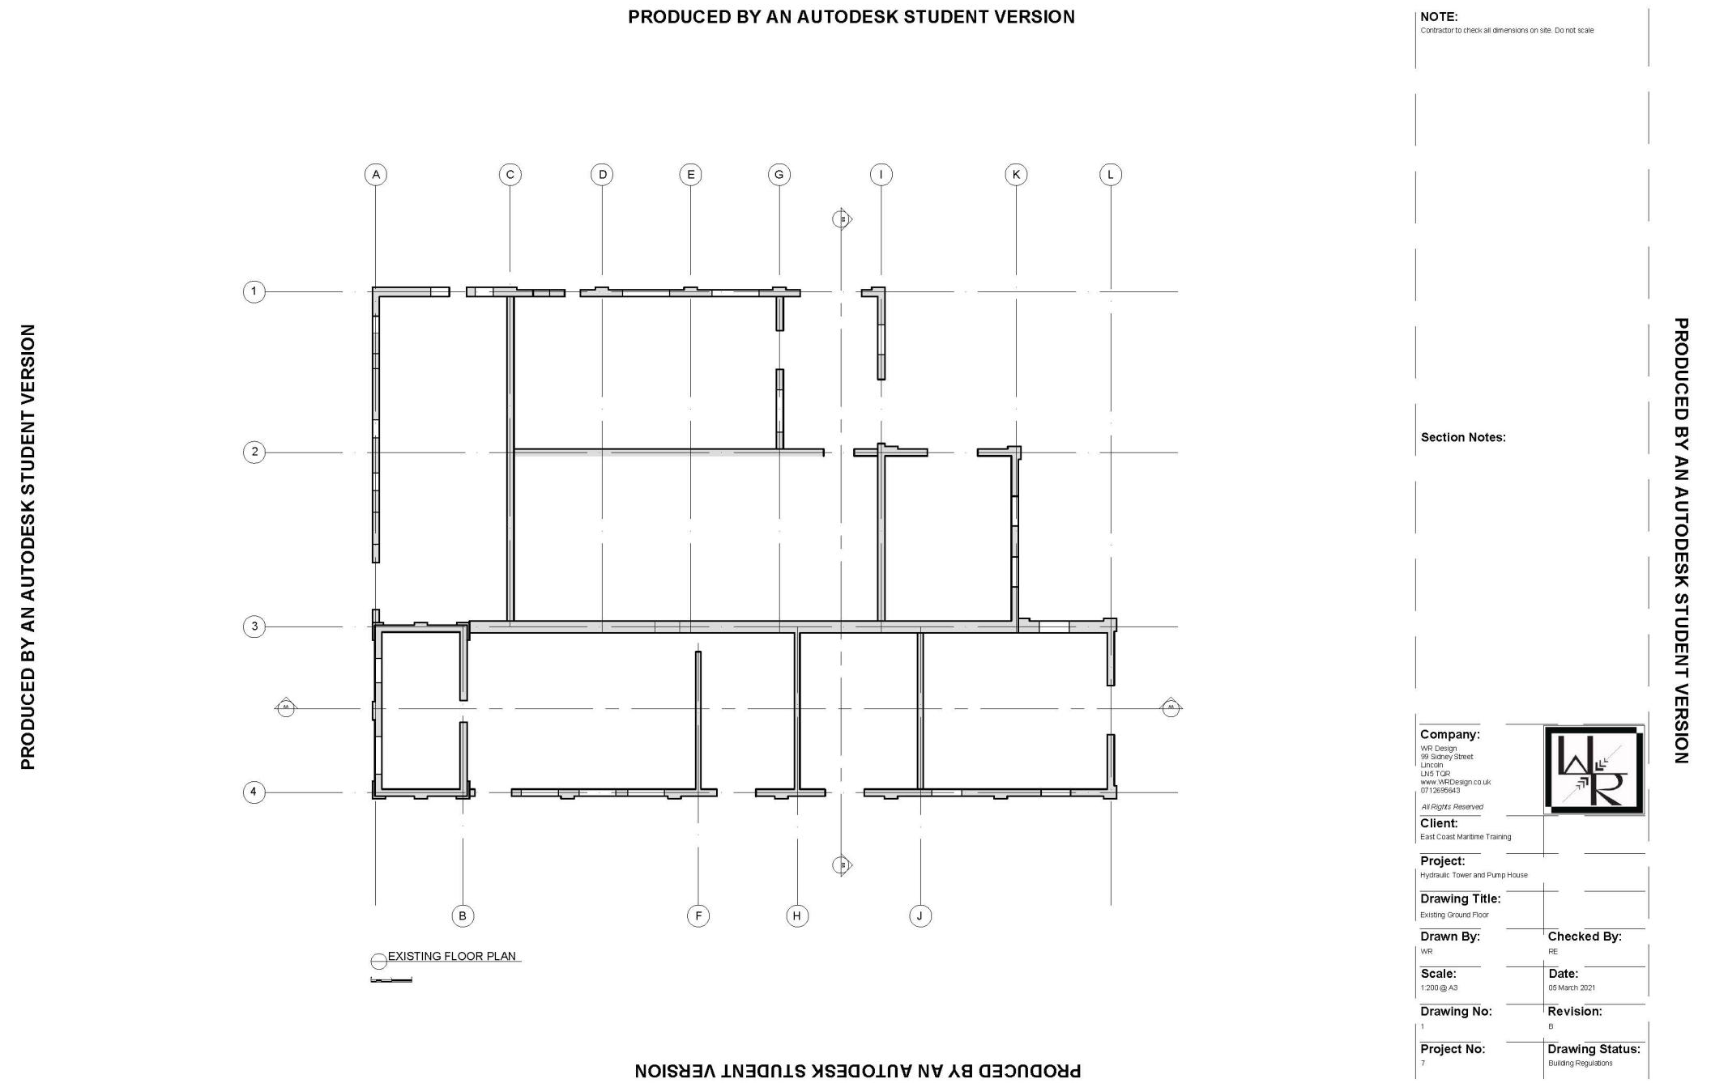
12. 2 EXISTING CAD DRAWINGS

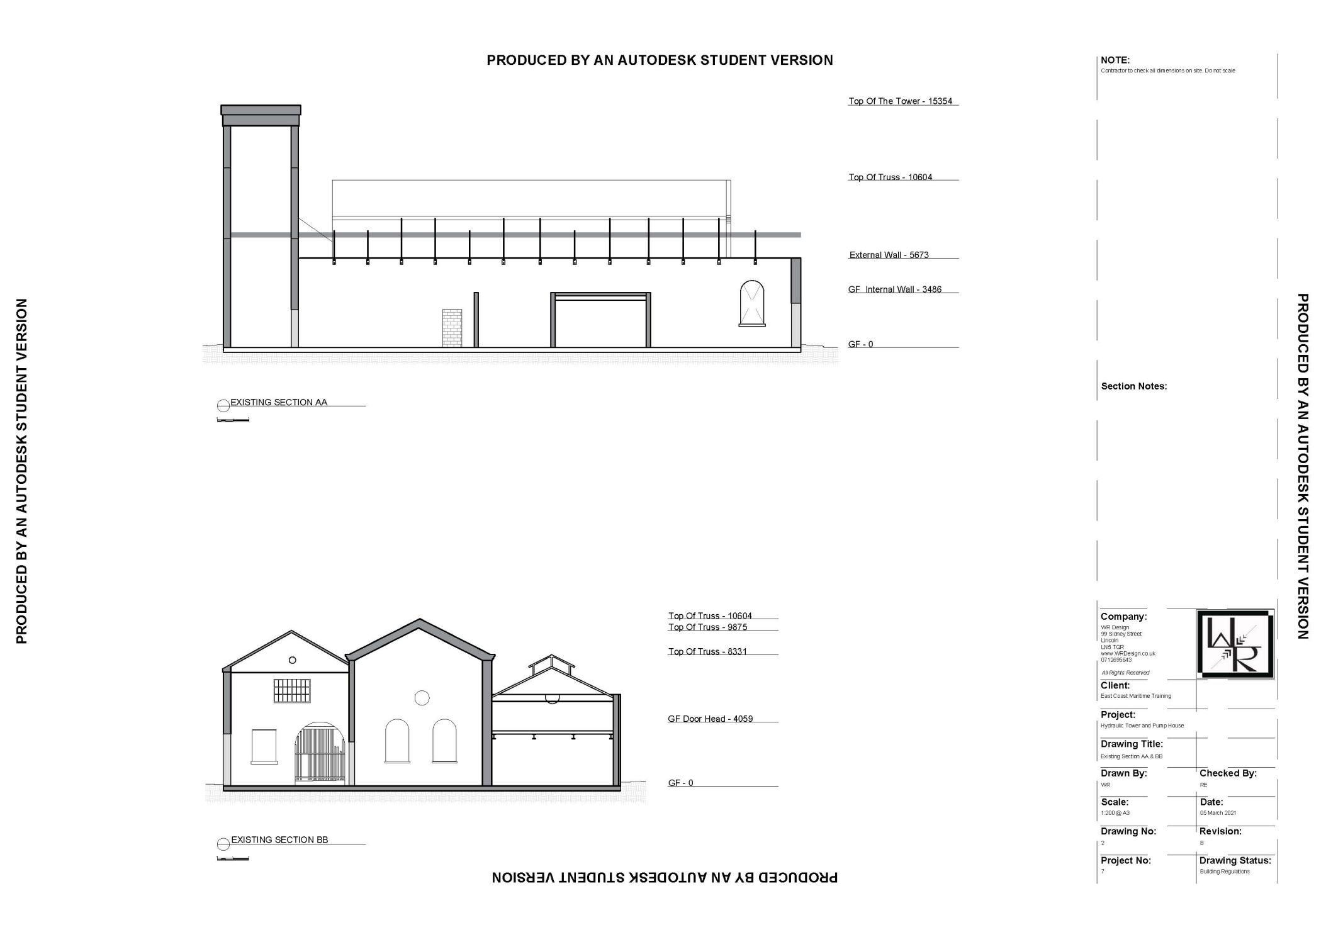

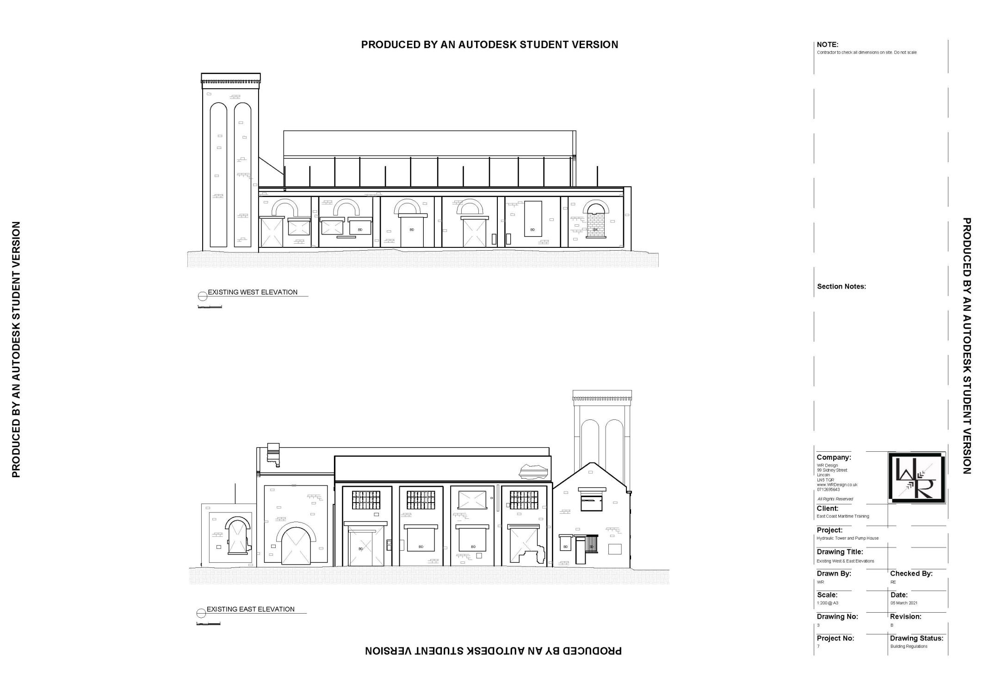
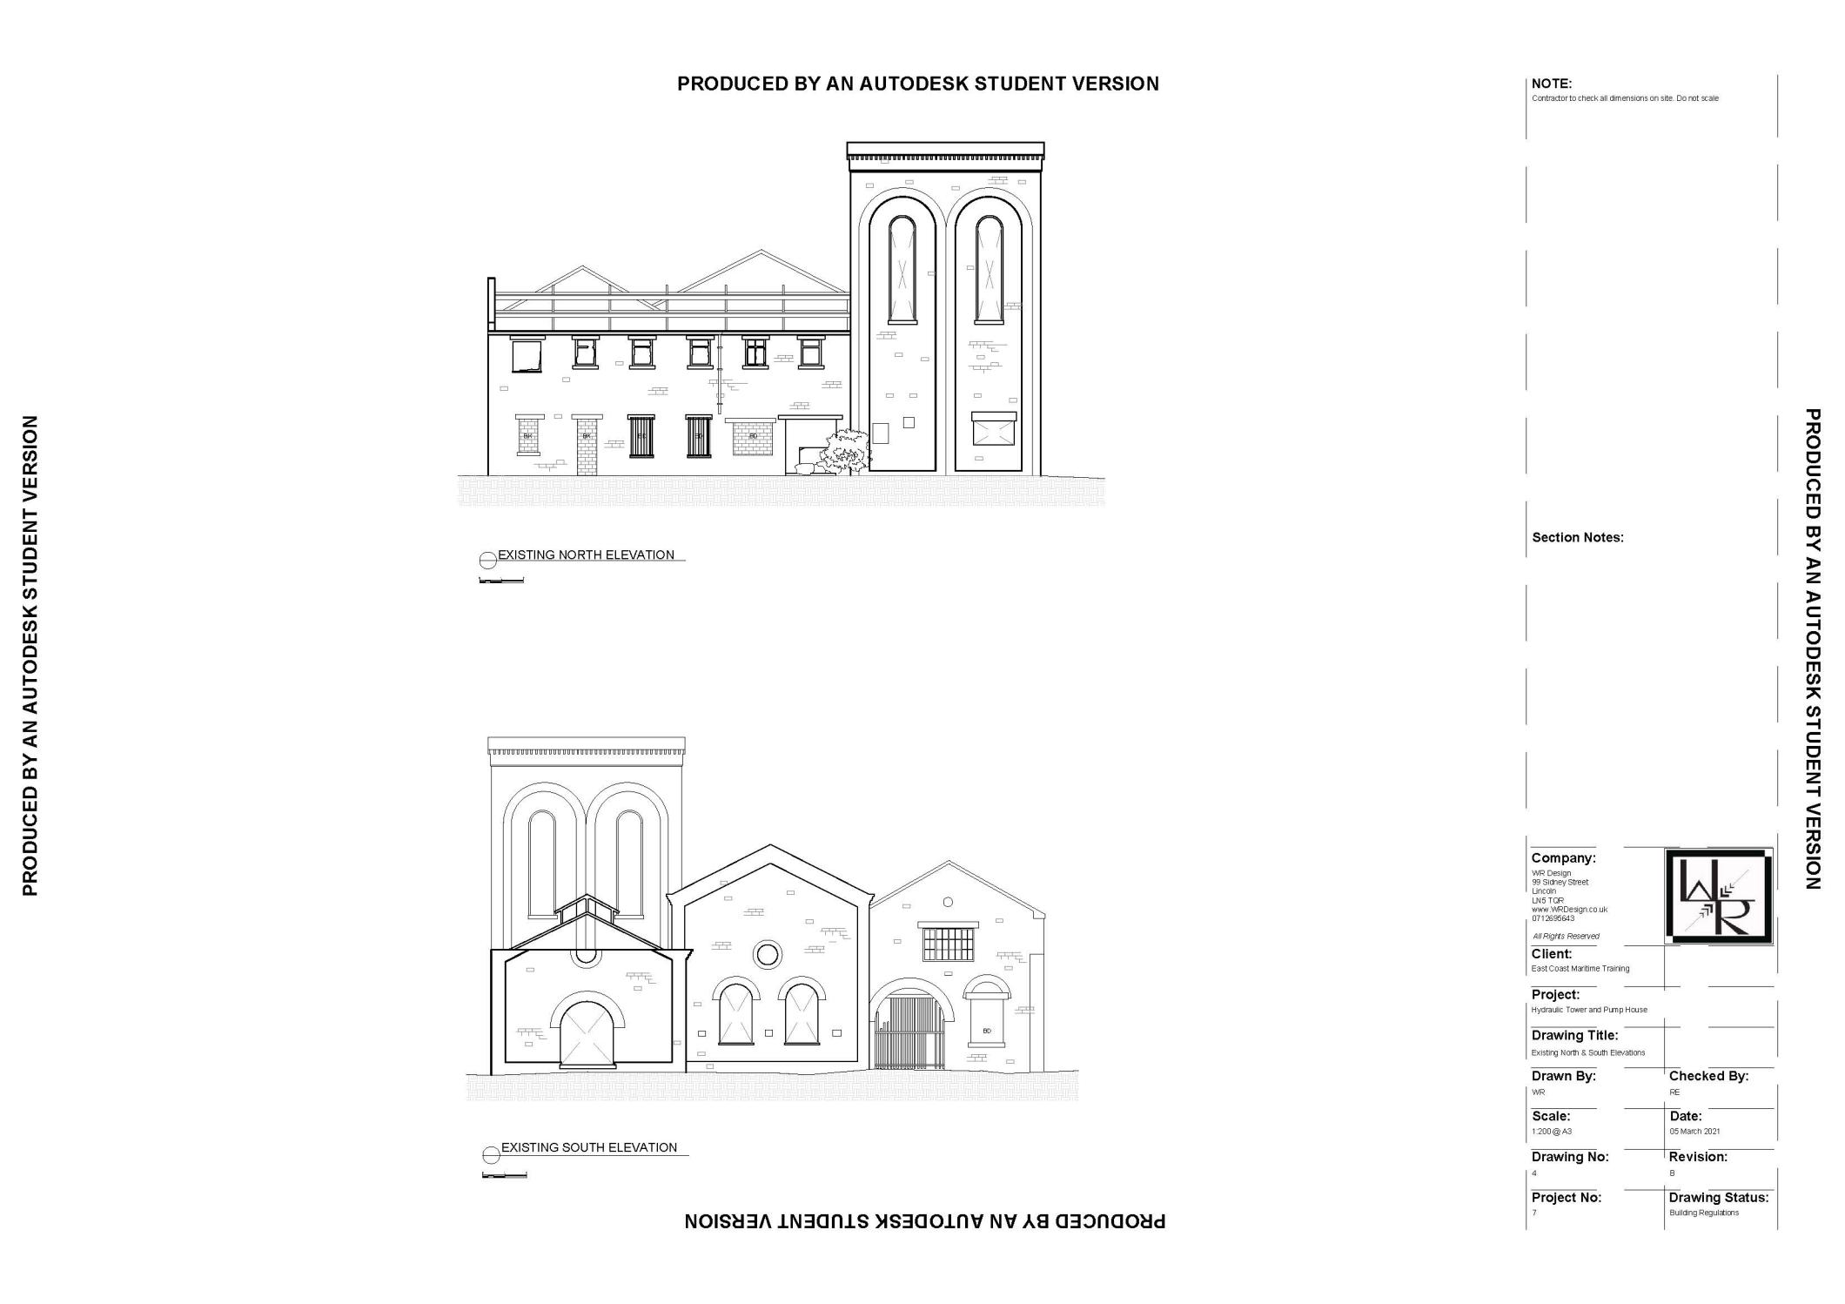

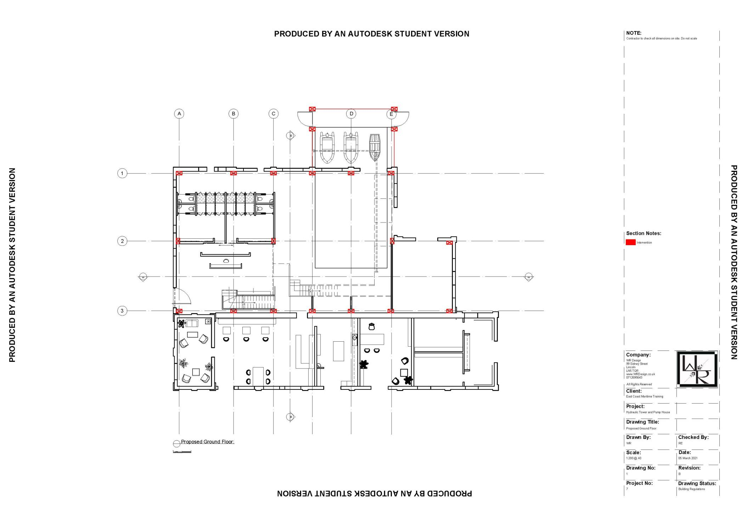
12.3 PROPOSED CAD DRAWINGS
