Disability & Dyslexia Team

Coursework/Exam Certificate – Visual Impairment/Blind

Student I.D. Number: 1733037

The above student is registered with the Disability and Dyslexia Team (DDT) with a diagnosis of a Visual Impairment or registered as Blind. The student uses a screen reader and assistive technology to produce written work and they may be unaware of visual irregularities in the work that they produce.

Errors resulting from the use of a screen reader may include the following:

- Visual materials, such as graphs and charts may not be presented in the correct format.

- Text may be presented in an incorrect format.

- The student may not notice spelling mistakes or typographical errors in their work.

Tutors are asked to make reasonable adjustments when marking coursework and to focus on content and understanding of the subject wherever possible. This does not apply to competence standards.

Coursework:
With adjustments in place a student is expected to meet the course competencies. This document asks that tutors take account of minor errors that, despite the student’s best efforts, may have been overlooked during the proofreading process.

Examinations and tests:
Errors may become more severe in test situations and towards the end of a piece of writing, particularly when the student is under time pressure.

This certificate is for the sole use of the student identified above. Any unauthorised use will result in disciplinary action up to and including exclusion.

Any queries contact the Disability & Dyslexia team:

Racism and gender bias within the architectural industry

Is the architectural industry facing a diversity crisis?

History and Theory
Alison Richards
U1733037

Acknowledgements
I would like to thank my daughters Aingel, Desree, Michelle and Starr, who have been a constant tower of encouragement throughout studies. I would also like to thank Dr Keith winter for constantly nurturing my creativity and believing in me. The history and theory family Claudia Palma and Sabina Andron for awakening a hidden interest in the history and theory.

CONTENT

Abstract
List of figures
1.Introduction
1.2 Aims
1.3 Methodology
2.Gender inequality
2.1 Women and technological practices
2.2 Working hours and family life
2.3 Homo-social behaviour
3.Race
3.1 Case Study - Beverly Lorraine Green
3.2 Location and creativity barriers
3.3 Project selection and employment barriers
3.4 Case Study – Pascale Sablan
3.5 Breaking down the barriers within the architectural industry
Conclusion
Recommendations

ABSTRACT

Background: The architectural industry is one of the leading industries across the world helping to shape and change the lives of people and the environment. Architecture is a revolving environment, that is highly influenced by other industries and the creative minds of its professionals. The presence of digital technology allows for the sharing of information and data to conduct diversity and inclusion reviews in line with other industries. This review aims to investigate the presence of barriers and the possibility of a diversity crisis within the architectural industry. An evaluation of the lack of opportunities presented to women and BAME individuals, as result of systemic behaviour and practices.

Objective: To review to possibility of gender and race discrimination in the architecture industry.

Methods: A selection of resources were used for this review ranging from journals articles and database search’s. The studies included male and female participants working, studying and interacting within industry, of different races and ages.

Results: The case studies and personal accounts convey the presence of barriers as result of race and gender within the industry.

Conclusion: The presence of barriers exists within the architectural industry, however further research is need to understand the extent of these barriers

Table of Figures

Figure 1. Number of jobs in the architectural industries in the UK
Figure 2. Gender pay difference between male and female architects in the UK
Figure 3 Gender pay difference between males and females in the architectural industries
Figure 4. Stuyvesant Town housing complex
Figure 5. United Nations Educational Scientific and cultural organisation (UNESCO) headquarters in Paris.
Figure 6. African Burial Ground National Monument in Manhattan, New York

INTRODUCTION
Architecture is an industry that surrounds us everywhere and every day. Knowingly or unknowingly, architecture dominates our day to day life from the properties that we reside in to the places where we walk and work. Buildings are getting bigger and bolder, whilst designs are getting excessive and extravagant. The more extrovert the design, the more applauds and credit to a building which is designed to convey the meaning, message or style that is attributed directly to its Architect. Through the availability of information and data, individuals have the ability to understand the personal elements of these design concepts and buildings. The continuous expansion of the digital world has led to individuals being able to access the details of professionals in the architectural industry, their motivation, personal characteristics and cultural background from their personal devices in instant.
With the development of multicultural societies around the world and the ability to move across borders easier than before, we would expect to see the architects who have designed our homes, workplaces and public spaces to be of all genders and races. Maintaining the diversity and inclusion narrative of professionals reflecting the populations they serve. However, reviews of the industry indicate the possibility of a diversity crisis, whereby females and ethnic minorities are experiencing additional barriers into the architectural industry at all levels of entry.
Barriers to professional industries may arise from historical content yet have the ability to significantly impact todays’ working practices. The influential suffragette movement had both a negative and positive influence on the present-day architecture industry. Many would remember the suffragettes as a group of white feminist women fighting for women’s rights. However, the forefront of the movement was predominantly white women, supported by women and men of colour who were purposely removed from frontline coverage. (Dodson, 2020) The suffragette activists would welcome the support of black males, to help increase their visibility, as they too were actively perusing their chance to vote, like their white male counterparts (Dodson, 2020). The presence of black males and other women, motivated black women to join the movement, increasing the size and publicity of the suffragette movement. Once the vote was granted to the women, patterns of this behaviour persisted throughout society whereby white males were considered first, followed by ethnic males and white women, and lastly women of an ethnic background. Evidence of this pattern has been recongised in the todays’ architecture industry.
For the purpose of this dissertation, I will be researching and analysing into the diversity or lack of diversity within the Architecture industry and if the level of representation in the industry is acceptable. I will be discussing sensitive topics such as whether it is a male and race dominated industry and if so where, how and why did this begin. I will use case studies and statistics to review and analyse the possible discrimination of gender, race, and whether it has the ability to restrict the furtherance of an individuals’ career or its progression.
Through my research I am to explore whether historical and cultural events have influenced the domination or non-domination in this industry of race and gender, and additionally, whether this has had an inclusive impact on the architectural industry. I will investigate into whether we have learnt from past events and has the industry evolved to mirror that of others where we have or are now prompting change and if so, is this sustainable. Does the presence of protected characteristics have the ability to create barriers into and within the architectural industry, leading to a potential diversity crisis?
Methodology
For the purpose of this review a range of educational resources will be analysed and considered for reference. These resources include YouTube, journal articles, national statistics and articles. Due to the context of these resources and the study of personal experiences, the number of study participants was not specified to a minimum or maximum. The studies included male and female participants working, studying and interacting within industry, of different races and ages. Studies that did not investigate the impact gender and race as possible barriers into the architecture industry were excluded, as they did help to prove or disprove the research question. The sources were divided into two groups gender and race, as these would be primary and secondary subjects for this review. The inclusion and exclusion criteria provided the structure for this review. For the purpose of this review a statistical analysis will be conducted on the data from the Office of National Statistics.
For the purpose of this review race will represent people of colour and ethnic minorities and gender will include males and females. The keywords include race, diversity, gender and barriers.

Keywords
Gender, race, diversity and barriers

Gender

When we discuss the notion of architectural design specifically is it fair to say that most of the population would immediately revert their thoughts to a Caucasian male, early or mid-50’s, living in a supersized wealthy home with his partner and kids. On the necessities, maybe not so but statically it is a fact that architecture is a male dominated industry and unfortunately females are much underrepresented.

Women and the technological aspects of the architectural industry
The architectural industry over the last 30 years has become heavily dependent on the computers, impacting the drawing and client interactions (Davis, 2014). It has been suggested that this era within the architectural industry is more diverse and supportive of women entering the industry, aiming to improve diversity. However, it can be argued the practices of architecture and the increased reliance on technology has favoured the male lifecycle compared to the female creating another potential barrier and reducing the diversity (Sang, Dainty and Ison, 2014). Sang, Dainty and Ison (2014) suggested younger males believe the industry is more liberal than before however, women do not have the technical skills to undertake the construction elements of the job. Davis (2014) argued the technical skills are not the only aspects needed to be considered when investigating female architects and their ability to embrace technology but also the pace in which technology develops. Therefore, with significantly more male architectural technologist then female technological advances and practices have the ability to further the diversity crisis in the architectural industry. Sang, Dainty and Ison (2014)’s study reported women being questioned on their technical expertise and status and this was less about their technical skills but a reflection of an assumption that women do not possess the technical aspects needed for role. Sang, Dainty and Ison (2014) study concluded male architects used the assumption of reduced technical competence as a method of disregarding female architects, further contributing to the gender crisis within the architecture industry.

Homo-social behaviour
The findings of this study conducted by Sang, Dainty and Ison (2014) reported architects having to work 60 hours and more per week, including weekend working. Mark(2015) reported the 87 percent of female architects described having children impeded their career due to the long hours and the timings of career progression. The reported number of women believed having children would negatively affect their career and status. This was agreed by 68 percent of the men participating in the study commissioned by the Architects’ Journal. A possible solution to support female architects wishing to have children may be the ability to work part time hours alongside their family lives. Yet, the Mark (2015) study found 23 percent of the female directors within the study worked part time hours. This may be attributed to their senior positions and may not be option for junior female architects progressing in their career. The architecture industry is not supportive of part time working unlike other industries, whereby women have this option when balancing work and family life their working hours. The study conducted by Sang, Dainty and Ison (2014)supported the inflexible hours are the nature of the industry and are not gender specific. Although the flexible working hours may be option for some women wanting to spread their time between family life and work, they are reported to receive a 51 percent drop in earnings, making the part time option a barrier within the industry.
Due to the multidisciplinary nature of the architectural industry, architects place a great importance of industry networking. Sang, Dainty and Ison (2014) also found study subjects mentioned the increased amount of male dominated networks, whereby clients, fellow architects and other industry professionals would socialise and discuss work related activities in the absence of females or in male dominated environments like golf ranges. Female respondents mentioned being excluded from client meetings and being replaced by male seniors during their projects. Women felt the lack of communication between themselves and their clients increased the probability of their work being dismissed. They later concluded that women did not feel they were only being excluded by their fellow male architects but also by clients as well.

Gender pay gap
The table below represents the differences in the architectural industry displaying statistics for job uptakes over a 7-year period, gender pay difference between males and females over 3-year period and the percentage difference between the two genders. The statistics were retrieved from the National Office of Statistics and are a representative of the UK population.
Number of jobs in the architectural industries in the UK
Year | Male | Female | Difference
2009 | 69 | 26 | 43
2010 | 71 | 27 | 44
2011 | 67 | 27 | 40
2012 | 65 | 26 | 39
2013 | 67 | 26 | 41
2014 | 74 | 27 | 47
2015 | 59 | 31 | 28
Figure 1. Number of jobs in the architecture industries occupied by male and females between 2009 and 2015.
Gender pay difference between male and female architects in the UK
Year | Male | Female | % difference | % of women
2018 | £19.85 per hour | £20.21 per hour | 1.8% | 32%
2019 | £22.14 per hour | £19.14 per hour | 13.6% | 29%
2020 | £22.04 per hour | £18.66 per hour | 15.3% | 29%
Figure 2. Hourly rate of male and female architects between 2018 and 2020

Gender pay difference between males and females in the architectural industries
Year | Male | Female | % difference | % of women
2018 | £19.42 per hour | £18.67 per hour | 3.9% | 20%
2019 | £20.34 per hour | £18.73 per hour | 7.9% | 21%
2020 | £22.04 per hour | £18.66 per hour | 15.3% | 29%
Figure 3. Hourly rate of male and female employees in the architectural industry including town planners and surveyors.

Figure 1 shows there is an average of 40% more males registered architects than females. In 2015 the industry experienced the greatest decrease in male architects from 74 in the previous year to 59. Although, the number of recorded female architects was at its highest over the 7-year period, the increase of 3 more female architects still indicates a gender disparity, contributing to the diversity crisis within the architectural industry.

Figure 2 displays the difference in hourly pay between male and female architects between 2018 and 2020. In 2018 females earned 1.8% more than the male counter parts, this year also had the greatest percentage of female architects over the three-year period. It can be suggested there is possible correlation between the percentage of females in the industry and the smaller gap favouring women. Nevertheless, this may not be the result of a more diverse industry but the requirement to report gender gaps in all big companies announced in 2017. The absence of data from 2017 does not permit further analysis of the potential cause of females earning more than males. However, in 2019 and 2020 this showed the greatest gender gaps, with males earning up to 15.3% more than females in the industry averagely earning £10,000 more each year. Each year females hourly rate decreased whereas the male experienced increase in 2019 from 2018, which later decreased in the 2020. The statistics show females experienced a 26% change in pay and males experienced a 21% change. Conclusively during the three-year period females did not have the same earning potential as their male colleagues, earning up to £20.21 whereas males were able to earn up to £22.14.

Figure 3 displays statistics on different occupations within the architectural industry. Males earned on average 9% more than females over the 3 years. It can be seen in the column male pay increase went up by 0.90p or more, whereas women a 0.06p increase than a decrease of 7p, widening the gender pay gap. Throughout the three years the numbers of women working in the industry increased but this was not reflected in the hourly rate of pay. Figure 3 was included as mentioned above female experienced gender preferences and discrimination from clients whom maybe considered as employees within the architectural industry.

Race

The Cambridge dictionary,2021 describes the term race as a reference used to group people, according to their physical characteristics. The frequent media coverage of racial injustices has led to diversity and inclusion being at the forefront of major industries including architecture. The below section will review two case studies about black female architects and their experiences, within the architecture industry. These studies will be supported by recent studies on race from industry professionals and provide accounts of male professional experiencing similar working practices.

Case Study 1: Beverly Lorraine Greene 1915-1957
Women have contributed to the Architecture and Interior Design Industry for many years. In 1942 Beverly Lorraine Greene at the age of 27 became the first African American Woman to become licensed as an architect in the United States of America(the modernist, 2020). During an era that was civil rights dominated and where most of the country was very much racially segregated and gender-bias, Greene was seen as having achieved a major accomplishment and to have broken gender and race barriers in a simultaneous hit.
Greene was born on the 4th October 1915 in Chicago Illinois. She went on to study at the University of Illinois at Urbana Champaign, which despite the times, was a racially integrated University. In 1936 she went on to become the first African-American woman to graduate with a Bachelor of Science degree in Architectural Engineering from this University and in 1937 she progressed further at the University to complete a Master of Science degree in City Planning and Housing. (the modernist, 2020)
Greene became one of the first few African Americans to be employed by the Chicago Housing Authority and shortly after, on 28th December 1942, at just 27 years old she achieved what some would consider as unobtainable. At the age of 27 Beverly Greene registered with the state of Illinois and became the first African-American female Architect in the United States of America. (The modernist, 2020). However, Greene still suffered the racial conflicts and prejudice that would restrict her and many of her black architect peers from being recognised and gaining employment in the architect industry in Chicago. (The modernist, 2020)
Greene moved to New York and applied work on the Stuyvesant Town, Manhattan housing project. Despite the company making it clear that African Americans would not be allowed to live in Stuyvesant Town, Greene prevailed and applied to be a part of the project not letting her gender or race become a factor. She was hired as the first black and female Architect on the project. However, it would be not until 1951 after years of protest that black families were permitted to move into this area. Greene’s presence on the project was short and she left shortly after and accepted a scholarship at Columbia University in 1945 which is where she obtained her Master’s Degree in Architecture (The modernist, 2020).

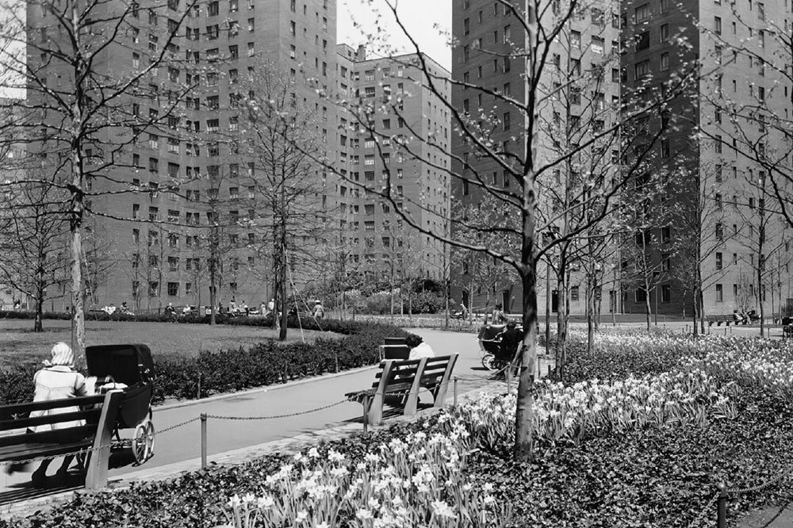
Figure 4. Stuyvesant Town housing complex. (The modernist, 2020)

Greene’s accreditation grew and she collaborated on the building of a theatre at the University of Arkansas in 1951 and the Arts Complex at Sarah Lawrence College in 1952. Greene’s most famous architectural contribution was her input into the United Nations Educational Scientific and cultural organisation (UNESCO) headquarters in Paris, France. Sadly Greene passed away at the tender age of 41 in 1957 before the completion of the build, which was in 1958 but she is largely recognised as a contributor to its existence.(the modernist, 2020)
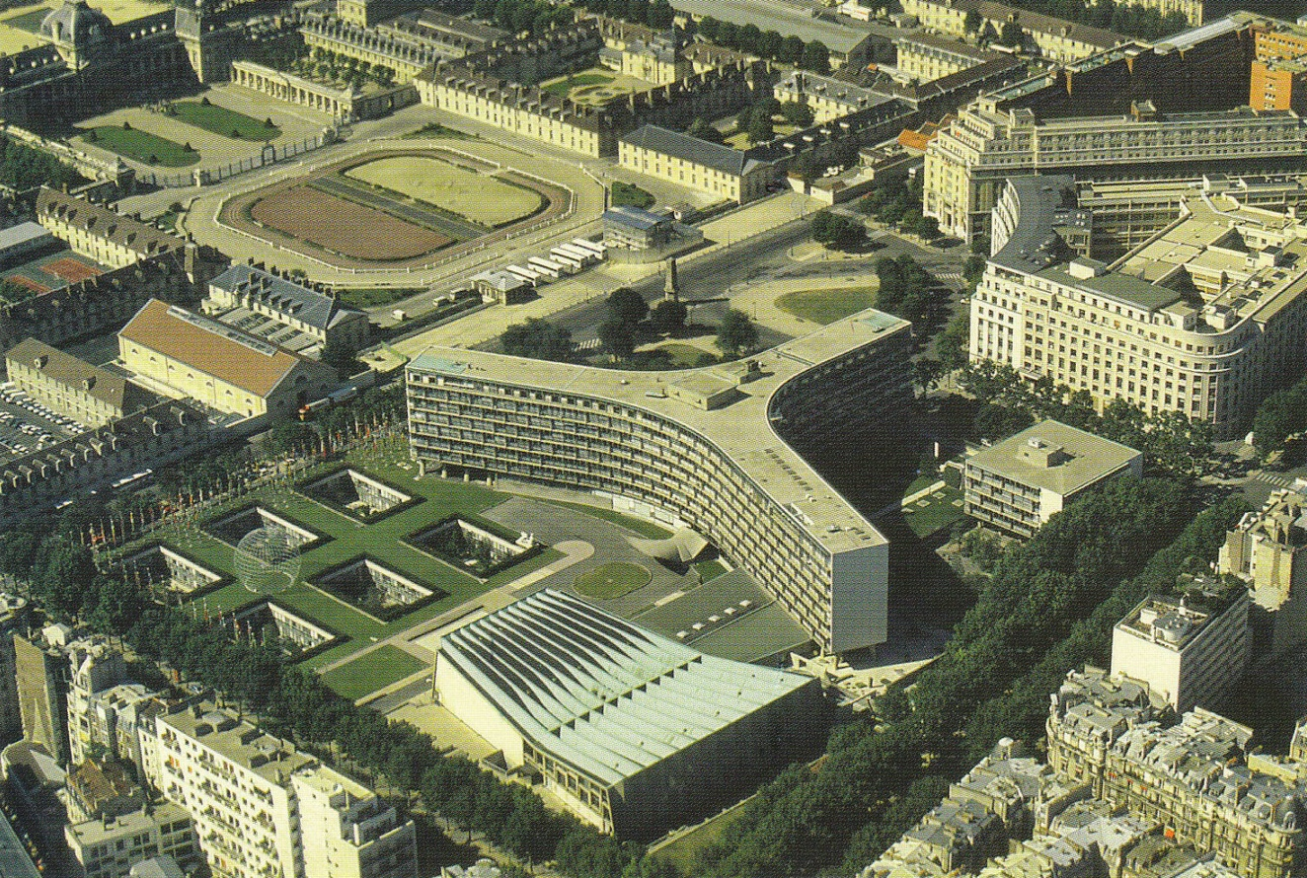
Figure 5. United Nations Educational Scientific and cultural organisation (UNESCO) headquarters in Paris. (The modernist, 2020)

Location and creativity barriers
Greene’s first experience of the race and gender barriers in the architectural industry, was when she unable to work in specific locations and projects, as result of race and gender. As the first black female registered architect, Greene was presented with barriers, not present with her Caucasian counterparts. The case study of Greene highlights the restrictive employment barriers prevented people of colour and women from practicing architecture in specific locations. As black female architect Greene found it difficult sustain work in her hometown of Chicago, being forced to relocate and practice in New York, where she later continued her studies and produced some of her most iconic work. Greene’s restricted practice experience appears to be present in todays’ industry, whereby findings from a survey conducted by Richard Waite 2020 race and diversity survey reported black female architects asking the industry to stop shutting the doors and let them do their job. In both instances Greene and other black female architects reported experiencing barriers that prevented them from working in particular locations, on specific projects and restrictions on their ability to practice architecture within the architectural industry. Due to the colour of their skin and gender. During Greene’s practice racism and gender discrimination was present in all industries, discrimination towards black people and women were not recongised as a barrier but a working practice of a Caucasian male dominated industry. The quote from Malcom X “The most disrespected person in America is the black women.”(Jones, 2020). The review conducted but Richard Waite 2020 reported architects of a black and ethnic minority (BAME) background experienced issues when interviewing and winning work. The root cause of this barrier, preventing women of ethnic backgrounds from practicing and working on particular projects cannot be found and reason why cannot be explained. However, the absence of a root cause questions whether the difficulties Greene faced in her career can be classified as setbacks and not barriers, as she was still able to progress with persistency. Although, she did have to relocate and upskill, she was still able to practice and create well renowned buildings as the first registered black female architect. (The modernist, 2020). Additionally, these barriers and setbacks may not be the result of a diversity crisis in the architectural industry but coincide with the social norms of segregation, gender bias and racial injustices during the 1940s and 1950s.
Project selection and employment barriers
It has been reported that BAME individuals, have faced barriers in the project selection stage, within their careers. BAME architects were occasionally selected for projects that would discriminate against their race or not considered for projects that directly pertain to their race. An example of this discriminatory barrier can be seen in the case study above whereby Greene was selected to design a housing project that would exclude black people from occupying the properties. This barrier has been recongised in todays’ practices. For example, the London borough of Southwark updated their architectural framework appointing 110 practices to design housing for their local population. This framework consisted of 76% of the residents being identifying as BAME, 25% were registered as black. However, the selected practices did not consist of any black lead architects. (Richard Waite 2020). The creation of this barrier may be the result of factors internal and external to the architectural industry. The reduced number of non-white lead architects and architectural practices may be a possible cause restricting architects of BAME background to not be considered for projects and architectural frameworks. Externally architects from an BAME background may experience this barrier due to lack of recommendations from associate industries. This factor can be supported by the reduced quantity of practices owned by individuals and the elusive publicity around their work. Experiencing this barrier architect Norma Shlarek was refused 19 times before being accepted into a junior position within firm, which led to her starting her own practice. Her firm went on to become the largest female led architectural firm. Nevertheless, gender bias and racial discrimination obstructed they firms ability to work on new projects, causing Shalarek to dissolve the firm and work for another company. (The Mordernist,2020).

Race: Case Study 2: Pascale Sablan 1983 – current
Pascale Sablan is the 315th female black registered architect in the United States of America. (Beyond the Built Environment, 2021). She is a regular advocate for promoting women and diversity in the architectural industry.
Sablan was commissioned as a preteen to paint a mural for the Pomonok Community Centre in Queens, New York. Her finished piece was a jungle gym that reflected the multi-cultural and diverse community of Pomonok. While she was drawing a male passer-by stopped and commented that she can draw straight lines without a ruler and that was a great skill for architect. (Beyond the Built Environment, 2021)
Sablan pursued a Bachelor of Architecture at Pratt Institute and this was followed by a Master of Science Degree in Advanced Architectural Design at Columbia University. Whilst studying at the Pratt Institute she joined Aarris Architects as an intern. With Aarris Architects she worked on the famous African Burial Ground National Monument in Manhattan, New York. This monument stands as the oldest and largest excavated burial ground in North America for both free and enslaved Africans. (Beyond the Built Envirnoment, 2021).
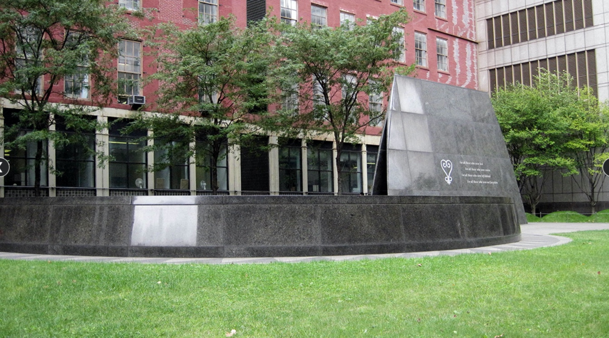Figure 6. African Burial Ground National Monument in Manhattan, New York.(Sablan, 2021)

After graduation from Columbia Sablan joined New York’s FXFowle Architects where she became an associate. In this role Sablan worked on the Museum of the Built Environment (MOBE) in Saudi Arabia. This building was dedicated to exploring the development of sustainable architectural design and the arts specifically within Saudi Arabia and the surrounding region. After being an associate for FXFOWLE for over a decade, Sablan joined New York’s S9 Architecture firm where she currently works as a Senior Associate. (Beyond the Built Envirnoment, 2021).
Sablan has volunteered for a number of years advocating for organisations such as NOMA (National Organisation of Minority Architects) and the AIA (American institute of Architects). Through this she came to understand how apparent the oppression and obstacles that women of all backgrounds were up against within the architectural industry. Sablan had identified a gap within the industry that was not aligning with her passion and beliefs. Using this as her drive and initiative she founded and is the Executive Director of Beyond the Built Environment. Beyond the Built Environment is a platform that represents those who are underrepresented in the architecture industry. With inclusion from pre-schoolers to professionals and experts the platforms approach of “Engage, Elevate, Educate and collaborate” helps to elevate, display and promote the work of women architects of varied backgrounds through showcases, exhibitions and documentaries. (Beyond the Built Envirnoment, 2021).
Sablan is making change for the future diversity in architecture and has even produced within her Beyond the Built Environment, multi-platforms to help encourage future change. The creation of “Learn out Loud” a series of books for children featuring diverse designers that encourage and guide children interested in architecture and design. “Say it Loud” is a travelling exhibition that has been translated in 8 different languages and helps to elevate the work of over 200 architects. “Say it with Media” is the latest initiative which encourages media outlets to commit to increasing their output, features and content of published work by women and BIPOC (Black, Indigenous and People of Colour). (Beyond the Built Envirnoment, 2021).
Sablan was the President of NOMA, New York from 2015 – 2016 and is currently the North-east Regional Vice President and Historian of NOMA. She is also a member of the AIA National Strategic Planning Committee and also serves on the Board of Directors at AIA New York and on the Board of Trustees at the Mary Louis Academy (Beyond the Built Envirnoment, 2021).

Breaking down the barriers within the architectural industry
Pascale Sablan champions women and diverse design professionals by documenting, curating and elevating their work. Sablan strives on taking roles and positions that give her the authority and power to change policy that supports a diverse and inclusive working environment within the architectural industry.

As a result of the barriers mentioned above for both women and people colour, Sablan has dedicated her architectural career to providing platforms that help to break these discriminatory barriers and allow individuals to have a creative voice. Richard Waite 2020 reported BAME architects feel their education was started with issues relating to their race. Sablan directly addresses these earlier educational issues through her book series, conveying the success of BAME and female architects, hoping to encourage young people into the profession. The Steven Lawrence foundation also supports young people perusing architecture related roles, though their getting into architecture tool kit. An individual account in the Richard Waite, 2020 survey declared there is freedom of creativity for white professionals, they are encouraged and considered to be innovative. In contrast, another individual stated black women were made to stay within a creative box and felt undervalued, not being allowed to express their creative initiatives, unlike their white counterparts. Seblan’s media platform provided a space for women and BAME individuals experiencing these creative restrictions to showcase their work through different media outlets. 91% of black participants surveyed in the Richard Waite, 2020 study reported barriers throughout and outside of the architecture industry. Timothy Onyenobi suggested in the survey that admissions teams in university’s should be trained on unconscious biases, with the aim to understand their biases towards BAME and women applicants. This suggestion can be considered as a universal method to breaking down the gender and racial barrier within the architectural industry, as it has the ability to affect the interactions between individuals. Sablan’s choice of influential roles also allows her to make and change policies on diversity and inclusion supporting both women and BAME professionals at the professional stage of their career. Sablan’s dual focused career and dedication to breaking the barriers, conveys the prevalent presence of racial and gender discrimination within the industry. It can be said that Sablan’s platforms target the barriers and allow entry for women and BAME individuals. However, the Richard Waite, 2020 survey stated these barriers require attention from all individuals and not just black and ethnic minorities.

Conclusion
The purpose of this review was to examine the possibility of a diversity crisis in the architecture industry. The review explored two elements of diversity, gender and race in relation to technology, social behaviours, pay, education and experience within the industry.

The most significant findings to arise from this review was the presence of subliminal and historical barriers throughout industry, targeting women and BAME individuals. Inflexible working hours, reduced pay, project restrictions and unconscious biases, are key factors used to create these barriers. The review has exposed the alternative pathways BAME individuals and women, have and are currently taking to be acknowledge and consider for projects, within their profession.

BAME women face two unethical barriers as professionals in the architecture industry: Being a woman and being of colour. These barriers have the ability to influence their architectural practice and the way they are perceived in a domestic and workplace environment. It can be concluded that Greene’s experience could be the attributed to the societal norms of the 1940s. However, the survey conducted by Richard Waite, 2020 and the Steven Lawrence Foundation conveyed, that these discriminatory practices are present in todays’ architectural industry. World renowned architect, Seblan has dedicated her career to breaking these barriers, through her platforms, books and advocacy. Her work helps to promote, encourage and engage people from younger generation to a practicing professional within the industry.

The findings of this review have eluded the presence of a diversity crisis being present in todays’ architectural industry. The barriers that were once created due to societal norms, are still present in todays’ practices and have a similar detrimental effect on women and BAME individuals.

Diversity should not be an obsolete agenda item. Changes require senior management support and continuous application in the architectural working practices. A behavioural change across the industry is required, in order for these positive practices to be sustainable and adopted at levels of entry.

The scope of this review was limited to gender and race, however increasing the scope to review the other elements of diversity would have approved or disproved the research question. Is the architecture industry experiencing a diversity crisis? Consideration for age, sexual orientation and disability would have allowed a more comprehensive approval or disapproval of the question. Although the review did not include these elements, the findings did suggest the presence of barriers within the industry for women and people of colour. This review may have benefited from a primary study design whereby a group of professionals working in the industry were interviewed about their experiences of the industry in relation to their race and gender.

Recommendations
This review has highlighted the absence of significant data within the architecture industry in relation to diversity. A larger study across the industry would help to provide more comprehensive evidence and data. The presence of this information will help companies, educational establishments and royal societies to create practices that will help to increase diversity and inclusion across the industry and eliminate historical barriers. Royal societies should conduct an annual audit for diversity, publishing in line with other sectors. The statistics should be accessible and a mandatory requirement for all registered practices and companies.

Bibliography

‘Architecture is systemically racist. So what is the profession going to do about it?’ (2020) The Architects’ Journal, 23 July. Available at: https://www.architectsjournal.co.uk/news/architecture-is-systemically-racist-so-what-is-the-profession-going-to-do-about-it (Accessed: 5 April 2021).
Beyond the Built Envirnoment (2021a) Pascale Sablan | BEYOND THE BUILT ENVIRONMENT, BeyondtheBuilt.com. Available at: https://www.beyondthebuilt.com/pascale-sablan (Accessed: 10 April 2021).
Beyond the Built Envirnoment (2021b) Pascale Sablan | BEYOND THE BUILT ENVIRONMENT, BeyondtheBuilt.com. Available at: https://www.beyondthebuilt.com/pascale-sablan (Accessed: 10 April 2021).
Davis, D. (2014) Where Gender Inequity Persists in Architecture: the Technology Sector, Architect. Available at: https://www.architectmagazine.com/practice/where-gender-inequity-persists-in-architecture-the-technology-sector_o (Accessed: 27 March 2021).
Dodson, A. P. (2020) ‘Why women’s suffrage matters for Black people’, The Undefeated, 18 August. Available at: https://theundefeated.com/features/why-womens-suffrage-matters-for-black-people/ (Accessed: 11 April 2021).
Gardner, N. (2019) ‘New Divisions of Digital Labour in Architecture’, Feminist Review, 123(1), pp. 106–125. doi: http://dx.doi.org/10.1177/0141778919879766.
Jones, F. (2020) Malcolm X Stood Up for Black Women When Few Others Would, Medium. Available at: https://zora.medium.com/malcolm-x-stood-up-for-black-women-when-few-others-would-68e8b2ea2747 (Accessed: 12 April 2021).
Mark, L. (2015) ‘Glass ceiling remains for women in architecture’, The Architects’ Journal. Available at: https://www.proquest.com/docview/1647766068/abstract/36DA9C7FA4964FAFPQ/8 (Accessed: 27 March 2021).
Number of licensed Black female architects increases to 500 (no date) Archinect. Available at: https://archinect.com/news/article/150233756/number-of-licensed-black-female-architects-increases-to-500 (Accessed: 24 March 2021).
Sablan, P. (2021) Pascale Sablan | BEYOND THE BUILT ENVIRONMENT, BeyondtheBuilt.com. Available at: https://www.beyondthebuilt.com/pascale-sablan (Accessed: 10 April 2021).
Sang, K. J., Dainty, A. R. and Ison, S. G. (2014) ‘Gender in the UK architectural profession: (re)producing and challenging hegemonic masculinity’, Work, Employment and Society, 28(2), pp. 247–264. doi: 10.1177/0950017013491306.
the modernist (2020) Beverly Loraine Green & Stuy Town, New York, the modernist. Available at: https://www.the-modernist.org/news/2020/6/11/spotlight-beverly-loraine-green (Accessed: 10 April 2021).
visionaryproject (2010) Norma Sklarek: My Childhood. Available at: https://www.youtube.com/watch?v=GssFR02cx8g&list=PLCwE4GdJdVRKttKo5pFJLlkS3mySA4A12 (Accessed: 12 April 2021).
Waite, R. (2020) ‘Architecture is systemically racist. So what is the profession going to do about it?’, The Architects’ Journal, 23 July. Available at: https://www.architectsjournal.co.uk/news/architecture-is-systemically-racist-so-what-is-the-profession-going-to-do-about-it (Accessed: 11 April 2021).

